The Origins of US Cold War Fears, 1946–1961
by John P. Irish

UNIT OVERVIEW
This unit has been developed by the Gilder Lehrman Institute of American History in partnership with World101 from the Council on Foreign Relations. These lesson plans were developed to enable students to understand, summarize, and evaluate original documents of historical significance. Students will learn and practice skills that will help them analyze, assess, and develop knowledgeable and well-reasoned points of view on visual and textual source materials.
In the two lessons in this unit the students will analyze and assess various documents, including speeches, government documents, and images from 1946 to 1961. The objective is to have students recognize the origins of the Cold War conflict between the US and the USSR by analyzing key elements of primary source materials. The students will examine, define, interpret, and organize the documents with the goal of answering the essential question: What fears led the United States into the Cold War? As an assessment, students will engage in a small-group seminar to critically evaluate the origins of these US fears.

NUMBER OF CLASS PERIODS: 2

GRADE LEVEL(S): 7–12

UNIT OBJECTIVES
Students will be able to
Analyze primary source documents using close-reading strategies
Identify and describe the historical context and main points of a document
Identify and describe the point of view and purpose of a document
Draw conclusions based on direct evidence found in the text
Evaluate and group documents based on shared categories
Collaborate effectively with classmates to develop and express positions and viewpoints

ESSENTIAL QUESTION
What fears led the United States into the Cold War?

COMMON CORE STATE STANDARDS
CCSS.ELA-Literacy.RH.6-8.1: Cite specific textual evidence to support analysis of primary and secondary sources.
CCSS.ELA-Literacy.RH.6-8.6: Identify aspects of a text that reveal an author’s point of view or purpose (e.g., loaded language, inclusion or avoidance of particular facts).
CCSS.ELA-Literacy.RH.6-8.7: Integrate visual information (e.g., in charts, graphs, photographs, videos, or maps) with other information in print and digital texts.
CCSS.ELA-Literacy.RH.9-10.1: Cite specific textual evidence to support analysis of primary and secondary sources, attending to such features as the date and origin of the information.
CCSS.ELA-Literacy.RH.9-10.2: Determine the central ideas or information of a primary or secondary source; provide an accurate summary of how key events or ideas develop over the course of the text.
CCSS.ELA-Literacy.RH.9-10.3: Analyze in detail a series of events described in a text; determine whether earlier events caused later ones or simply preceded them.
CCSS.ELA-Literacy.RH.9-10.8: Assess the extent to which the reasoning and evidence in a text support the author’s claims.
CCSS.ELA-Literacy.RH.9-10.9: Compare and contrast treatments of the same topic in several primary and secondary sources.
CCSS.ELA-Literacy.RH.11-12.1: Cite specific textual evidence to support analysis of primary and secondary sources, connecting insights gained from specific details to an understanding of the text as a whole.
CCSS.ELA-Literacy.RH.11-12.2: Determine the central ideas or information of a primary or secondary source; provide an accurate summary that makes clear the relationships among the key details and ideas.
CCSS.ELA-Literacy.RH.11-12.3: Evaluate various explanations for actions or events and determine which explanation best accords with textual evidence, acknowledging where the text leaves matters uncertain.
CCSS.ELA-Literacy.RH.11-12.7: Integrate and evaluate multiple sources of information presented in diverse formats and media (e.g., visually, quantitatively, as well as in words) in order to address a question or solve a problem.
CCSS.ELA-Literacy.RH.11-12.8: Evaluate an author’s premises, claims, and evidence by corroborating or challenging them with other information.
CCSS.ELA-Literacy.RH.11-12.9: Integrate information from diverse sources, both primary and secondary, into a coherent understanding of an idea or event, noting discrepancies among sources.

LESSON 1: EXPLORING THE FEARS (Document Analysis)

OVERVIEW
In the first lesson, students will identify, examine, and analyze the language and imagery of primary source documents related to the fears that led the United States into the Cold War from 1946 to 1961. They will work with a variety of primary source materials including speeches, government documents, and images. They will determine the historical context, summarize key ideas, and analyze the point of view and purpose of each document. At the end of the lesson, the class will come together to discuss the fears that led the United States into the Cold War.

HISTORICAL BACKGROUND
The Origins of US Cold War Fears, 1946–1961
by Daniel Sargent, Associate Professor, Department of History, University of California Berkeley

The fear that animated US policy in the early Cold War should perplex and intrigue us. For more than a hundred years, Americans had disavowed foreign entanglements. Their government had exercised power mostly within the Western Hemisphere, whose physical separation from Europe and Asia assuaged fears of external attack. And the United States had emerged from the Second World War in a position of supreme strength. Other belligerents suffered invasion, occupation, and bombing, but the United States had fought the war with its homeland essentially unscathed, doubling the size of its economy during the war. Few, if any, states in the history of international relations have ever commanded a position of relative strength such as the United States enjoyed in 1945.
So how should we explain the surge of fearfulness that overwhelmed American society in the late 1940s and endured, in abated form, for decades to follow? No single answer will suffice; what historians call the anti-Communist “Red Scare” was a complex phenomenon, and explanation requires attentiveness to both the American scene and the global context, to structural characteristics of American politics and to the happenstance of events.
Start with the global scene. The United States and its democratic-capitalist ideological synthesis were not the war’s sole victors. The others were the Soviet Union and its Marxist-Leninist ideological creed. Nazi invasion had battered the Soviet homeland, but the USSR emerged from the Second World War with its prestige at high ebb. Communist parties had fought valiantly against Axis occupation in both Europe and Asia; at the war’s end, Communists who looked to Moscow for leadership were poised to exercise unprecedented influence in the politics of the decolonizing and postcolonial world. As relations between the United States and the Soviet Union deteriorated, Communism’s gains looked, from a US standpoint, like setbacks.
The dynamics of US domestic politics amplified the sensation of slippage, especially after Republican gains in the 1946 mid-term election returned divided government to Washington for the first time since 1933. Committed to global leadership, the Truman administration talked up the Communist threat in order to secure support for its internationalist commitments, including the Marshall Plan. This approach worked, but its consequences proved fateful. In order to justify internationalist commitments, American leaders pumped up the specter of an external threat, which empowered Truman’s domestic critics to assail the administration for insufficient vigor in protecting the United States against external enemies. Revelations that high-placed Americans, including State Department official Alger Hiss, had spied for the Soviet Union ratcheted up the political cytokine storm.
Events amplified the crisis of confidence. In the span of less than a year, the Soviet Union tested an atomic bomb, in August 1949; Mao Zedong declared victory in the Chinese Civil War, in October 1949; the Soviet Union and China forged an intimate alliance, in January 1950; and North Korea, a Soviet client, invaded South Korea in June 1950. These rapid-fire events thrust the American Cold War into its most intense phase. So dramatic were the setbacks that some, including Senator Joseph McCarthy, reasoned that high-placed officials within the Truman administration must be traitors and Communists. The most lurid allegations subsided, but fears of a devastating nuclear attack persisted, as both the United States and the Soviet Union acquired hydrogen bombs in the early 1950s and, as the decade progressed, growing fleets of intercontinental delivery vehicles, including bombers and missiles.
Cold War fears mellowed after the Red Scare of the early 1950s subsided but did not dissipate. Instead, setbacks that showcased American vulnerabilities prompted renewed cycles of panic—and action. One came in 1957–1958 after the Soviet launch of an artificial satellite, Sputnik, prompted a new wave of national anxiety over the prospect of US relative decline. Another came in 1962, after President Kennedy revealed to the American people that the Soviet Union had installed short- and medium-range missiles on the island of Cuba, penetrating the Western Hemisphere that Americans since John Quincy Adams had declared closed to external powers.
Over time, though, Americans became accustomed to the structural hostility that defined the Cold War conflict, and the threat of thermonuclear war faded into the background, no longer the captivating preoccupation it had been during the Cold War’s formative phase. The fading of ideological and geopolitical fears portended the transition to a distinctive new phase in the Soviet-American conflict, from the era of fear-fueled escalation to the era of détente.
Learn more about the Cold War at World101’s Historical Context module Global Era.

Daniel Sargent, an associate professor of history and the Goldman School of Public Policy at the University of California Berkeley, is the author of A Superpower Transformed: The Remaking of American Foreign Relations in the 1970s (2015) and co-editor of The Shock of the Global: The 1970s in Perspective (2010).

MATERIALS
Historical Background: “The Origins of Cold War Fears, 1946–1961” by Daniel Sargent, Associate Professor, University of California Berkeley, with Important Phrases activity sheet
Primary Sources with Activity Sheets
  - #1: Excerpts from Bernard M. Baruch, “The Baruch Plan,” June 14, 1946 in Library of Congress. Environment and Natural Resources Policy Division, United States. Nuclear Proliferation Factbook (Washington: US Government Printing Office, 1985), pp. 14 and 18. Available on Hathi Trust Digital Library, catalog.hathitrust.org/Record/002766262.
  - #2: Edwin Marcus, “Can He Block It?” ca. 1947, Library of Congress, loc.gov/pictures/item/2016683506/. By permission of the Marcus family.
  - #3: Excerpts from George Kennan, “The Sources of Soviet Conduct,” Foreign Affairs, July 1947, https://www.foreignaffairs.com/articles/russian-federation/1947-07-01/sources-soviet-conduct.
  - #4: Herblock, “Fire!” June 17, 1949, A 1949 Herblock Cartoon, © The Herb Block Foundation.
  - #5: Excerpts from “US Objectives and Programs for National Security,” NSC-68, April 1950, in United States, Department of State, Foreign Relations of the Unites States, 1950, vol. 1 (Washington: US Government Printing Office, 1977), pp. 282 and 287. Available on Hathi Trust Digital Library, catalog.hathitrust.org/Record/002754464.
  - #6: Excerpts from Joseph McCarthy, “Enemies from Within” Speech Delivered in Wheeling, West Virginia (1950) in Congressional Record: Proceedings and Debates of the 81st Congress, Second Session, vol. 96, pt. 2 (Washington DC: US Government Printing Office, 1950), pp. 1954 and 1956. Available from govinfo.gov/app/collection/crec.
  - #7: “Trouble on the Docks,” Fight the Red Menace: The Children’s Crusade against Communism Trading Cards (Philadelphia: Bowman Gum, Inc., 1951), The Gilder Lehrman Institute of American History, GLC09627.07.
  - #8: Excerpt from Judge Irving Kaufman’s Sentencing Statement in the Rosenberg Case,” March 29, 1951 in Rosenberg v. United States, FindLaw, caselaw.findlaw.com/us-supreme-court/346/273.html.
  - #9: Sheet music cover from Irving Caesar, “Pledge of Allegiance to the Flag” (Washington DC: US Government Printing Office, 1955), Wikipedia.
  - #10: Marion S. Trikosko, photographer. Woman in bomb shelter which is stocked with food and other supplies; bunk bed in corner, September 9, 1961, US News and World Report Collection, Library of Congress, loc.gov/item/2015647175/.
  - #11: Alexei Kutzkov of Moscow by Howard Sochurek, February 1958, and Stephen Lapekas of Chicago by Stan Wayman, March 1958, LIFE Photo Collection, © Time Inc.
  - #12: Excerpt from Dwight D. Eisenhower, Farewell Radio and Television Address to the American People,” January 17, 1961, Online by Gerhard Peters and John T. Woolley, The American Presidency Project, presidency.ucsb.edu/node/234856.

PROCEDURE
- Divide the class into small groups (e.g., three to five is an ideal number for each group).
- Hand out the Historical Background for homework before Lesson 1 or “share read” it in class. This is done by having the students follow along silently while you begin reading aloud, modeling prosody, inflection, and punctuation. After a few sentences, ask the class to join in with the reading while you continue to read aloud, still serving as the model. This technique will support struggling readers as well as English language learners (ELL).
- Optional: Depending on the time available and the needs of your students, you can have them complete the Important Phrases activity sheet for homework or in class, as a whole-class exercise or individually.
- Hand out the Cold War primary sources (#1–12). If possible, have a copy of Document 1 projected so that everyone can see it and you can refer to it easily.
- Share read the excerpt from the first document with the students as described above.
- The students will encounter vocabulary that they do not know. One benefit of having the students work in groups is that they can reason out together the meanings of words in context. If the students are truly stuck on a word that is critical to the passage, you can open up a class discussion. As a last resort, you can provide the meaning.
- Go through the activity with the students as a class, modeling how to answer the different sections.
  - “Historical Context of the Document”: The students can use the provided Historical Background, their textbook, and appropriate websites (such as World101’s Historical Context module Global Era) to help them identify the historical context of the primary sources in the lesson. They should identify some of the larger, or broader, events taking place that help explain the meaning and purpose of the document (e.g., the “Historical Context of the Declaration of Independence” would be the end of the Seven Years’ War, the massive British debt, the end to Salutary Neglect, the failure of compromise and reconciliation between the colonies and the British, etc.).
  - “Summarize Key Ideas”: The students should select three main ideas in the document and put those ideas in their own words.
  - “Point of View” and “Purpose”: The students must determine whose point of view is being expressed in the primary source and the purpose of the primary source, providing evidence from the document to support their position.
- After you complete Document #1 as a class, the groups should complete the rest of the activity sheets.
- Wrap-up: Discuss final conclusions and clarify points of confusion.

LESSON 2: exploring the fears (Small-Group Seminar)

OVERVIEW
In the second lesson, students will group the primary source documents from Lesson 1, and the Cold War fears they represent, into categories—social, political, religious, intellectual, technological, and economic. At the end of the lesson, they will participate in small-group seminars to respond to the prompt “Evaluate the relative importance of the fears that led the United States into the Cold War between 1946 and 1961.”

MATERIALS
- Documents and activity sheets used in Lesson 1.
- Activity sheets
  - Categorizing Cold War Fears
  - Ranking Causation

PROCEDURE
- Divide the class into the groups from Lesson 1 or new groups.
- Make sure students have their Cold War documents and activity sheets from Lesson 1.
- Hand out the “Categorizing Cold War Fears” activity sheet. If possible, have a copy projected so that everyone can see it and you can refer to it easily.
- Students should work in groups to complete the activity. You may want to model the categorization of the first document for them. Let them know that there is no right or wrong way to categorize the documents. The purpose of the activity is to have the students think about the characteristics shared by different types of documents. This understanding will also be important for the later small-group seminar, when the students will be asked to take a position on the seminar prompt, “Evaluate the relative importance of the fears that led the United States into the Cold War between 1946 and 1961.”
- Hand out the “Ranking Causation” activity sheets and ask students to complete the activity on their own, not with their groups.
- Divide the students into new groups. Depending on the class size, you may want to divide up the class in three different ways.
  - For a small class, you may choose to keep the students together in one group.
  - For a medium-sized class, you may choose to divide the class into two groups. Arrange the students into an inner and an outer circle. Have the inner group start the seminar and then switch in the middle, allowing the outer group to finish the discussion. Usually, the outer group completes another task while the inner group is in discussion (e.g., taking notes on the inner group’s discussion).
  - For a large class, you may choose to divide the class into groups of five, each group seated in a circle. Each circle will be a self-contained seminar group.
- Read the seminar prompt to the class: “Evaluate the relative importance of the fears that led the United States into the Cold War between 1946 and 1961.”
- Students should take turns sharing their response with their group. The seminar prompt encourages students to consider what the top three categories of Cold War fears were and rank them from most to least important. Each group needs to come to a consensus.
- Wrap-up: Discuss final conclusions and clarify points of confusion.

Historical Background
The Origins of US Cold War Fears, 1946–1961
by Daniel Sargent, Associate Professor, Department of History, University of California Berkeley

The fear that animated US policy in the early Cold War should perplex and intrigue us. For more than a hundred years, Americans had disavowed foreign entanglements. Their government had exercised power mostly within the Western Hemisphere, whose physical separation from Europe and Asia assuaged fears of external attack. And the United States had emerged from the Second World War in a position of supreme strength. Other belligerents suffered invasion, occupation, and bombing, but the United States had fought the war with its homeland essentially unscathed, doubling the size of its economy during the war. Few, if any, states in the history of international relations have ever commanded a position of relative strength such as the United States enjoyed in 1945.
So how should we explain the surge of fearfulness that overwhelmed American society in the late 1940s and endured, in abated form, for decades to follow? No single answer will suffice; what historians call the anti-Communist “Red Scare” was a complex phenomenon, and explanation requires attentiveness to both the American scene and the global context, to structural characteristics of American politics and to the happenstance of events.
Start with the global scene. The United States and its democratic-capitalist ideological synthesis were not the war’s sole victors. The others were the Soviet Union and its Marxist-Leninist ideological creed. Nazi invasion had battered the Soviet homeland, but the USSR emerged from the Second World War with its prestige at high ebb. Communist parties had fought valiantly against Axis occupation in both Europe and Asia; at the war’s end, Communists who looked to Moscow for leadership were poised to exercise unprecedented influence in the politics of the decolonizing and postcolonial world. As relations between the United States and the Soviet Union deteriorated, Communism’s gains looked, from a US standpoint, like setbacks.
The dynamics of US domestic politics amplified the sensation of slippage, especially after Republican gains in the 1946 mid-term election returned divided government to Washington for the first time since 1933. Committed to global leadership, the Truman administration talked up the Communist threat in order to secure support for its internationalist commitments, including the Marshall Plan. This approach worked, but its consequences proved fateful. In order to justify internationalist commitments, American leaders pumped up the specter of an external threat, which empowered Truman’s domestic critics to assail the administration for insufficient vigor in protecting the United States against external enemies. Revelations that high-placed Americans, including State Department official Alger Hiss, had spied for the Soviet Union ratcheted up the political cytokine storm.
Events amplified the crisis of confidence. In the span of less than a year, the Soviet Union tested an atomic bomb, in August 1949; Mao Zedong declared victory in the Chinese Civil War, in October 1949; the Soviet Union and China forged an intimate alliance, in January 1950; and North Korea, a Soviet client, invaded South Korea in June 1950. These rapid-fire events thrust the American Cold War into its most intense phase. So dramatic were the setbacks that some, including Senator Joseph McCarthy, reasoned that high-placed officials within the Truman administration must be traitors and Communists. The most lurid allegations subsided, but fears of a devastating nuclear attack persisted, as both the United States and the Soviet Union acquired hydrogen bombs in the early 1950s and, as the decade progressed, growing fleets of intercontinental delivery vehicles, including bombers and missiles.
Cold War fears mellowed after the Red Scare of the early 1950s subsided but did not dissipate. Instead, setbacks that showcased American vulnerabilities prompted renewed cycles of panic—and action. One came in 1957–1958 after the Soviet launch of an artificial satellite, Sputnik, prompted a new wave of national anxiety over the prospect of US relative decline. Another came in 1962, after President Kennedy revealed to the American people that the Soviet Union had installed short- and medium-range missiles on the island of Cuba, penetrating the Western Hemisphere that Americans since John Quincy Adams had declared closed to external powers.
Over time, though, Americans became accustomed to the structural hostility that defined the Cold War conflict, and the threat of thermonuclear war faded into the background, no longer the captivating preoccupation it had been during the Cold War’s formative phase. The fading of ideological and geopolitical fears portended the transition to a distinctive new phase in the Soviet-American conflict, from the era of fear-fueled escalation to the era of détente.
Learn more about the Cold War at World101’s Historical Context module Global Era.

Daniel Sargent, an associate professor of history and the Goldman School of Public Policy at the University of California Berkeley, is the author of A Superpower Transformed: The Remaking of American Foreign Relations in the 1970s (2015) and co-editor of The Shock of the Global: The 1970s in Perspective (2010).
.

Historical Background: Important Phrases
Which phrases or sentences related to US Cold War fears are most informative or important in this scholarly essay? Choose three and give the reason for your choice.
Phrase 1:
_____________________________________________________________________________________
Why is this phrase informative or important?
__________________________________________________________________________________________________________________________________________________________________________

Phrase 2:
_____________________________________________________________________________________
Why is this phrase informative or important?
__________________________________________________________________________________________________________________________________________________________________________

Phrase 3:
_____________________________________________________________________________________
Why is this phrase informative or important?
__________________________________________________________________________________________________________________________________________________________________________

Analyzing Primary Source Documents Activity Sheet: #1
Historical Context of the Document:
_______________________________________________________________________________________________________________________________________________________________________________________________________________________________________________________________

Behind the black portent of the new atomic age lies a hope which, seized upon with faith, can work our salvation. If we fail, then we have damned every man to be the slave of Fear. Let us not deceive ourselves: We must elect World Peace or World Destruction.
Science has torn from nature a secret so vast in its potentialities that our minds cower from the terror it creates. Yet terror is not enough to inhibit the use of the atomic bomb. The terror created by weapons has never stopped man from employing them. For each new weapon a defense has been produced, in time. But now we face a condition in which adequate defense does not exist.
Science, which gave us this dread power, shows that it can be made a giant help to humanity, but science does not show us how to prevent its baleful use. So we have been appointed to obviate that peril by finding a meeting of the minds and the hearts of our peoples. Only in the will of mankind lies the answer . . .
When an adequate system for control of atomic energy, including the renunciation of the bomb as a weapon, has been agreed upon and put into effective operation and condign punishments set up for violations of the rules of control which are to be stigmatized as international crimes, we propose that—
Manufacture of atomic bombs shall stop;
Existing bombs shall be disposed of pursuant to the terms of the treaty, . . .
Now as to violations: in the agreement, penalties of as serious a nature as the nations may wish and as immediate and certain in their execution as possible, should be fixed for—
Illegal possession or use of an atomic bomb;
Illegal possession, or separation, of atomic material suitable for use in an atomic bomb . . .
—Bernard Baruch to the UN Atomic Energy Commission, June 14, 1946 (Excerpts)

Summary of Key Ideas:
*
*
*
Point of View of the Document (cite evidence from the document to support your answer):
_______________________________________________________________________________________________________________________________________________________________________________________________________________________________________________________________

Purpose of the Document (cite evidence from the document to support your answer):
_______________________________________________________________________________________________________________________________________________________________________________________________________________________________________________________________

Analyzing Primary Source Documents Activity Sheet: #2
Historical Context of the Document:
_______________________________________________________________________________________________________________________________________________________________________________________________________________________________________________________________

Edwin Marcus, “Can He Block It?” ca. 1947 (Library of Congress).
By permission of the Marcus family.
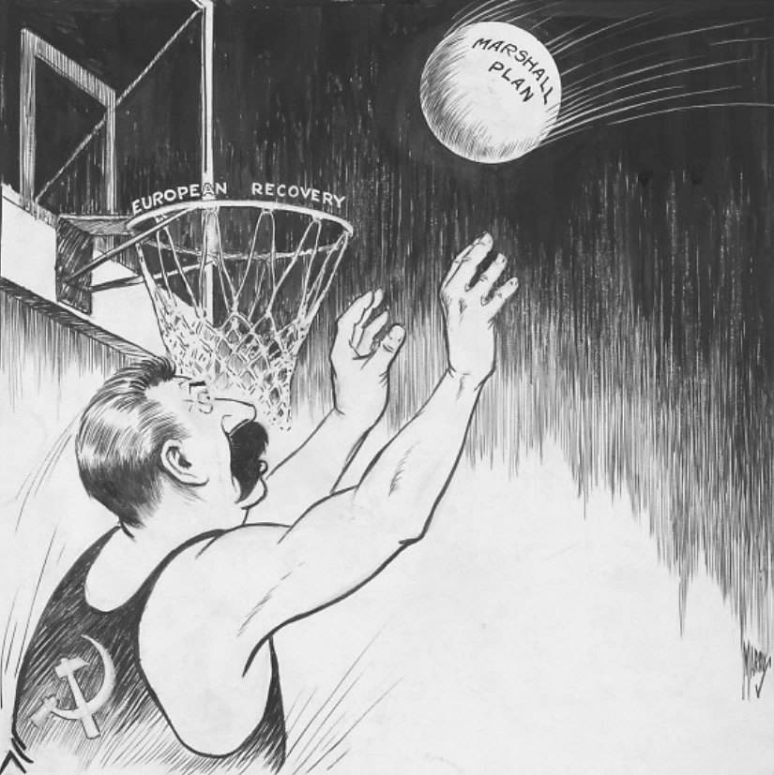

Summary of Key Ideas:
*
*
*
Point of View of the Document (cite evidence from the document to support your answer):
_______________________________________________________________________________________________________________________________________________________________________________________________________________________________________________________________

Purpose of the Document (cite evidence from the document to support your answer):
_______________________________________________________________________________________________________________________________________________________________________________________________________________________________________________________________

Analyzing Primary Source Documents Activity Sheet: #3
Historical Context of the Document:
_______________________________________________________________________________________________________________________________________________________________________________________________________________________________________________________________

It is clear that the United States cannot expect in the foreseeable future to enjoy political intimacy with the Soviet regime. It must continue to regard the Soviet Union as a rival, not a partner, in the political arena. It must continue to expect that Soviet policies will reflect no abstract love of peace and stability, no real faith in the possibility of a permanent happy coexistence of the Socialist and capitalist worlds, but rather a cautious, persistent pressure toward the disruption and weakening of all rival influence and rival power.
Balanced against this are the facts that Russia, as opposed to the western world in general, is still by far the weaker party, that Soviet policy is highly flexible, and that Soviet society may well contain deficiencies which will eventually weaken its own total potential. This would of itself warrant the United States entering with reasonable confidence upon a policy of firm containment, designed to confront the Russians with unalterable counterforce at every point where they show signs of encroaching upon the interests of a peaceful and stable world. . . .
It would be an exaggeration to say that American behavior unassisted and alone could exercise a power of life and death over the Communist movement and bring about the early fall of Soviet power in Russia. But the United States has it in its power to increase enormously the strains under which Soviet policy must operate, to force upon the Kremlin a far greater degree of moderation and circumspection than it has had to observe in recent years, and in this way to promote tendencies which must eventually find their outlet in either the breakup or the gradual mellowing of Soviet power.
—George F. Kennan, “The Sources of Soviet Conduct,” Foreign Affairs, July 1947 (Excerpts)

Summary of Key Ideas:
*
*
*
Point of View of the Document (cite evidence from the document to support your answer):
_______________________________________________________________________________________________________________________________________________________________________________________________________________________________________________________________

Purpose of the Document (cite evidence from the document to support your answer):
_______________________________________________________________________________________________________________________________________________________________________________________________________________________________________________________________

Analyzing Primary Source Documents Activity Sheet: #4
Historical Context of the Document:
_______________________________________________________________________________________________________________________________________________________________________________________________________________________________________________________________

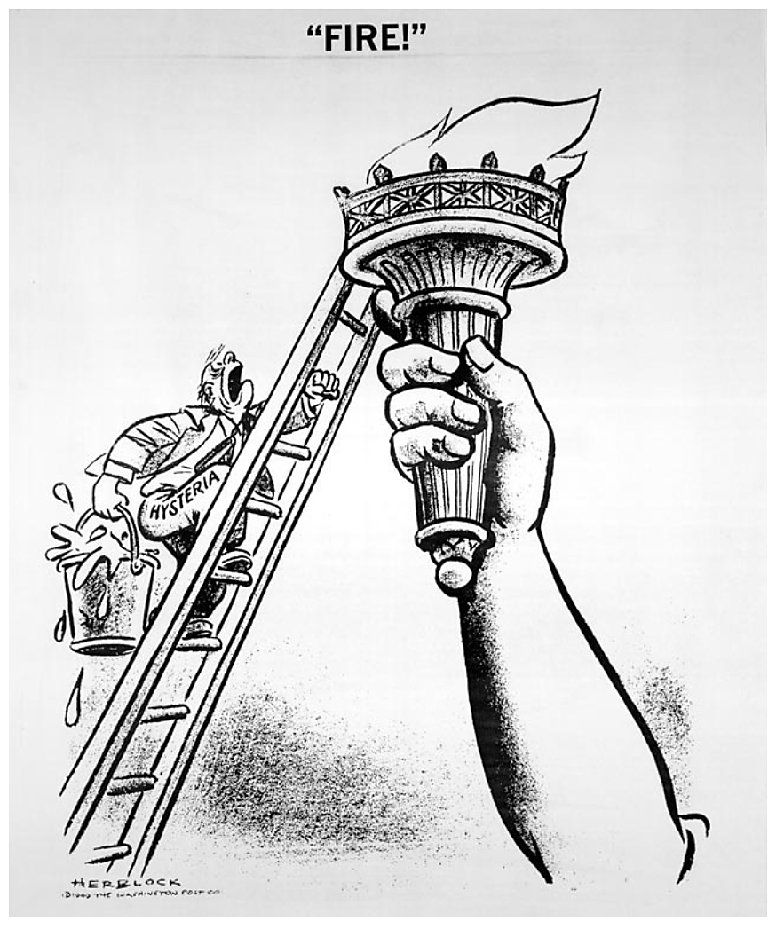
A 1949 Herblock Cartoon, © The Herb Block Foundation.

Summary of Key Ideas:
*
*
*
Point of View of the Document (cite evidence from the document to support your answer):
_______________________________________________________________________________________________________________________________________________________________________________________________________________________________________________________________

Purpose of the Document (cite evidence from the document to support your answer):
_______________________________________________________________________________________________________________________________________________________________________________________________________________________________________________________________

Analyzing Primary Source Documents Activity Sheet: #5
Historical Context of the Document:
_______________________________________________________________________________________________________________________________________________________________________________________________________________________________________________________________

A more rapid build-up of political, economic, and military strength and thereby of confidence in the free world than is now contemplated is the only course which is consistent with progress toward achieving our fundamental purpose. The frustration of the Kremlin design requires the free world to develop a successfully functioning political and economic system and a vigorous political offensive against the Soviet Union. These, in turn, require an adequate military shield under which they can develop. It is necessary to have the military power to deter, if possible, Soviet expansion, and to defeat, if necessary, aggressive Soviet or Soviet-directed actions of a limited or total character. The potential strength of the free world is great; its ability to develop these military capabilities and its will to resist Soviet expansion will be determined by the wisdom and will with which it undertakes to meet its political and economic problems. . . .
The threat to the free world involved in the development of the Soviet Union’s atomic and other capabilities will rise steadily and rather rapidly. For the time being, the United States possesses a marked atomic superiority over the Soviet Union which, together with the potential capabilities of the United States and other free countries in other forces and weapons, inhibits aggressive Soviet action. This provides an opportunity for the United States, in cooperation with other free countries, to launch a build-up of strength which will support a firm policy directed to the frustration of the Kremlin design. The immediate goal of our efforts to build a successfully functioning political and economic system in the free world backed by adequate military strength is to postpone and avert the disastrous situation which, in light of the Soviet Union’s probable fission bomb capability and possible thermonuclear bomb capability, might arise in 1954 on a continuation of our present programs.
—NSC-68 (Report to the President, April 7, 1950) (Excerpts)

Summary of Key Ideas:
*
*
*
Point of View of the Document (cite evidence from the document to support your answer):
_______________________________________________________________________________________________________________________________________________________________________________________________________________________________________________________________

Purpose of the Document (cite evidence from the document to support your answer):
_______________________________________________________________________________________________________________________________________________________________________________________________________________________________________________________________

Analyzing Primary Source Documents Activity Sheet: #6
Historical Context of the Document:
_______________________________________________________________________________________________________________________________________________________________________________________________________________________________________________________________

Five years after a world war has been won, men’s hearts should anticipate a long peace, and men’s minds should be free from the heavy weight that comes with war. But this is not such a period—for this is not a period of peace. This is a time of the “cold war.” This is a time when all the world is split into two vast, increasingly hostile armed camps—a time of a great armaments race. . . .
Today we are engaged in a final, all-out battle between communistic atheism and Christianity. The modern champions of communism have selected this as the time. And, ladies and gentlemen, the chips are down—they are truly down. . . .
The reason why we find ourselves in a position of impotency is not because our only powerful potential enemy has sent men to invade our shores, but rather because of the traitorous actions of those who have been treated so well by this Nation. It has not been the less fortunate or members of minority groups who have been selling this Nation out, but rather those who have had all the benefits that the wealthiest nation on earth has had to offer—the finest homes, the finest college education, and the finest jobs in Government we can give.
This is glaringly true in the State Department. There the bright young men who are born with silver spoons in their mouths are the ones who have been the worst. . . . In my opinion the State Department, which is one of the most important government departments, is thoroughly infested with Communists. I have in my hand 57 cases of individuals who would appear to be either card carrying members or certainly loyal to the Communist Party, but who nevertheless are still helping to shape our foreign policy. . . .
—Joseph R. McCarthy’s speech to the Ohio County Republican
Women’s Club, February 9, 1950 (Excerpts)

Summary of Key Ideas:
*
*
*
Point of View of the Document (cite evidence from the document to support your answer):
_______________________________________________________________________________________________________________________________________________________________________________________________________________________________________________________________

Purpose of the Document (cite evidence from the document to support your answer):
_______________________________________________________________________________________________________________________________________________________________________________________________________________________________________________________________

Analyzing Primary Source Documents Activity Sheet: #7
Historical Context of the Document:
_______________________________________________________________________________________________________________________________________________________________________________________________________________________________________________________________
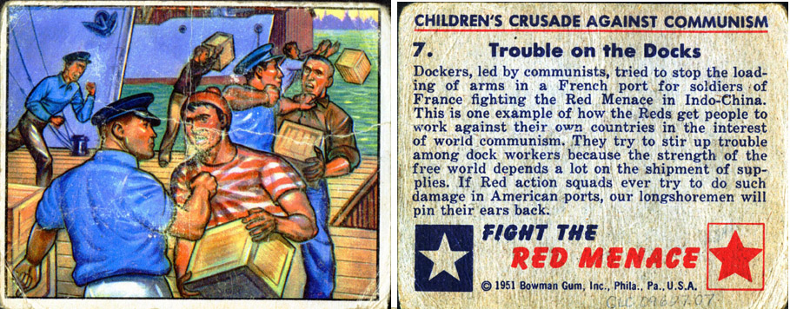
“Trouble on the Docks,” Fight the Red Menace, 1951 (The Gilder Lehrman Institute, GLC09627.07)
Summary of Key Ideas:
*
*
*
Point of View of the Document (cite evidence from the document to support your answer):
_______________________________________________________________________________________________________________________________________________________________________________________________________________________________________________________________

Purpose of the Document (cite evidence from the document to support your answer):
_______________________________________________________________________________________________________________________________________________________________________________________________________________________________________________________________

Analyzing Primary Source Documents Activity Sheet: #8
Historical Context of the Document:
_______________________________________________________________________________________________________________________________________________________________________________________________________________________________________________________________

I believe your conduct in putting into the hands of the Russians the A-bomb years before our best scientists predicted Russia would perfect the bomb has already caused, in my opinion, the Communist aggression in Korea, with the resultant casualties exceeding 50,000 and who knows but that millions more of innocent people may pay the price of your treason. Indeed, by your betrayal you undoubtedly have altered the course of history to the disadvantage of our country.
—Judge Irving Kaufman, US District Court for the
Southern District of New York, March 29, 1951 (Excerpt)

Summary of Key Ideas:
*
*
*
Point of View of the Document (cite evidence from the document to support your answer):
_______________________________________________________________________________________________________________________________________________________________________________________________________________________________________________________________

Purpose of the Document (cite evidence from the document to support your answer):
_______________________________________________________________________________________________________________________________________________________________________________________________________________________________________________________________

Analyzing Primary Source Documents Activity Sheet: #9
Historical Context of the Document:
_______________________________________________________________________________________________________________________________________________________________________________________________________________________________________________________________

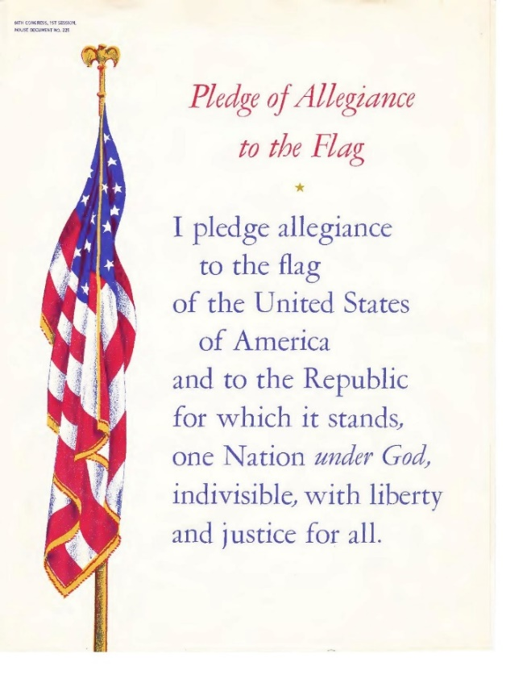
Sheet music cover from Irving Caesar, “Pledge of Allegiance to the Flag”
(Washington DC: US Government Printing Office, 1955)

Summary of Key Ideas:
*
*
*
Point of View of the Document (cite evidence from the document to support your answer):
_______________________________________________________________________________________________________________________________________________________________________________________________________________________________________________________________

Purpose of the Document (cite evidence from the document to support your answer):
_______________________________________________________________________________________________________________________________________________________________________________________________________________________________________________________________

Analyzing Primary Source Documents Activity Sheet: #10
Historical Context of the Document:
_______________________________________________________________________________________________________________________________________________________________________________________________________________________________________________________________

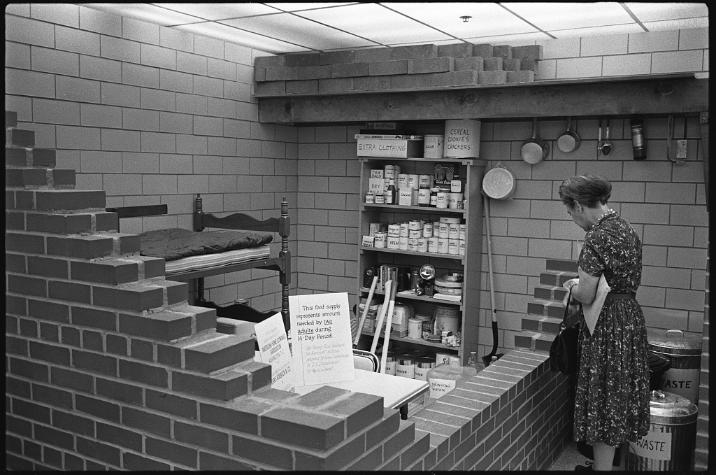
“Woman in bomb shelter which is stocked with food and other supplies; bunk bed in corner” by Marion S. Trikosko, 1961. (US News and World Report Collection, Library of Congress)

Summary of Key Ideas:
*
*
*
Point of View of the Document (cite evidence from the document to support your answer):
_______________________________________________________________________________________________________________________________________________________________________________________________________________________________________________________________

Purpose of the Document (cite evidence from the document to support your answer):
_______________________________________________________________________________________________________________________________________________________________________________________________________________________________________________________________

Analyzing Primary Source Documents Activity Sheet: #11
Historical Context of the Document:
_______________________________________________________________________________________________________________________________________________________________________________________________________________________________________________________________

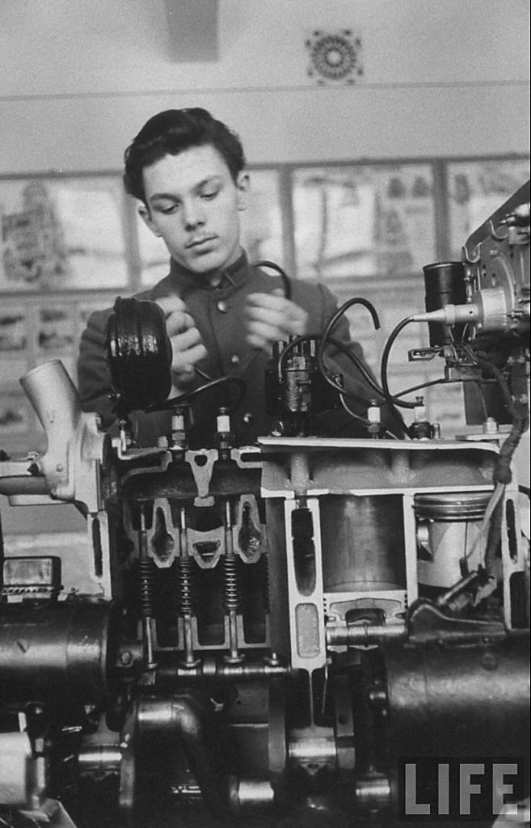 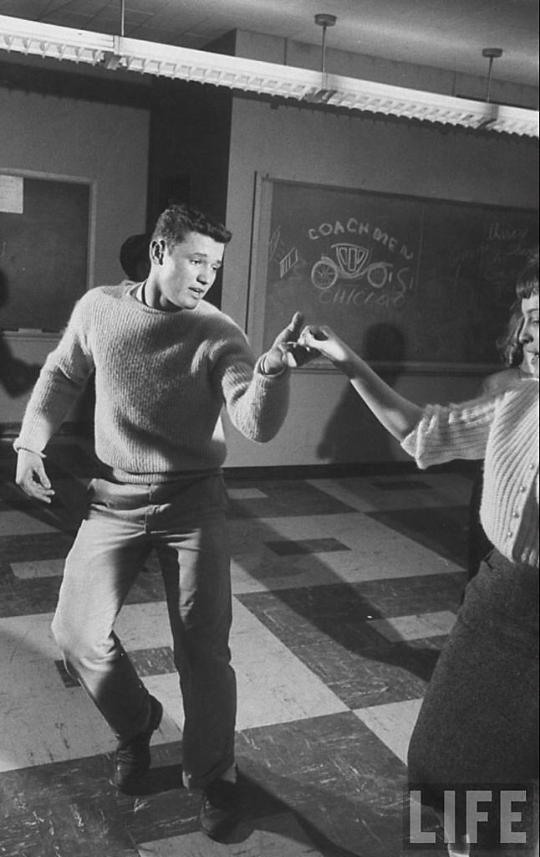
Alexei Kutzkov of Moscow and Stephen Lapekas of Chicago, 1958 (LIFE Photo Collection, © Time Inc.)

Summary of Key Ideas:
*
*
*
Point of View of the Document (cite evidence from the document to support your answer):
_______________________________________________________________________________________________________________________________________________________________________________________________________________________________________________________________

Purpose of the Document (cite evidence from the document to support your answer):
_______________________________________________________________________________________________________________________________________________________________________________________________________________________________________________________________

Analyzing Primary Source Documents Activity Sheet: #12
Historical Context of the Document:
_______________________________________________________________________________________________________________________________________________________________________________________________________________________________________________________________

A vital element in keeping the peace is our military establishment. Our arms must be mighty, ready for instant action, so that no potential aggressor may be tempted to risk his own destruction.
Our military organization today bears little relation to that known by any of my predecessors in peacetime, or indeed by the fighting men of World War II or Korea.
Until the latest of our world conflicts, the United States had no armaments industry. American makers of plowshares could, with time and as required, make swords as well. But now we can no longer risk emergency improvisation of national defense; we have been compelled to create a permanent armaments industry of vast proportions. Added to this, three and a half million men and women are directly engaged in the defense establishment. We annually spend on military security more than the net income of all United States corporations.
This conjunction of an immense military establishment and a large arms industry is new in the American experience. The total influence–economic, political, even spiritual–is felt in every city, every State house, every office of the Federal government. We recognize the imperative need for this development. Yet we must not fail to comprehend its grave implications. Our toil, resources and livelihood are all involved; so is the very structure of our society.
In the councils of government, we must guard against the acquisition of unwarranted influence, whether sought or unsought, by the military-industrial complex. The potential for the disastrous rise of misplaced power exists and will persist.
We must never let the weight of this combination endanger our liberties or democratic processes. We should take nothing for granted. Only an alert and knowledgeable citizenry can compel the proper meshing of the huge industrial and military machinery of defense with our peaceful methods and goals, so that security and liberty may prosper together.
–Dwight D. Eisenhower, “Farewell Radio and Television Address,” January 17, 1961 (Excerpt)

Summary of Key Ideas:
*
*
*
Point of View of the Document (cite evidence from the document to support your answer):
_______________________________________________________________________________________________________________________________________________________________________________________________________________________________________________________________

Purpose of the Document (cite evidence from the document to support your answer):
_______________________________________________________________________________________________________________________________________________________________________________________________________________________________________________________________

Categorizing Cold War Fears
Directions: Examine each primary source document and determine what category the topic fits into: social, political, religious, intellectual, technological, economic. Then use evidence from the document to explain why you put it in that category.

Document #1: _____________________________________________________________________________________
Category (circle one): social political religious intellectual technological economic
Justification (cite evidence from the document to support your answer): __________________________________________________________________________________________________________________________________________________________________________

Document #2: _____________________________________________________________________________________
Category (circle one): social political religious intellectual technological economic
Justification (cite evidence from the document to support your answer): __________________________________________________________________________________________________________________________________________________________________________

Document #3: _____________________________________________________________________________________
Category (circle one): social political religious intellectual technological economic
Justification (cite evidence from the document to support your answer): __________________________________________________________________________________________________________________________________________________________________________

Document #4: _____________________________________________________________________________________
Category (circle one): social political religious intellectual technological economic
Justification (cite evidence from the document to support your answer): __________________________________________________________________________________________________________________________________________________________________________

Document #5: _____________________________________________________________________________________
Category (circle one): social political religious intellectual technological economic
Justification (cite evidence from the document to support your answer): __________________________________________________________________________________________________________________________________________________________________________

Document. #6: _____________________________________________________________________________________
Category (circle one): social political religious intellectual technological economic
Justification (cite evidence from the document to support your answer): __________________________________________________________________________________________________________________________________________________________________________

Document #7: _____________________________________________________________________________________
Category (circle one): social political religious intellectual technological economic
Justification (cite evidence from the document to support your answer): __________________________________________________________________________________________________________________________________________________________________________

Document #8: _____________________________________________________________________________________
Category (circle one): social political religious intellectual technological economic
Justification (cite evidence from the document to support your answer): __________________________________________________________________________________________________________________________________________________________________________

Document #9: _____________________________________________________________________________________
Category (circle one): social political religious intellectual technological economic
Justification (cite evidence from the document to support your answer): __________________________________________________________________________________________________________________________________________________________________________

Document #10: _____________________________________________________________________________________
Category (circle one): social political religious intellectual technological economic
Justification (cite evidence from the document to support your answer): __________________________________________________________________________________________________________________________________________________________________________

Document #11: _____________________________________________________________________________________
Category (circle one): social political religious intellectual technological economic
Justification (cite evidence from the document to support your answer): __________________________________________________________________________________________________________________________________________________________________________

Document #12: _____________________________________________________________________________________
Category (circle one): social political religious intellectual technological economic
Justification (cite evidence from the document to support your answer): __________________________________________________________________________________________________________________________________________________________________________

Ranking Causation
Directions: Select the three most important categories of fears that led the United States into the Cold War and rank them from most important (1st) to least important (3rd).
1st Category (circle): social political religious intellectual technological economic
Documents in This Category:
*
*
*
Justification for This Ranking:
____________________________________________________________________________________________________________________________________________________________________________________________________________________________________________________________________________________________________________________________________________________

2nd Category (circle): social political religious intellectual technological economic
Documents in This Category:
*
*
*
Justification for This Ranking:
____________________________________________________________________________________________________________________________________________________________________________________________________________________________________________________________________________________________________________________________________________________

3rd Category (circle): social political religious intellectual technological economic
Documents in This Category:
*
*
*
Justification for This Ranking:
____________________________________________________________________________________________________________________________________________________________________________________________________________________________________________________________________________________________________________________________________________________

