The Cold War as a Culture War: Visualizing Values and the Role of Pop Culture
by John P. Irish

UNIT OVERVIEW
This unit has been developed in conjunction with the Council on Foreign Relations and is a part of the Gilder Lehrman Institute’s Teaching Literacy through History resources, designed to align with the Common Core State Standards. These units were developed to enable students to understand, summarize, and evaluate original documents of historical significance. Students will learn and practice the skills that will help them analyze, assess, and develop knowledgeable and well-reasoned points of view on visual and textual source materials.
Over the course of the two lessons, the students will analyze and assess visual primary sources, including political cartoons, art, advertisements, propaganda, and photographs from 1945 to 1992. The objective is to analyze how the Cold War was expressed as a culture war between the United States and the Soviet Union by analyzing key elements of the images in this lesson. The students will examine, define, interpret, and organize the documents to answer the essential question: How did the Cold War manifest itself as a culture war between the United States and the Soviet Union? As an assessment, the students will use their analysis of the images to engage in a small group seminar discussion about the similarities and differences in the values expressed by people in the United States and the Soviet Union during the Cold War.

NUMBER OF CLASS PERIODS: 2

GRADE LEVELS: 7–12

UNIT OBJECTIVES
Students will be able to
- Analyze primary source images using analysis strategies
- Identify and describe the historical context of an image
- Identify and describe the evidence in an image
- Interpret meaning based on direct evidence found in an image
- Evaluate and group documents based on shared categories
- Collaborate effectively to develop and express positions and viewpoints

ESSENTIAL QUESTION
How did the Cold War manifest itself as a culture war between the United States and the Soviet Union?

COMMON CORE STANDARDS
CCSS.ELA-Literacy.RH.6-8.1: Cite specific textual evidence to support analysis of primary and secondary sources.
CCSS.ELA-Literacy.RH.6-8.6: Identify aspects of a text that reveal an author’s point of view or purpose (e.g., loaded language, inclusion or avoidance of particular facts).
CCSS.ELA-Literacy.RH.6-8.7: Integrate visual information (e.g., in charts, graphs, photographs, videos, or maps) with other information in print and digital texts.
CCSS.ELA-Literacy.RH.9-10.1: Cite specific textual evidence to support analysis of primary and secondary sources, attending to such features as the date and origin of the information.
CCSS.ELA-Literacy.RH.9-10.2: Determine the central ideas or information of a primary or secondary source; provide an accurate summary of how key events or ideas develop over the course of the text.
CCSS.ELA-Literacy.RH.9-10.6: Compare the point of view of two or more authors for how they treat the same or similar topics, including which details they include and emphasize in their respective accounts.
CCSS.ELA-Literacy.RH.9-10.8: Assess the extent to which the reasoning and evidence in a text support the author’s claims.
CCSS.ELA-Literacy.RH.9-10.9: Compare and contrast treatments of the same topic in several primary and secondary sources.
CCSS.ELA-Literacy.RH.11-12.1: Cite specific textual evidence to support analysis of primary and secondary sources, connecting insights gained from specific details to an understanding of the text as a whole.
CCSS.ELA-Literacy.RH.11-12.2: Determine the central ideas or information of a primary or secondary source; provide an accurate summary that makes clear the relationships among the key details and ideas.
CCSS.ELA-Literacy.RH.11-12.3: Evaluate various explanations for actions or events and determine which explanation best accords with textual evidence, acknowledging where the text leaves matters uncertain.
CCSS.ELA-Literacy.RH.11-12.7: Integrate and evaluate multiple sources of information presented in diverse formats and media (e.g., visually, quantitatively, as well as in words) in order to address a question or solve a problem.
CCSS.ELA-Literacy.RH.11-12.8: Evaluate an author’s premises, claims, and evidence by corroborating or challenging them with other information.
CCSS.ELA-Literacy.RH.11-12.9: Integrate information from diverse sources, both primary and secondary, into a coherent understanding of an idea or event, noting discrepancies among sources.

LESSON 1: The Cold War: A Culture War in Images

OVERVIEW
In the first lesson, students will identify, examine, and analyze the language and imagery of primary source documents related to the idea of the Cold War as a culture war. Students will work with political cartoons, propaganda posters, photographs, and other graphic representations of the Cold War between the United States and the Soviet Union between 1945 and 1992. For each document the students will identify the historical context, physical setting, central figures or objects, action, and mood or theme of the image.

HISTORICAL BACKGROUND
The Cold War as a Culture War
by Thomas Nichols, University Professor, US Naval War College
War is about more than military engagements. In the modern era, wars engage the efforts and imagination of the public, especially when democracies require sacrifice from citizens who wish to know why they are being asked to fight and die on behalf of the state. This is why culture is a part of every conflict, especially when states engage in “cold wars,” characterized by the use of proxies in other nations, espionage, economic sanctions, and other measures short of war. Not everyone watches the news, but almost everyone goes to the movies or watches television.
The modern world got its first glimpses of all-out warfare, the kind that engages entire societies, with the rise of Napoleon (who would create entire armies through wide-scale drafts) and the American Civil War, but it is not until the first two world wars that ideologies–nationalism, communism, democracy–become central to war. These ideas required not only the public’s labor and military service, but their emotional and political engagement. During wartime, governments produce propaganda and motivational materials. In a cold war, the culture itself expresses debates and political fears, perhaps–or especially–due to the absence of large-scale violence. This was a notable aspect of the great struggle between the United States and the Soviet Union in the twentieth century, which engaged popular passions and expressed them through the popular culture.
The fears and conflicts of the Cold War were fought out not just on battlefields in Vietnam and Korea, but in many arenas, including America’s movie screens, televisions, radios, and graphic arts. Americans in the 1950s feared the enemy within their own societies in movies like I Married a Communist, and then feared what we had become in the 1970s fighting that enemy in Three Days of the Condor. We lived in fear of World War III, imagining what it would be like to fight and win it in Red Dawn, or what would happen if we all lost and destroyed Earth only to become The Planet of the Apes.
The messages and anxieties were, by the late Cold War, ubiquitous. In 1985, a young person who wanted to watch MTV would see an image of nuclear destruction about once an hour; if that was too much, they could read a 1985 issue of Superman in which The Man of Steel has a nightmare about being the sole survivor of a nuclear holocaust; and if that was too disturbing, they could play Trinity, one of the first interactive computer games in which the player must voyage through time to stop the first atomic bomb test in 1945 and avert global destruction forty years later.
Popular culture is how the public speaks to itself–and to its leaders. There is no way to study any modern conflict, hot or cold, without taking into account the power not only of mass media, but mass entertainment, which reaches more people and might well have a greater effect on the public.
Learn more about the Cold War at World101 from the Council on Foreign Relations:
- “How Did the Cold War Stay Cold?” at https://world101.cfr.org/historical-context/global-era/how-did-cold-war-stay-cold
- “What Kinds of Government Exist?” at https://world101.cfr.org/how-world-works-and-sometimes-doesnt/forms-government/what-kinds-governments-exist

Thomas Nichols is a University Professor at the US Naval War College and an adjunct professor at the US Air Force School of Strategic Force Studies. He is a specialist on international security affairs, including US-Russia relations, nuclear strategy, and NATO issues.

MATERIALS
- Optional: Historical Background: “The Cold War as a Culture War” by Thomas Nichols, University Professor, US Naval War College, with Important Phrases activity sheet
- Documents 1–12 with activity sheets
  - Ivanov and Burova, “Rebuild for Glory!” 1945, SPUTNIK/Alamy Stock Photo.
  - “Mother Looking at Baby in a Bassinet,” Ladies Home Journal, June 1946.
  - “All Bow Down to the US Dollar!” from Krokodil in William Nelson, Out of the Crocodile’s Mouth: Russian Cartoons about the United States from “Krokodil,” Moscow’s Humor Magazine (Washington DC: Public Affairs Press, 1949), p. 49, from The Marshall Plan at 70 – Big Picture, George C. Marshall European Center for Security Studies, mcrl.libguides.com/big_picture.
  - E. Spreckmeester, “Whatever the Weather, We Only Reach Welfare Together,” European Recovery Programme, 1950, George C. Marshall Foundation, marshallfoundation.org/library/posters/whatever-weather-reach-welfare-together/.
  - Igor B. Berezovsky, “We Are Fulfilling the Party’s Tasks!” Soviet Publishing House for the Visual Arts, Moscow, 1957, Wikimedia, commons.wikimedia.org/wiki/
File:Soviet_Socialist_Realism_We_will_fulfill.svg
  - Jackson Pollock, Autumn Rhythm (Number 30), 1950, Photo: Alan Wylie/Alamy Stock Photo.
  - “Soviet Man, Be Proud. Glory to the Heroes of the Homeland,” 1960, World History Archive/Alamy Stock Photo.
  - Buzz Aldrin Salutes the US Flag, 1969, NASA, hq.nasa.gov/alsj/a11/images11.html#5874.
  - “Seventeen Moments in Soviet History,” 1973, Matrix, Michigan State University, soviethistory.msu.edu/1973-2/soviet-consumerism.
  - Andy Warhol, Green Coca-Cola Bottles, 1962, Photo: Martin Shields/Alamy Stock Photo.
  - Edmund S. Valtman, “I Can’t Believe My Eyes,” 1991, Library of Congress, loc.gov/item/2016687306/.
  - Ronald Reagan Presents Mikhail Gorbachev with the Ronald Reagan Freedom Award, May 4, 1992, Ronald Reagan Presidential Library, reaganfoundation.org/library-museum/.
- Any United States History textbook, or access to any online resource

PROCEDURE
- Divide the class into small groups of three to five students.
- The students should be familiar with the historical context of the Cold War. You may share the provided Historical Background with them as well as the Important Phrases activity sheet.
- Make sure the students have access to a US history textbook or the internet.
- Hand out the Cold War documents (1–12). If possible, have a copy of Document 1 displayed so everyone can see it and you can refer to it easily.
- Go through Document 1 with the class, modeling how to complete the different sections.
- Each document activity sheet contains key vocabulary terms that are essential for helping the students understand the meaning of the image. Students should be familiar with these words before they begin the activity: American abstract expressionism, American consumerism, Apollo 11, Congress for Cultural Freedom, glasnost, Marshall Plan, NASA, NATO, perestroika, Socialist realism, Soviet consumerism, Space Race, Sputnik I, Truman Doctrine,
- The title, author, and date are not provided on the activity sheets. You can give the students this information (from the Materials list above) or let the students interpret the images without that information.
- “Historical Context of the Document” asks students to explain some of the larger or broader events taking place that help that document make sense (e.g., the historical context of George Kennan’s “Long Telegram” would be the end of World War II, Stalin’s aggressive gestures toward Iran and Turkey, Truman’s tougher stance in dealing with the Soviets, the uncooperative behavior of the Soviets regarding the World Bank and International Monetary Fund, etc.). They should use the Historical Background, their textbooks, “How Did the Cold War Stay Cold?” and “What Kinds of Government Exist?” from World101 from the Council of Foreign Relations, and appropriate online resources to identify the historical contexts.
- Each image is followed by a table. In the first column, “Observational Evidence,” students will note down evidence about the setting, central figures or objects, action, and mood or theme of the posters, cartoon, or photograph. In the second column, “Meaning of the Observed Evidence,” the students will analyze what the evidence suggests about the meaning of the image.
- The students should work in their groups to complete the activity sheets for Documents 2–12.
- Wrap-up: Discuss the groups’ conclusions and clarify any points of confusion that arose in the students’ interpretations and understanding of the Cold War.
LESSON 2: Similarities and Differences in Cultural Values

OVERVIEW
In the second lesson, students will use the images and completed activity sheets from Lesson 1 to identify the similarities and differences in the cultural values of people in the United States and the Soviet Union during the Cold War. The students will determine whether or not each image represents a cultural value that is shared. At the end of the lesson, the students will participate in small group seminars to respond to the prompt: Evaluate the extent of similarities and differences in the cultural values of people in the United States and the Soviet Union during the Cold War.

MATERIALS
- Documents 1–12 from Lesson 1
- Activity Sheets
  - Identifying Cultural Values
  - Venn Diagram: Similarities and Differences in Cultural Values

PROCEDURE
- Divide the class into groups. You may use the same groups as in Lesson 1 or create new groups.
- Make sure students have their Cold War images from Lesson 1.
- Hand out the “Identifying Cultural Values” activity sheet. If possible, have a copy displayed so everyone can see it and you can refer to it easily.
- Students should work in groups to complete the chart. You may want to model identifying the first image for them. Let them know there is no right or wrong way to identify the images. The purpose of identifying the cultural value expressed in each image is to have the students think about the overall message of each image. This will be important for the small group seminar, when the students will be asked to take a position on the seminar prompt: Evaluate the extent of similarities and differences in the cultural values of people in the United States and the Soviet Union during the Cold War.
- Hand out the “Venn Diagram: Similarities and Differences in Cultural Values.” Each student will complete the diagram independently.
- Divide the students into new groups. Depending on the class size, you may want to divide up the class in three different ways.
- For a small class, you may choose to keep the students together in one group.
- For a medium-sized class, you may choose to divide the class into two groups. Arrange the students into an inner and an outer circle. Have the inner group start the seminar and then switch in the middle, allowing the outer group to finish the discussion. Usually, the outer group completes another task while the inner group is in discussion (e.g., taking notes on the inner group’s discussion).
- For a large class, you may choose to divide the class into groups of five, each group seated in a circle. Each circle will be a self-contained seminar group.
- Read the seminar discussion prompt to the class: Evaluate the extent of similarities and differences in the cultural values of people in the United States and the Soviet Union during the Cold War.
- Students should take turns, going around the circle, sharing their response to the seminar prompt. Each group needs to come to a consensus.
- Wrap-up: Discuss the groups’ final interpretations and clarify any points of confusion.

Historical Background
The Cold War as a Culture War
by Thomas Nichols, University Professor, US Naval War College
War is about more than military engagements. In the modern era, wars engage the efforts and imagination of the public, especially when democracies require sacrifice from citizens who wish to know why they are being asked to fight and die on behalf of the state. This is why culture is a part of every conflict, especially when states engage in “cold wars,” characterized by the use of proxies in other nations, espionage, economic sanctions, and other measures short of war. Not everyone watches the news, but almost everyone goes to the movies or watches television.
The modern world got its first glimpses of all-out warfare, the kind that engages entire societies, with the rise of Napoleon (who would create entire armies through wide-scale drafts) and the American Civil War, but it is not until the first two world wars that ideologies–nationalism, communism, democracy–become central to war. These ideas required not only the public’s labor and military service, but their emotional and political engagement. During wartime, governments produce propaganda and motivational materials. In a cold war, the culture itself expresses debates and political fears, perhaps–or especially–due to the absence of large-scale violence. This was a notable aspect of the great struggle between the United States and the Soviet Union in the twentieth century, which engaged popular passions and expressed them through the popular culture.
The fears and conflicts of the Cold War were fought out not just on battlefields in Vietnam and Korea, but in many arenas, including America’s movie screens, televisions, radios, and graphic arts. Americans in the 1950s feared the enemy within their own societies in movies like I Married a Communist, and then feared what we had become in the 1970s fighting that enemy in Three Days of the Condor. We lived in fear of World War III, imagining what it would be like to fight and win it in Red Dawn, or what would happen if we all lost and destroyed Earth only to become The Planet of the Apes.
The messages and anxieties were, by the late Cold War, ubiquitous. In 1985, a young person who wanted to watch MTV would see an image of nuclear destruction about once an hour; if that was too much, they could read a 1985 issue of Superman in which The Man of Steel has a nightmare about being the sole survivor of a nuclear holocaust; and if that was too disturbing, they could play Trinity, one of the first interactive computer games in which the player must voyage through time to stop the first atomic bomb test in 1945 and avert global destruction forty years later.
Popular culture is how the public speaks to itself–and to its leaders. There is no way to study any modern conflict, hot or cold, without taking into account the power not only of mass media, but mass entertainment, which reaches more people and might well have a greater effect on the public.

Learn more about the Cold War at World101 from the Council on Foreign Relations:
- “How Did the Cold War Stay Cold?” at https://world101.cfr.org/historical-context/global-era/how-did-cold-war-stay-cold
- “What Kinds of Government Exist?” at https://world101.cfr.org/how-world-works-and-sometimes-doesnt/forms-government/what-kinds-governments-exist

Thomas Nichols is a University Professor at the US Naval War College and an adjunct professor at the US Air Force School of Strategic Force Studies. He is a specialist on international security affairs, including US-Russia relations, nuclear strategy, and NATO issues.

Historical Background: Important Phrases
Which phrases or sentences related to the Cold War as a culture war are most informative or important in this scholarly essay? Choose three and give the reason for your choices.

Phrase 1:
_____________________________________________________________________________________

Why is this phrase or sentence informative or important?
__________________________________________________________________________________________________________________________________________________________________________

Phrase 2:
_____________________________________________________________________________________

Why is this phrase or sentence informative or important?
__________________________________________________________________________________________________________________________________________________________________________

Phrase 3:
_____________________________________________________________________________________

Why is this phrase or sentence informative or important?
__________________________________________________________________________________________________________________________________________________________________________

Image Analysis: Document 1
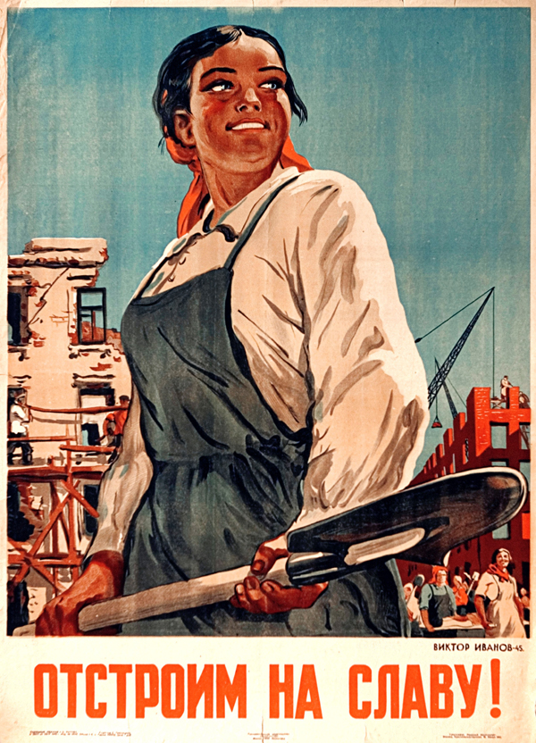
Key Terms: Truman Doctrine | Marshall Plan

Title of Image
______________________________________________________________________________

Creator of the Image _______________________________________

Date of Image: _________

Historical Context
____________________________________________________________________________________________________________________________________________________________
“Rebuild for Glory!”
(SPUTNIK/Alamy Stock Photo)

Observed Evidence | Meaning of the Observed Evidence
Setting

Central Figures or Objects

Action

Mood or Theme

Image Analysis: Document 2
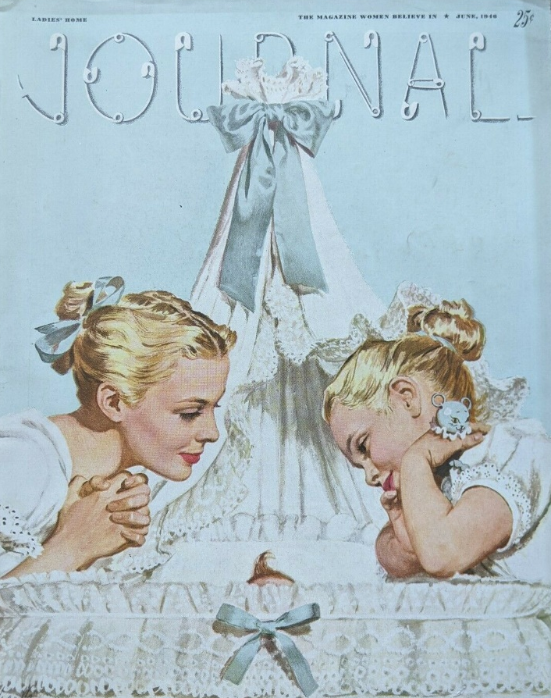
Key Terms: Truman Doctrine | Marshall Plan

Title of Image
______________________________________________________________________________

Creator of the Image _______________________________________

Date of Image: _________

Historical Context
____________________________________________________________________________________________________________________________________________________________

Observed Evidence | Meaning of the Observed Evidence
Setting

Central Figures or Objects

Action

Mood or Theme

Image Analysis: Document 3
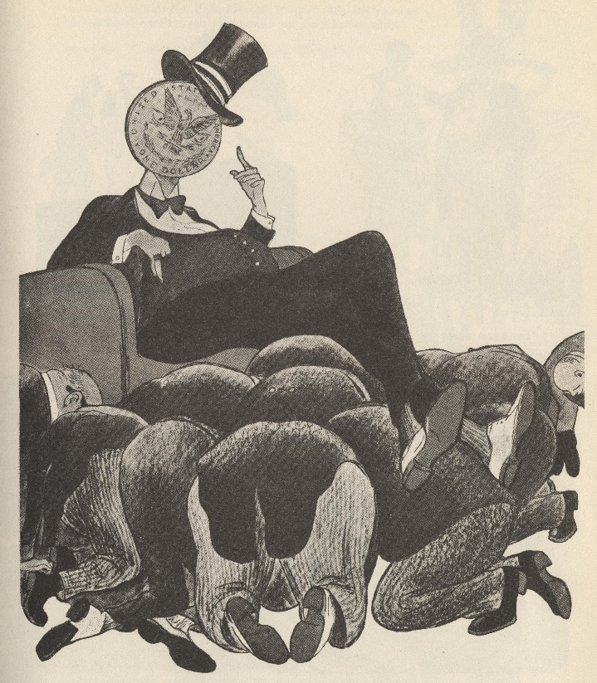
Key Terms: Truman Doctrine | Marshall Plan
Title of Image
______________________________________________________________________________

Creator of the Image _______________________________________

Date of Image: _________

Historical Context
____________________________________________________________________________________________________________________________________________________________
“All Bow Down to the US Dollar!”
(Marshall European Center for Security Studies)

Observed Evidence | Meaning of the Observed Evidence
Setting

Central Figures or Objects

Action

Mood or Theme

Image Analysis: Document 4
Key Terms: Truman Doctrine | Marshall Plan | NATO
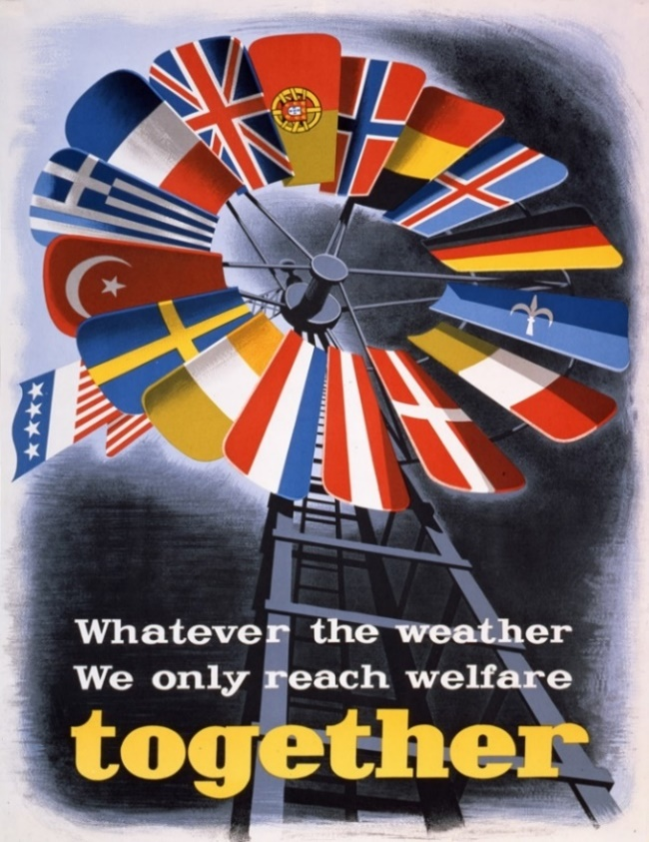
Title of Image
______________________________________________________________________________

Creator of the Image _______________________________________

Date of Image: _________

Historical Context
____________________________________________________________________________________________________________________________________________________________
(George C. Marshall Foundation)

Observed Evidence | Meaning of the Observed Evidence
Setting

Central Figures or Objects

Action

Mood or Theme

Image Analysis: Document 5
Key Terms: Socialist realism

Title of Image
_____________________________________________________________________________
Creator of the Image: ____________________
Date of Image: __________________________
Historical Context
____________________________________________________________________________________________________________________________________________________________

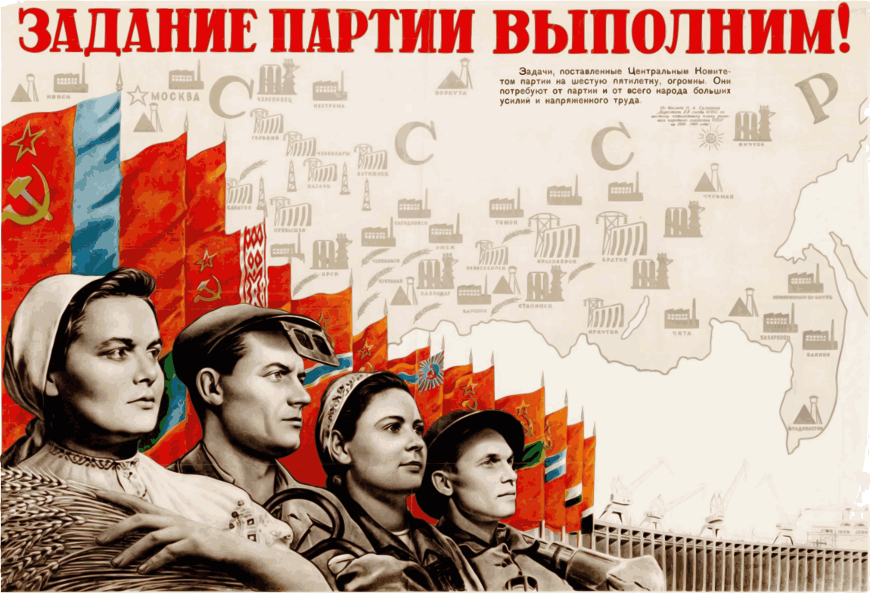
“We Are Fulfilling the Party’s Tasks!” (Wikimedia)

Observed Evidence | Meaning of the Observed Evidence
Setting

Central Figures or Objects

Action

Mood or Theme

Image Analysis: Document 6
Key Terms: American abstract expressionism | Congress for Cultural Freedom

Title of Image
_____________________________________________________________________________
Creator of the Image: ____________________
Date of Image: __________________________
Historical Context
____________________________________________________________________________________________________________________________________________________________

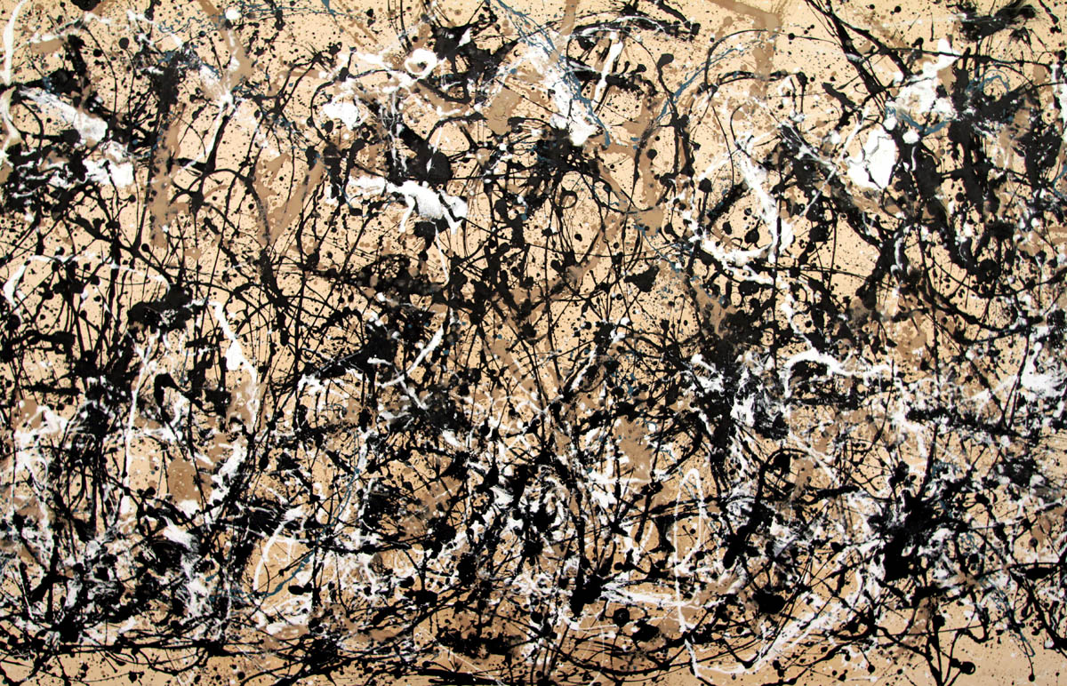
(Alan Wylie/Alamy Stock Photo)

Observed Evidence | Meaning of the Observed Evidence
Setting

Central Figures or Objects

Action

Mood or Theme

Image Analysis: Document 7
Key Terms: Sputnik I | Space Race

Title of Image
______________________________________________________________________________
Creator of the Image: ____________________
Date of Image: __________________________
Historical Context
____________________________________________________________________________________________________________________________________________________________

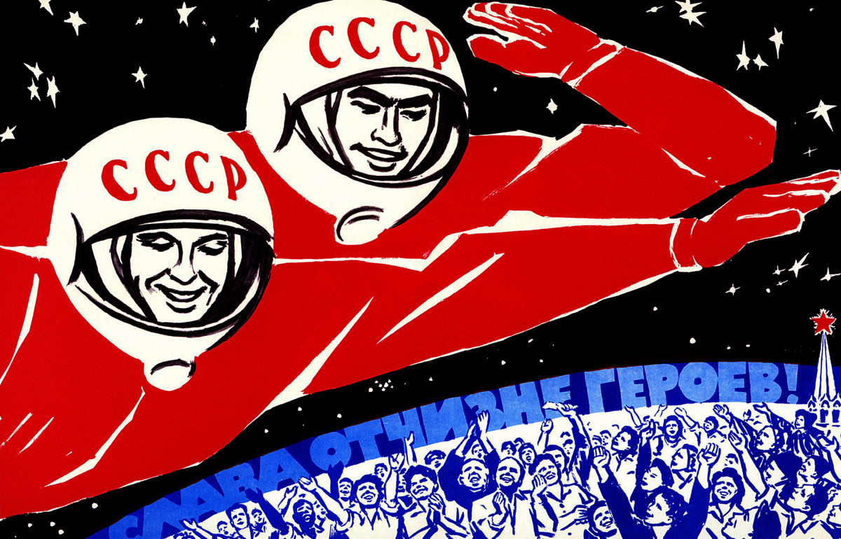
“Soviet Man, Be Proud. Glory to the Heroes of the Homeland!”
(World History Archive/Alamy Stock Photo)

Observed Evidence | Meaning of the Observed Evidence
Setting

Central Figures or Objects

Action

Mood or Theme

Image Analysis: Document 8
Key Terms: Apollo 11 | Space Race | NASA
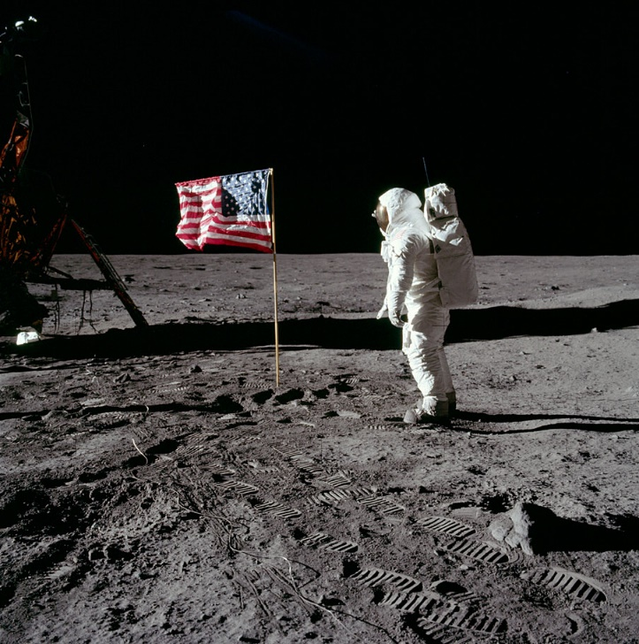
Title of Image
______________________________________________________________________________

Creator of the Image _______________________________________

Date of Image: _________

Historical Context
____________________________________________________________________________________________________________________________________________________________
(NASA)

Observed Evidence | Meaning of the Observed Evidence
Setting

Central Figures or Objects

Action

Mood or Theme

Image Analysis: Document 9
Key Terms: Soviet consumerism

Title of Image
______________________________________________________________________________
Creator of the Image: ____________________
Date of Image: __________________________
Historical Context
____________________________________________________________________________________________________________________________________________________________

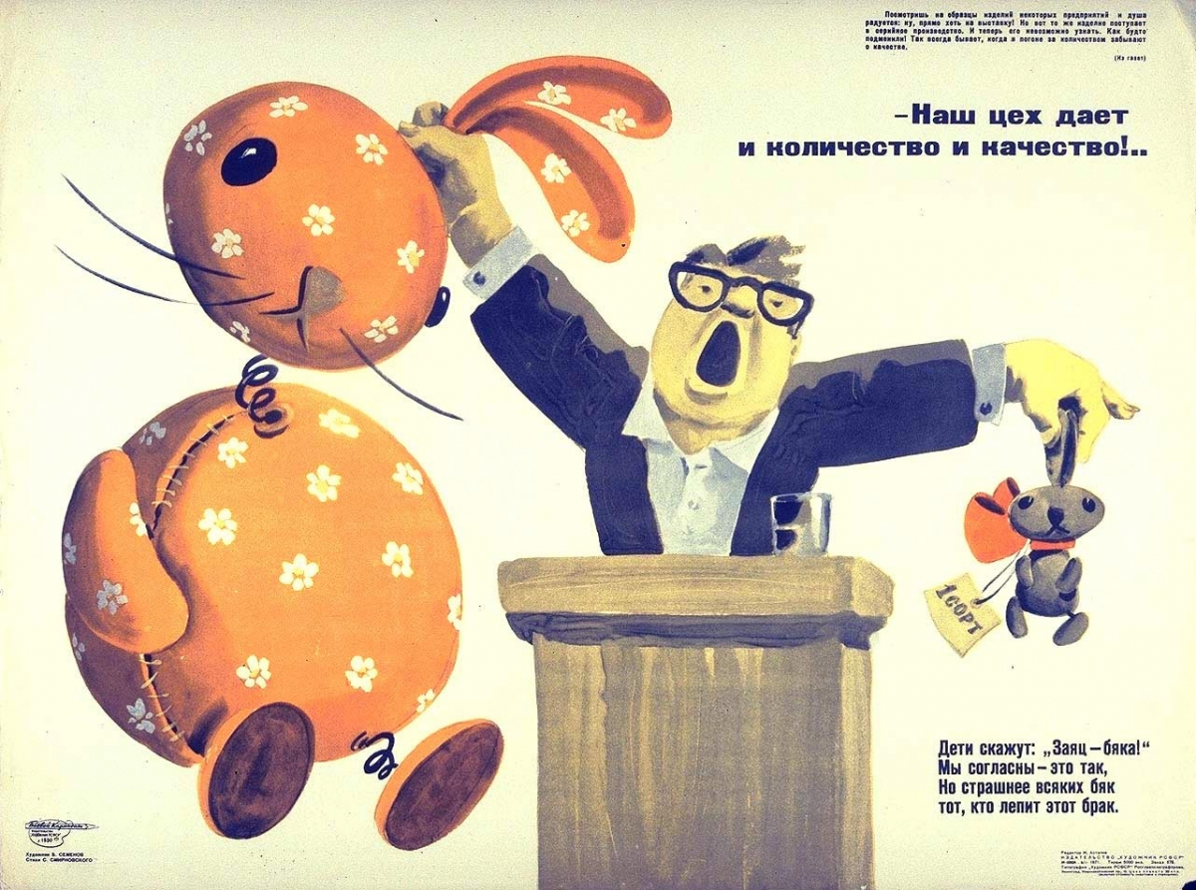
(Seventeen Moments in Soviet History, Michigan State University)

Observed Evidence | Meaning of the Observed Evidence
Setting

Central Figures or Objects

Action

Mood or Theme

Image Analysis: Document 10
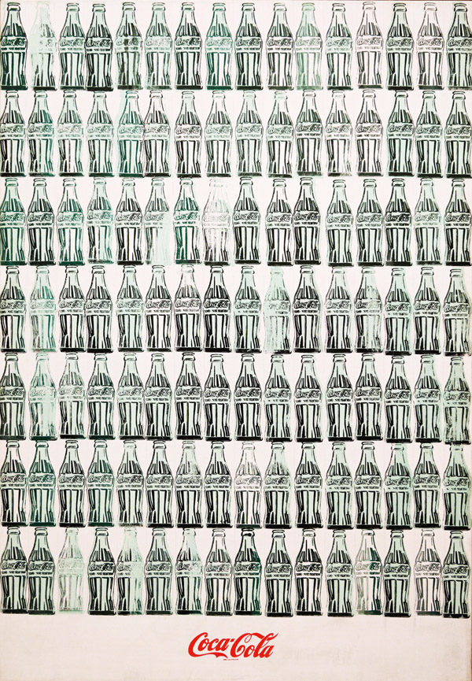
Key Terms: American consumerism

Title of Image
______________________________________________________________________________

Creator of the Image _______________________________________

Date of Image: _________

Historical Context
____________________________________________________________________________________________________________________________________________________________
(Photo: Martin Shields/Alamy Stock Photo)

Observed Evidence | Meaning of the Observed Evidence
Setting

Central Figures or Objects

Action

Mood or Theme

Image Analysis: Document 11
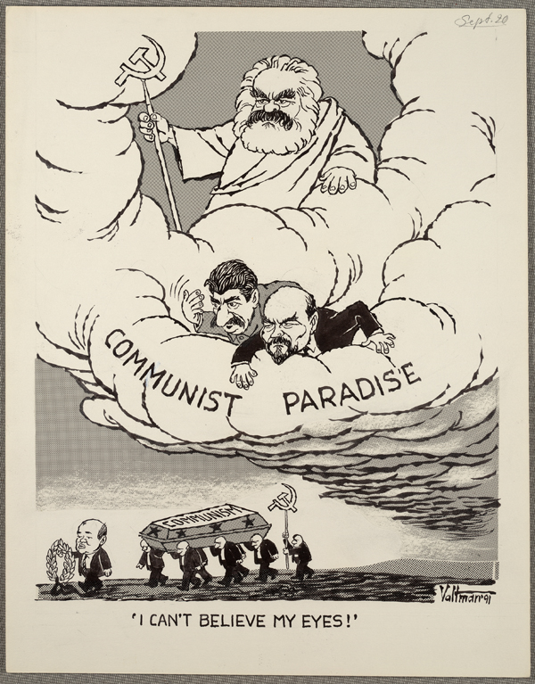
Key Terms: Perestroika | Glasnost
Title of Image
______________________________________________________________________________

Creator of the Image _______________________________________

Date of Image: _________

Historical Context
____________________________________________________________________________________________________________________________________________________________
(Library of Congress)

Observed Evidence | Meaning of the Observed Evidence
Setting

Central Figures or Objects

Action

Mood or Theme

Image Analysis: Document 12
Key Terms: Perestroika | Glasnost
Title of Image
______________________________________________________________________________
Creator of the Image: ____________________
Date of Image: __________________________
Historical Context
____________________________________________________________________________________________________________________________________________________________

(Ronald Reagan Presidential Library)

Observed Evidence | Meaning of the Observed Evidence
Setting

Central Figures or Objects

Action

Mood or Theme

Identifying Cultural Values
Directions: For each document, select the category of cultural value (social, political, religious, intellectual, technological, economic) that best reflects the document’s message and support your decision with evidence from the document.

Document 1 ______________________________
Category (circle one): social political religious intellectual technological economic
Cultural Value Implied (cite evidence from the document to support your answer):
__________________________________________________________________________________________________________________________________________________________________________

Document 2 ______________________________
Category (circle one): social political religious intellectual technological economic
Cultural Value Implied (cite evidence from the document to support your answer): __________________________________________________________________________________________________________________________________________________________________________

Document 3 ______________________________
Category (circle one): social political religious intellectual technological economic
Cultural Value Implied (cite evidence from the document to support your answer):
__________________________________________________________________________________________________________________________________________________________________________

Document 4 ______________________________
Category (circle one): social political religious intellectual technological economic
Cultural Value Implied (cite evidence from the document to support your answer):
__________________________________________________________________________________________________________________________________________________________________________

Document 5 ______________________________
Category (circle one): social political religious intellectual technological economic
Cultural Value Implied (cite evidence from the document to support your answer):
__________________________________________________________________________________________________________________________________________________________________________

Document 6 ______________________________
Category (circle one): social political religious intellectual technological economic
Cultural Value Implied (cite evidence from the document to support your answer):
__________________________________________________________________________________________________________________________________________________________________________

Document 7 ______________________________
Category (circle one): social political religious intellectual technological economic
Cultural Value Implied (cite evidence from the document to support your answer):
__________________________________________________________________________________________________________________________________________________________________________

Document 8 ______________________________
Category (circle one): social political religious intellectual technological economic
Cultural Value Implied (cite evidence from the document to support your answer):
__________________________________________________________________________________________________________________________________________________________________________

Document 9 ______________________________
Category (circle one): social political religious intellectual technological economic
Cultural Value Implied (cite evidence from the document to support your answer):
__________________________________________________________________________________________________________________________________________________________________________

Document 10 ______________________________
Category (circle one): social political religious intellectual technological economic
Cultural Value Implied (cite evidence from the document to support your answer):
__________________________________________________________________________________________________________________________________________________________________________

Document 11 ______________________________
Category (circle one): social political religious intellectual technological economic
Cultural Value Implied (cite evidence from the document to support your answer):
__________________________________________________________________________________________________________________________________________________________________________

Document 12 ______________________________
Category (circle one): social political religious intellectual technological economic
Cultural Value Implied (cite evidence from the document to support your answer):
__________________________________________________________________________________________________________________________________________________________________________

Venn Diagram: Similarities and Differences In Cultural Values
Directions: Organize the cultural values you identified in the images. The top section is for cultural values that were exclusively expressed in images from the United States, the bottom section is for cultural values that were exclusively expressed in images from the Soviet Union, and the middle section is for shared cultural values.

US

Shared

USSR

