“The Spirit of Empire”: America Debates Imperialism
by Nate McAlister

UNIT OVERVIEW
This unit has been developed by the Gilder Lehrman Institute of American History in partnership with World101 from the Council on Foreign Relations. These lesson plans were developed to enable students to understand, summarize, and evaluate original documents of historical significance.
Students will learn and practice skills that will help them analyze, assess, and develop knowledgeable and well-reasoned points of view on visual and textual source materials.
In the two lessons in this unit the students will analyze and assess political cartoons, newspaper and magazine articles, opinion pieces, government documents, speeches, and a diary entry from the late nineteenth and early twentieth centuries. The objective is to have students recognize the contrasting views of the pro- and anti-imperialist arguments and analyze key elements of primary sources surrounding the debate over US imperialism. Using these key elements students will examine, evaluate, and discuss the meaning and message of each document to determine if it is a pro- or anti- imperialist document. As an assessment, students will use phrases from the documents in the first lesson to create “found” speeches that express both sides of the debates over US imperialism at the turn of the twentieth century.

NUMBER OF CLASS PERIODS: 2
GRADE LEVEL(S): 7–12

UNIT OBJECTIVES
Students will be able to
- Analyze primary sources
- Summarize the meaning of primary sources
- Infer subtle messages from primary sources

ESSENTIAL QUESTION
What did the United States gain and lose as a result of imperialism?

Produced by the Gilder Lehrman Institute of American History. © 2021 Council on Foreign Relations
gilderlehrman.org and world101.cfr.org

COMMON CORE STATE STANDARDS
2
CCSS.ELA-Literacy.RH.6-8.1: Cite specific textual evidence to support analysis of primary and secondary sources.
CCSS.ELA-Literacy.RH.6-8.2: Determine the central ideas or information of a primary or secondary source; provide an accurate summary of the source distinct from prior knowledge or opinions.
CCSS.ELA-Literacy.RH.9-10.1: Cite specific textual evidence to support analysis of primary and secondary sources, attending to such features as the date and origin of the information.
CCSS.ELA-Literacy.SL.6.1.D: Review the key ideas expressed and demonstrate understanding of multiple perspectives through reflection and paraphrasing.
CCSS.ELA-Literacy.SL.6.2: Interpret information presented in diverse media and formats (e.g., visually, quantitatively, orally) and explain how it contributes to a topic, text, or issue under study.
CCSS.ELA-Literacy.SL.8.2: Analyze the purpose of information in diverse media and formats (e.g., visually, quantitatively, orally) and evaluate the motives (e.g., social, commercial, political) behind its presentation.
CCSS.ELA-Literacy.SL.8.3: Delineate a speaker’s argument and specific claims, evaluating the soundness of the reasoning and relevance and sufficiency of the evidence and identifying when irrelevant evidence is introduced.
CCSS.ELA-Literacy.W.8.2: Write informative/explanatory texts to examine a topic and convey ideas, concepts, and information through the selection, organization, and analysis of relevant content.
CCSS.ELA-Literacy.W.11-12.2: Write informative/explanatory texts to examine and convey complex ideas, concepts, and information clearly and accurately through the effective selection, organization, and analysis of content.
CCSS.ELA-Literacy.W.11-12.2.B: Develop the topic thoroughly by selecting the most significant and relevant facts, extended definitions, concrete details, quotations, or other information and examples appropriate to the audience’s knowledge of the topic.

LESSON 1: AMERICA DEBATES IMPERIALISM
3

OVERVIEW
In the first lesson, students will identify, examine, and analyze the language and imagery in primary sources related to the debate on US imperialism after the Spanish-American War in 1898. Students will work with a variety of documents including political cartoons, newspaper and magazine articles, opinion pieces, government documents, speeches, and a diary entry. Students will identify the pro- or anti-imperialist message(s) in each document and support their identification with evidence from the documents. At the end of the lesson, the class will come together to discuss the documents and present evidence-based arguments to support their decisions.

HISTORICAL BACKGROUND
Adapted from Robert W. Cherny, “Empire Building,” History Resources, The Gilder Lehrman Institute of American History, gilderlehrman.org/history-resources/essays/empire-building
Between 1898 and 1900, the US engaged in a brief but decisive war with Spain, acquired island territories stretching nearly halfway around the world, and took part in a military action in China— announcing to all that the United States was now a major world power.
Though most Americans paid little attention to foreign affairs until the late 1890s, there were some throughout the years after the Civil War who hoped for a greater role for the United States outside its borders. Some Americans had long regarded the Caribbean and Central America as potential areas for expansion. During the late 1880s and early 1890s America’s involvement in world affairs did begin to change.
Americans began to look outward. Advocacy came from many sources, including Protestant ministers, scholars, business figures, and politicians. Though each had their own ideas and goals, the outcome was a change in the way many Americans, and especially American policy makers, viewed the nation’s role in world affairs.
By the 1880s, popular books claimed that Anglo-Saxons—the people of England and their descendants elsewhere in the world—had demonstrated a unique capacity for civilization and had a duty to enlighten and uplift other peoples. Rudyard Kipling, an English poet, expressed these views when he urged the United States to “take up the white man’s burden,” a phrase that came to describe a

self-imposed obligation to go into distant lands, bring the supposed blessings of Anglo-Saxon civilization to their peoples, Christianize them, and sell them manufactured goods.
4
However, not all Americans supported the expansion of American territory and influence through military force. And, in fact, there were those, including some in the administration, who saw the war with Spain as an opportunity to seize territory and acquire an American colonial empire. By the Treaty of Paris, signed in December 1898, Spain surrendered its claim to Cuba, ceded Puerto Rico and Guam to the United States, and sold the Philippines for $20 million. For the first time in American history, a treaty acquiring new territory failed to confer US citizenship on the residents.
The Treaty of Paris dismayed Democrats, Populists, and some conservative Republicans, sparking a public debate over acquisition of the Philippines in particular and imperialism in general. An anti- imperialist movement quickly formed, with William Jennings Bryan, Andrew Carnegie, Grover Cleveland, Carl Schurz, and Mark Twain among its outspoken proponents. For the United States to deny self-government to the newly acquired territories, they claimed, threatened the very concept of democracy. “The Declaration of Independence,” warned Carnegie, “will make every Filipino a thoroughly dissatisfied subject.” Others voiced racist arguments, claiming that Filipinos were incapable of self-government and that the United States would be corrupted by ruling such people.
Those who defended acquisition of the Philippines echoed President McKinley’s lofty pronouncements about America’s duty, and never used the terms imperialism and colonies to describe the new acquisitions. Others cited economic benefits: “We are raising more than we can consume, making more than we can use. Therefore we must find new markets for our produce.” Such “new markets” were not limited to the new possessions. A strong naval and military presence in the Philippines would make the United States a leading power in eastern Asia, thereby supporting access for American business to markets in China.
In addition, making the Caribbean an “American lake” was, in significant part, a strategic move, motivated by the need to protect American control of the Panama Canal (constructed 1904–1914) against any European power that might seek a foothold in the Caribbean that could be used to attack the canal. American dominance in the region also promoted American investment there, investment sometimes encouraged by US authorities. The presence of significant American investments, in turn, encouraged the continuation of US dominance.

This pattern of increased involvement in world affairs, but without treaty commitments to support or defend other nations, has been called unilateral internationalism. That is, the United States was thoroughly involved in world affairs—it dominated the Caribbean, held possessions stretching halfway around the world, nurtured even more widespread commercial activities by its citizens, and participated fully in the east Asian balance of power. But that involvement was unilateral; that is, the United States did not ally itself with any other nation. That pattern persisted, with some modifications, through the 1920s and 1930s, giving way to a multilateral approach during World War II and the Cold War.
5
Learn more about the global context of colonialism at World101 from the Council on Foreign Relations.

Robert W. Cherny is a professor emeritus of history at San Francisco State University. He is the author of American Politics in the Gilded Age, 1868–1900 (1997) and A Righteous Cause: The Life of William Jennings Bryan (1985, reprint 1994).

MATERIALS
- Optional: Historical Background and Important Phrases activity sheet; adapted from Robert Cherny, “Empire Building,” History Resources, The Gilder Lehrman Institute of American History, gilderlehrman.org/history-resources/essays/empire-building
- Primary Sources with learning activities (starting on page 18) and without learning activities (starting on page 38)
§ Political Cartoon: “Ten Thousand Miles from Tip to Tip” from Marshall Everett, Exciting Experiences in Our Wars with Spain and the Filipinos (Chicago: Book Publishers Union, 1899). Background: “In this cartoon map, the American Eagle spreads his wings from the Philippines to Porto Rico, ‘Ten thousand miles from tip to tip.’ Inset is a much smaller eagle, presiding over the eastern US 100 years earlier, in 1798. This map originally appeared on the front page of the Philadelphia Press for Sunday, August 14, 1898. The artist’s name is partially illegible, but the last name appears to be Gebhardt or Ghebhardt.” (Courtesy Cornell University Library, Division of Rare & Manuscript Collections)
§ Political Cartoon: “We Must Finish the Nicaragua Canal,” Judge, June 18, 1898.

Background: “A cartoon from Judge magazine, at the height of American expansionism, showing US interests (marked by American flags) from the Philippines, Hawaii and Alaska to Cuba. The battleship USS Oregon had been commissioned in 1896 and served initially in the Pacific. In March 1898, in anticipation of the Spanish-American War, she was ordered to the Caribbean. The voyage took 66 days, which led to greater public recognition of the need for construction of a central-American canal. In this cartoon, Uncle Sam—heavily armed with sword and cannon—says, ‘I'll have to cut that canal! See how easy I could relieve Dewey and protect our coast. No more “Oregon business” for me.’ During this period of time, Judge magazine published at least five cartoon maps supporting and encouraging US expansionism.” (Courtesy Cornell University Library, Division of Rare & Manuscript Collections)
6
§ Political Cartoon: “The Trouble in Cuba,” Judge, August 10, 1895.
Background: “A satirical map reflecting American sentiment toward Cuba, three years before the beginning of the Spanish-American War. ‘Uncle Sam’ has his eye on Cuba, portrayed as a small fish, and announces: ‘I’ve had my eye on that morsel for a long time; guess I’ll have to take it in!’ During this period of time, Judge magazine published at least five cartoon maps supporting and encouraging US expansionism.” (Courtesy Cornell University Library, Division of Rare & Manuscript Collections)
§ Political Cartoon: “His 128th Birthday,” Puck, June 29, 1904.
Background: “A cartoon map on the cover of Puck magazine questioning American expansionism on the eve of the Fourth of July. The American eagle sits just north of the proposed Panama Canal, one wingtip in the Philippines, the other sheltering Puerto Rico. The caption expresses concern: ‘Gee, but this is an awful stretch!’ Puck’s caution contrasts sharply with its competitor, Judge magazine, which published at least five cartoon maps supporting and encouraging US expansionism during this period of time.” (Courtesy Cornell University Library, Division of Rare & Manuscript Collections)
§ Newspaper Article: Adlai E. Stevenson, “Imperialism Is the Spirit of Empire,” and Benjamin
F. Shively, “Liberty Is Safe Only Where Power Is Curbed,” St. Louis (MO) Republic, July 15, 1900. Chronicling America: Historic American Newspapers, Library of Congress, chroniclingamerica.loc.gov.

§ Newspaper Article [excerpts]: “Imperialism,” Hawaiian Star, August 9, 1900, Chronicling America: Historic American Newspapers, Library of Congress, chroniclingamerica.loc.gov.
7
§ Newspaper Article [excerpts]: “Only a Bugaboo,” Marietta (OH) Daily Leader, September 9, 1900, Chronicling America: Historic American Newspapers, Library of Congress, chroniclingamerica.loc.gov.
§ Newspaper Article [excerpts]: “A Definition of Imperialism” by Louis R. Ehrich, The Conservative (Nebraska City, NE), October 25, 1900, Chronicling America: Historic American Newspapers. Library of Congress, chroniclingamerica.loc.gov.
§ Political Platform [excerpts]: “Platform of the American Anti-Imperialist League” from Carl Schurz, The Policy of Imperialism: Address by Hon. Carl Schurz at the Anti-Imperialist Conference in Chicago, October 17, 1899 (Chicago: American Anti-Imperialist League, 1899. Liberty Tracts, Number Four)
§ Speech [excerpts]: The Retention of the Philippine Islands: Speech of Hon. Henry Cabot Lodge in the Senate of the United States, March 7, 1900 (Washington: [Washington DC: Government Printing Office], 1900), p. 8.
§ Diary [excerpts]: Diary of Edward Emerich, June 14 and 15 and July 12, 1898, The Gilder Lehrman Institute of American History, GLC07048.
§ Print: Our Victorious Fleets in Cuban Waters, Currier & Ives, New York, 1898, The Gilder Lehrman Institute of American History, GLC03534.
§ Periodical Article [excerpt]: “A Triumphal Parade of Insurgent Troops in Manila” and “The Cost of Empire,” Harper’s Weekly, November 26, 1898, The Gilder Lehrman Institute of American History, GLC08725.13.
§ Periodical Article [excerpt]: “A Triumphal Parade of Insurgent Troops in Manila” and “Imperialism and the Senate,” Harper’s Weekly, November 26, 1898, The Gilder Lehrman Institute of American History, GLC08725.13.
§ Treaty [excerpt]: A Treaty of Peace between the United States and Spain, US Congress, 55th Cong., 3d sess., Senate Doc. No. 62, Part 1 (Washington: Government Printing Office, 1899), pp. 5–6.

§ Speech [excerpts]: Free America Free Cuba Free Philippines: Addresses at a Meeting in Faneuil Hall, Saturday, March 30, 1901 (Boston: New England Anti-Imperialist League, 1901), pp. 6 and 8.
8
§ Optional: Declaration of Independence: Both sides used the Declaration of Independence to support their arguments. An excerpt of the text is being provided for reference and context.
- Activity Sheets
§ The Imperialism Debate: Categorizing the Sources
§ The Imperialism Debate: What Is Gained? What Is Lost?

PROCEDURE
9
Note
In this lesson there are three different activities to choose from. Please read through each before deciding which option is most appropriate for your students.

Option 1
- Optional: You may choose to incorporate the Historical Background (and the Important Phrases activity sheet) at any point throughout the two lessons in this unit, or you may discuss the information in the essay by Robert Cherny with the class.
- Place students into pairs or small groups and hand out, provide a digital copy of, or screen share the four “Analyzing Imperialism [Political Cartoon]” activity sheets.
  - Students will analyze the primary sources and determine if the messages are pro- or anti- imperialist. Students will cite evidence from the primary sources to support their answers.
- Lead the students through the analysis of one of the political cartoons as a class. Have students conduct a brief 30-second analysis on their own. Have them volunteer ideas about the message(s) of the cartoon. It is perfectly fine if they disagree. Next, have them cite evidence from the political cartoon that supports their answer. The discussion and analysis of evidence is crucial to a deeper understanding of the primary source.
- Have students complete the analysis of the remaining political cartoons. If you are working remotely, you may choose to place students in breakout rooms.
- Upon completion of the four activity sheets, hand out, provide a digital copy of, or screen share the rest of the Analyzing Imperialism activity sheets.
- Lead the students in a “share read” of one of the texts before they complete the rest of the activity sheets. To share read the text, have the students follow along silently while you begin to read aloud, modeling prosody, inflection, and punctuation. Ask the class to join in with the reading after a few sentences while you continue to read aloud. This technique will support struggling readers and English language learners (ELL).
- Have students complete the remaining activity sheets.

§ As with the political cartoons, students will analyze the primary sources and determine if the messages are pro- or anti-imperialist. They will cite evidence from the primary sources to support their answers.
10
§ Optional: Some of the primary sources refer to the Declaration of Independence. You may choose to distribute the Declaration (provided) and focus some of the class discussion on how pro-imperialists and anti-imperialists used the rhetoric of the Declaration.
- When students have completed all the activity sheets, have them discuss which primary sources had the greatest impact and the most effective message.
- Have students answer the essential question: What did the United States gain and lose as a result of imperialism? This may be completed as a wrap-up discussion or an exit-ticket activity. They may use the “Imperialism Debate: What Is Gained? What Is Lost?” activity sheet to outline their arguments.

Option 2
11
- Optional: You may choose to incorporate the Historical Background (and the Important Phrases activity sheet) at any point throughout the two lessons in this unit, or you may discuss the information in the essay by Robert Cherny with the class.
- Place students into pairs or small groups and hand out, provide a digital copy of, or screen share all the primary sources without the activities, starting on page 38.
- Lead the students through the analysis of one of the political cartoons as a class. Have students conduct a brief 30-second analysis on their own. Have them volunteer ideas about the message(s) of the cartoon. It is perfectly fine if they disagree. Next, have them cite evidence from the political cartoon that supports their answer. The discussion and analysis of evidence is crucial to a deeper understanding of the primary source.
- Lead the students in a “share read” of one the texts before they complete the rest of the activity. To share read the text, have the students follow along silently while you begin to read aloud, modeling prosody, inflection, and punctuation. Ask the class to join in with the reading after a few sentences while you continue to read aloud. This technique will support struggling readers and English language learners (ELL).
- Have students complete the analysis of the cartoons and text by dividing the documents into two categories, identifying each as either pro- or anti-imperialist. If you are working remotely, you may choose to place students in breakout rooms.
- When students have completed their categorization, have them cite evidence from each primary source to support their decisions on the “Imperialism Debate: Categorizing the Sources” activity sheet.
- When students have completed the activity sheet, have them discuss which primary sources had the greatest impact and the most effective message.
- Have students answer the essential question: What did the United States gain and lose as a result of imperialism? This may be completed as a wrap-up discussion or an exit-ticket activity. They may use the “Imperialism Debate: What Is Gained? What Is Lost?” activity sheet to outline their arguments.

Option 3
12
If time or student learning level is a consideration, the following modifications may be considered.
- Optional: You may choose to incorporate the Historical Background (and the Important Phrases activity sheet) at any point throughout the two lessons in this unit, or you may discuss the information in the essay by Robert Cherny with the class.
- Place students into pairs or small groups and hand out, provide a digital copy of, or screen share the following primary sources. You may use either the Analyzing Imperialism activity sheets (starting on page 18) if using Option A in Procedure 4 below or the pages without the activities (starting on page 38) if using Option B in Procedure 4.
  - Political Cartoon: “His 128th Birthday”
  - Political Cartoon: “We Must Finish the Nicaragua Canal”
  - Newspaper Article: “A Definition of Imperialism”
  - Newspaper Article: “Only a Bugaboo”
  - Political Platform: Platform of the American Anti-Imperialist League
  - Speech: The Retention of the Philippine Islands: Speech of Hon. Henry Cabot Lodge
- Lead the students through the analysis of one of the political cartoons as a class. Have students conduct a brief 30-second analysis on their own. Have them volunteer ideas about the message(s) of the cartoon. It is perfectly fine if they disagree. Next, have them cite evidence from the political cartoon that supports their answer. The discussion and analysis of evidence is crucial to a deeper understanding of the primary source.
- Lead the students in a “share read” of one of the texts before they complete the rest of the activity. To share read the text, have the students follow along silently while you begin to read aloud, modeling prosody, inflection, and punctuation. Ask the class to join in with the reading after a few sentences while you continue to read aloud. This technique will support struggling readers and English language learners (ELL).
- Choose Option A or B to analyze the primary sources.
  - Option A: Students will analyze the primary sources using the specific “Analyzing Imperialism” activity sheets listed above and determine if the messages are pro- or anti- imperialism. Students will cite evidence from the primary sources to support their answers.

  - Option B: Have students identify each document as either pro- or anti-imperialist. When students have completed their categorization, have them cite evidence from each document to support their decision using the “Categorizing the Sources” activity sheet.
13
- When they have completed either of the activities, have students discuss which primary sources had the greatest impact and the most effective message.
- Have students answer the essential question: What did the United States gain and lose as a result of imperialism? This may be completed as a wrap-up discussion or an exit-ticket activity. They may use the “Imperialism Debate: What Is Gained? What Is Lost?” activity sheet to outline their arguments.

LESSON 2: Pro- and Anti-Imperialist “Found” Speeches
14

OVERVIEW
In the second lesson, the students will use the materials from Lesson 1 to create “found” speeches. At the end of the lesson, the class will come together to discuss their speeches and the pro- and anti- imperialist arguments, and answer the essential question for the unit.

MATERIALS
- All materials used in Lesson 1
- Assessment Activity: Pro-and Anti-Imperialist Speeches: What Is Gained? What Is Lost?
- Teacher’s Resource: Sample of Pro-and Anti-Imperialist Speeches

PROCEDURE
- Place students into pairs or small groups and hand out, provide a digital copy of, or screen share the “Pro-and Anti-Imperialist Speeches: What Is Gained? What Is Lost?” activity sheet.
- Students will synthesize the materials from Lesson 1 to create a pro-imperialist speech and an anti-imperialist speech. They will choose a total of five sentences or phrases for each speech, one sentence/phrase per document. They will insert each sentence/phrase into the activity sheet, one phrase per line, to create a coherent speech on each side of the debate. Give the students some latitude in their selection of sentences or phrases and the order in which they use them. See the example provided on page 37.
- Students will provide a title that summarizes the message of each speech.
- Have students discuss the essential question: What did the United States gain and lose as a result of imperialism?

Adapted from Robert W. Cherny, “Empire Building,” History Resources, The Gilder Lehrman Institute of American History, gilderlehrman.org/history-resources/essays/empire-building
15
Historical Background
Between 1898 and 1900, the US engaged in a brief but decisive war with Spain, acquired island territories stretching nearly halfway around the world, and took part in a military action in China— announcing to all that the United States was now a major world power.
Though most Americans paid little attention to foreign affairs until the late 1890s, there were some throughout the years after the Civil War who hoped for a greater role for the United States outside its borders. Some Americans had long regarded the Caribbean and Central America as potential areas for expansion. During the late 1880s and early 1890s America’s involvement in world affairs did begin to change.
Americans began to look outward. Advocacy came from many sources, including Protestant ministers, scholars, business figures, and politicians. Though each had their own ideas and goals, the outcome was a change in the way many Americans, and especially American policy makers, viewed the nation’s role in world affairs.
By the 1880s, popular books claimed that Anglo-Saxons—the people of England and their descendants elsewhere in the world—had demonstrated a unique capacity for civilization and had a duty to enlighten and uplift other peoples. Rudyard Kipling, an English poet, expressed these views when he urged the United States to “take up the white man’s burden,” a phrase that came to describe a self-imposed obligation to go into distant lands, bring the supposed blessings of Anglo-Saxon civilization to their peoples, Christianize them, and sell them manufactured goods.
However, not all Americans supported the expansion of American territory and influence through military force. And, in fact, there were those, including some in the administration, who saw the war with Spain as an opportunity to seize territory and acquire an American colonial empire. By the Treaty of Paris, signed in December 1898, Spain surrendered its claim to Cuba, ceded Puerto Rico and Guam to the United States, and sold the Philippines for $20 million. For the first time in American history, a treaty acquiring new territory failed to confer US citizenship on the residents.
The Treaty of Paris dismayed Democrats, Populists, and some conservative Republicans, sparking a public debate over acquisition of the Philippines in particular and imperialism in general. An anti- imperialist movement quickly formed, with William Jennings Bryan, Andrew Carnegie, Grover Cleveland, Carl Schurz, and Mark Twain among its outspoken proponents. For the United States to

deny self-government to the newly acquired territories, they claimed, threatened the very concept of democracy. “The Declaration of Independence,” warned Carnegie, “will make every Filipino a thoroughly dissatisfied subject.” Others voiced racist arguments, claiming that Filipinos were incapable of self-government and that the United States would be corrupted by ruling such people.
16
Those who defended acquisition of the Philippines echoed President McKinley’s lofty pronouncements about America’s duty, and never used the terms imperialism and colonies to describe the new acquisitions. Others cited economic benefits: “We are raising more than we can consume, making more than we can use. Therefore we must find new markets for our produce.” Such “new markets” were not limited to the new possessions. A strong naval and military presence in the Philippines would make the United States a leading power in eastern Asia, thereby supporting access for American business to markets in China.
In addition, making the Caribbean an “American lake” was, in significant part, a strategic move, motivated by the need to protect American control of the Panama Canal (constructed 1904–1914) against any European power that might seek a foothold in the Caribbean that could be used to attack the canal. American dominance in the region also promoted American investment there, investment sometimes encouraged by US authorities. The presence of significant American investments, in turn, encouraged the continuation of US dominance.
This pattern of increased involvement in world affairs, but without treaty commitments to support or defend other nations, has been called unilateral internationalism. That is, the United States was thoroughly involved in world affairs—it dominated the Caribbean, held possessions stretching halfway around the world, nurtured even more widespread commercial activities by its citizens, and participated fully in the east Asian balance of power. But that involvement was unilateral; that is, the United States did not ally itself with any other nation. That pattern persisted, with some modifications, through the 1920s and 1930s, giving way to a multilateral approach during World War II and the Cold War.
Learn more about the global context of colonialism at World101.

Robert W. Cherny is a professor emeritus of history at San Francisco State University. He is the author of American Politics in the Gilded Age, 1868–1900 (1997) and A Righteous Cause: The Life of William Jennings Bryan (1985, reprint 1994).

Which phrases or sentences related to US imperialism are most informative or important in this scholarly essay? Choose three and give the reason for your choice.
17
Name(s)- Period- Date-
Historical Background: Important Phrases

Phrase 1:

Why is this phrase informative or important?

Phrase 2:

Why is this phrase informative or important?

Phrase 3:

Why is this phrase informative or important?

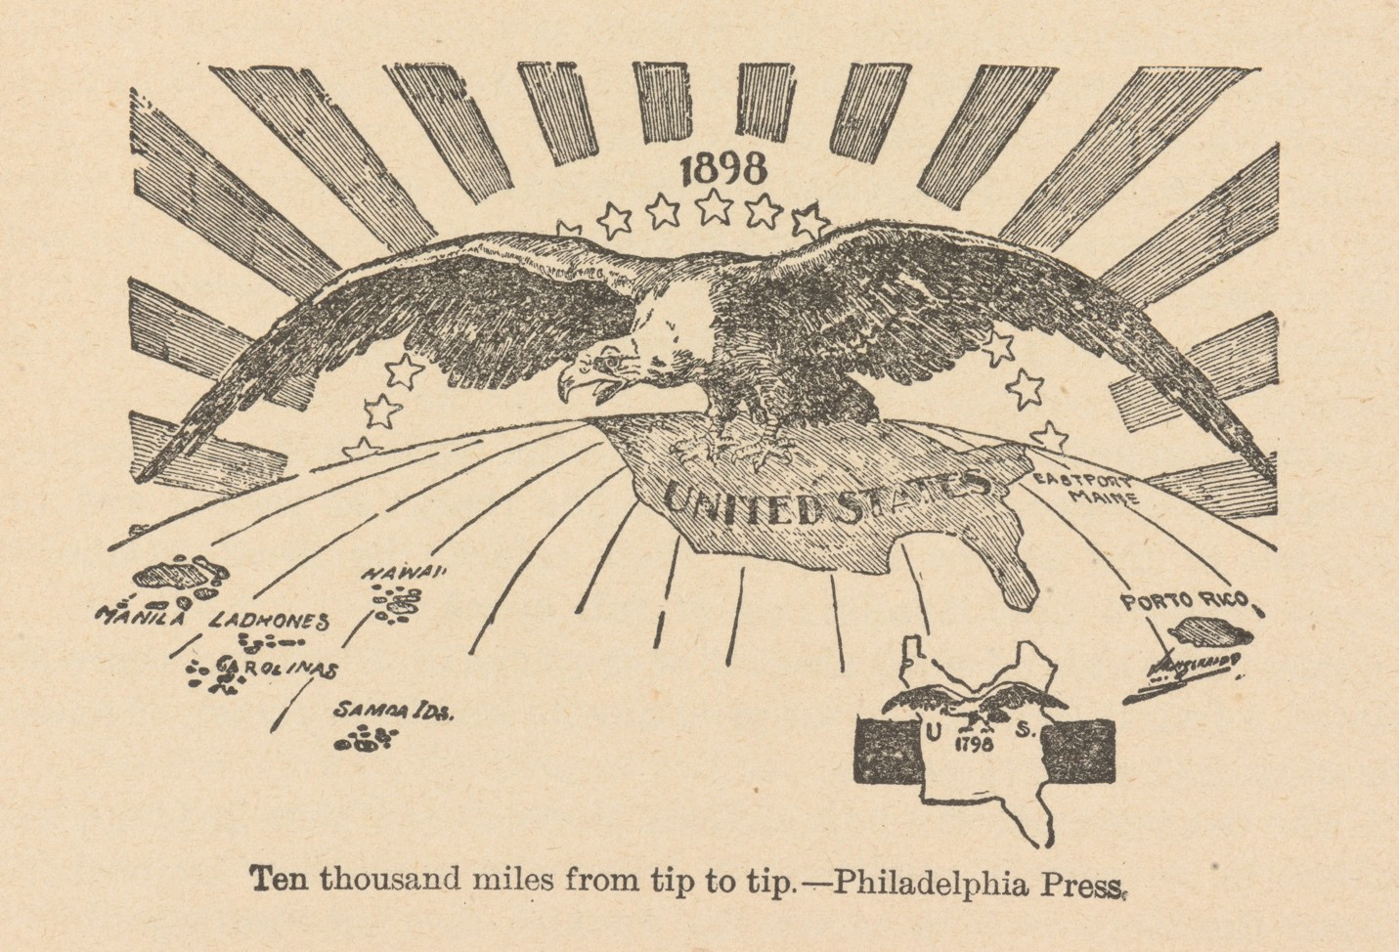
Philadelphia Press, August 14, 1898. (Chicago University Library, Division of Rare and Manuscript Collections)

Is the document pro- or anti-imperialist?
Circle one
Pro-imperialist Anti-imperialist
According to the document, what would the US gain or lose as a result of imperialism?

18
Name(s)- Period- Date-
Analyzing Imperialism [Political Cartoon]

Cite evidence from the primary source above to support your answer:

Cite evidence from the document to support your answer:

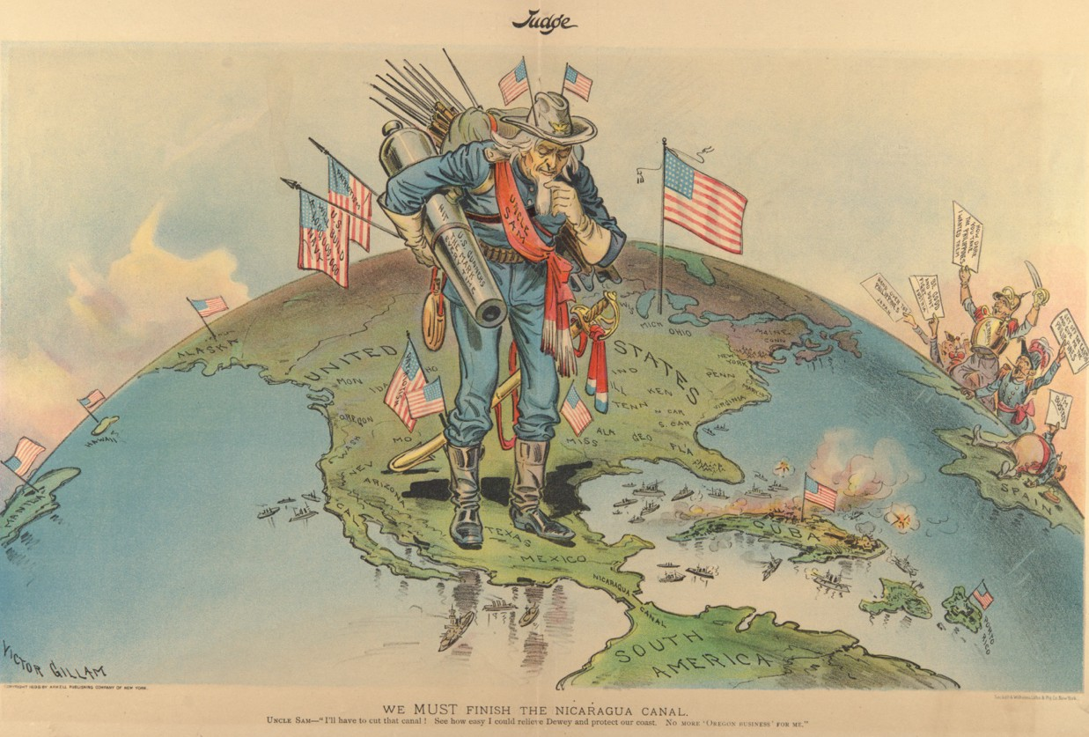
Judge, June 18, 1898. (Chicago University Library, Division of Rare and Manuscript Collections)

Is the document pro- or anti-imperialist?
Circle one
Pro-imperialist Anti-imperialist
According to the document, what would the US gain or lose as a result of imperialism?

19
Name(s)- Period- Date-
Analyzing Imperialism [Political Cartoon]

Cite evidence from the primary source above to support your answer:

Cite evidence from the document to support your answer:

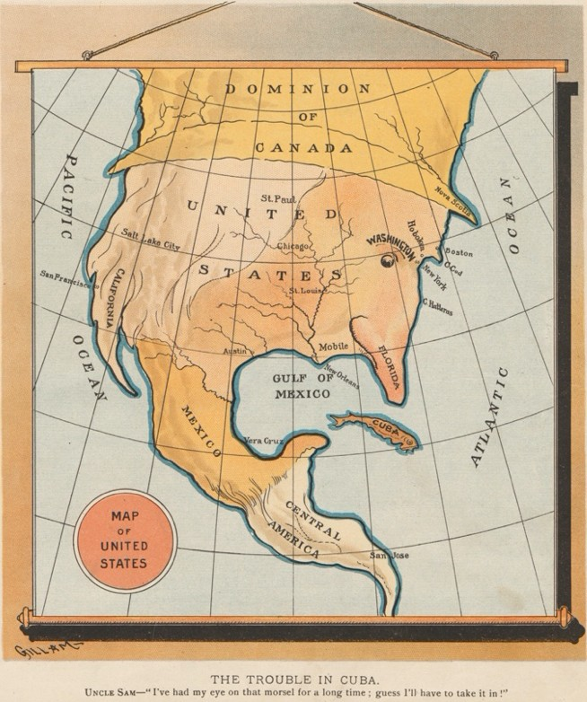20
Name(s)- Period- Date-
Analyzing Imperialism [Political Cartoon]

Judge, August 10, 1895. (Chicago University Library, Division of Rare and Manuscript Collections)

Is the document pro- or anti-imperialist?
Circle one
Pro-imperialist Anti-imperialist
According to the document, what would the US gain or lose as a result of imperialism?

Cite evidence from the primary source above to support your answer:

Cite evidence from the document to support your answer:

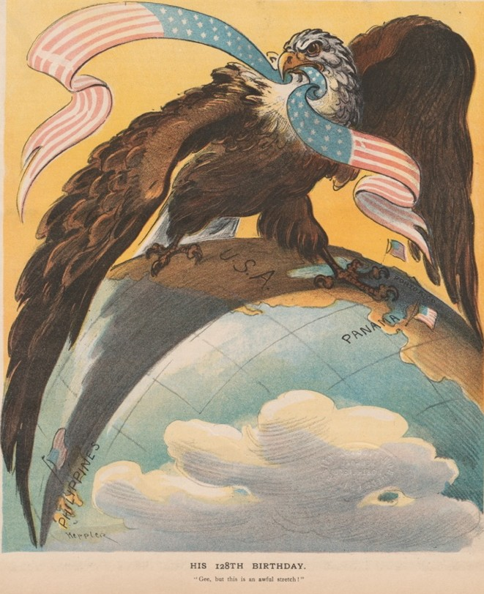21
Name(s)- Period- Date-

Analyzing Imperialism [Political Cartoon]

Puck, June 29, 1904. (Chicago University Library, Division of Rare
and Manuscript Collections)

Is the document pro- or anti-imperialist?
Circle one
Pro-imperialist Anti-imperialist
According to the document, what would the US gain or lose as a result of imperialism?

Cite evidence from the primary source above to support your answer:

Cite evidence from the document to support your answer:

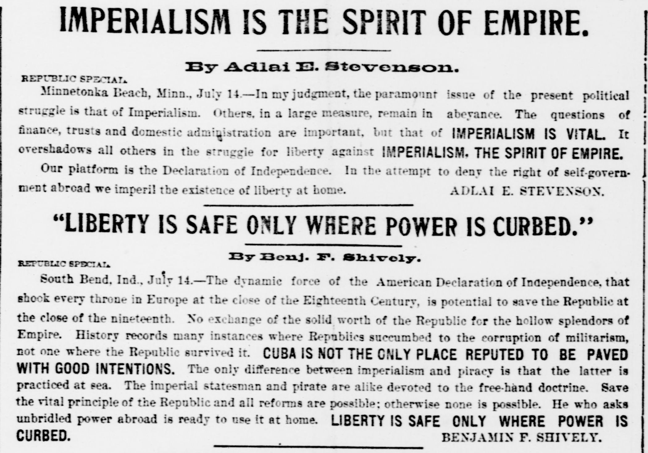

St. Louis (MO) Republic, July 15, 1900

Is the document pro- or anti-imperialist?
Circle one
Pro-imperialist Anti-imperialist
According to the document, what would the US gain or lose as a result of imperialism?

22
Name(s)- Period- Date-
Analyzing Imperialism [Newspaper Article]

Cite evidence from the primary source above to support your answer:

Cite evidence from the document to support your answer:

. . . “Imperialism” has for one of its definitions “a policy of territorial extension.” Under such a definition the United States has followed a course of “Imperialism” for a great many years. “Imperialism” carried the pioneers out west, “Imperialism” made the Louisiana purchase, “Imperialism” added California, Arizona and New Mexico to the Union; and “Imperialism secured the territory of Alaska. “Imperialism” seems to be a very old American word.

23
Name(s)- Period- Date-

Analyzing Imperialism [Newspaper Article]

“IMPERIALISM” [excerpts]
. . . But “Imperialism” is defined to mean that “we, the United States, have found a helpless people over sea who are not equal to the task of self-government, whom the fortunes of war have thrown upon our hands and whom we are bound to guide along the path that leads to the broadest and fullest liberty.” . . .
“Imperialism of this kind is innately American. American “Imperialism” means the expansion of American ideals. It is the leading of a people to a higher and broader life and a freer political status. The word was applied to do an injury, it can be used to raise the [Republican] party to its lasting glory.

Hawaiian Star, August 9, 1900

Is the document pro- or anti-imperialist?
Circle one
Pro-imperialist Anti-imperialist
According to the document, what would the US gain or lose as a result of imperialism?

Cite evidence from the primary source above to support your answer:

Cite evidence from the document to support your answer:

24
Name(s)- Period- Date-

Analyzing Imperialism [Newspaper Article]

ONLY A BUGABOO
AN EFFORT TO FRIGHTEN VOTERS [excerpts]
. . . The administration has not favored expansion for expansion’s sake. Except in the case of Hawaii, which had itself long ago applied for annexation, it did not seek the territory which has come under our flag. The expansion has come as the unavoidable result of the Spanish war. It was the universal demand of the American people that Spanish power should be expelled from the western hemisphere. The fate of the war brought the same destruction of Spanish power in the Philippines. . . .
We had extinguished Spanish authority; we could not permit anarchy; we could not throw the Philippines into the turmoil of foreign contention; the only thing left was to accept the responsibility ourselves. In accepting this responsibility we are fulfilling the highest national obligation of humanity and civilization, and to call the performance of that duty imperialism is simply an attempt to mislead the people with an opprobrious [shameful] term. Ours is a government of the people, by the people, and for the people. Imperialism is autocratic rule without law and against the public will.

Marietta (OH) Daily Leader, September 9, 1900

Is the document pro- or anti-imperialist?
Circle one
Pro-imperialist Anti-imperialist

According to the document, what would the US gain or lose as a result of imperialism?

Cite evidence from the primary source above to support your answer:

Cite evidence from the document to support your answer:

A DEFINITION OF IMPERIALISM by Louis R. Ehrich [excerpts] EDITOR CONSERVATIVE:
. . . The government of men without their rightful participation in the governing legislative body,—the enforcement of taxation without representation—the coercive imposition on a governed race of less favorable laws than those enjoyed by the governing race,—this, or what we are now doing to the people of Porto Rico, is imperialism.
. . . [T]he attempt to enforce unfounded sovereignty by military power,—the murdering of thousands of human beings because they are inspired with the republican virtue of desiring their independence,—all this, or what we are now doing in the Philippines, is imperialism. . . .
The theory that one man, because he is whiter or stronger, has title to greater rights than another—the willingness, for glory or for profit, to hold another race in subjugation,—the readiness by force to exploit foreign lands and foreign peoples,—the relegation of sovereignty and of government to might instead of the forum of right,—this is imperialism.

The Conservative, Nebraska City, NE, October 25, 1900

Is the document pro- or anti-imperialist?
Circle one
Pro-imperialist Anti-imperialist

According to the document, what would the US gain or lose as a result of imperialism?

25
Name(s)- Period- Date-
Analyzing Imperialism [Newspaper Article]

Cite evidence from the primary source above to support your answer:

Cite evidence from the document to support your answer:

26
Name(s)- Period- Date-

Analyzing Imperialism [Political Platform]

PLATFORM OF THE
AMERICAN ANTI-IMPERIALIST LEAGUE [excerpts]
We hold that the policy known as imperialism is hostile to liberty and tends toward militarism, an evil from which it has been our glory to be free. We regret that it has become necessary in the land of Washington and Lincoln to reaffirm that all men, of whatever race or color, are entitled to life, liberty, and the pursuit of happiness. We maintain that governments derive their just powers from the consent of the governed. We insist that the subjugation of any people is “criminal aggression” and open disloyalty to the distinctive principles of our government. . . .
We urge that Congress be promptly convened to announce to the Filipinos our purpose to concede to them the independence for which they have so long fought and which of right is theirs.
The United States have always protested against the doctrine of international law which permits the subjugation of the weak by the strong. A self-governing state cannot accept sovereignty over an unwilling people. The United States cannot act upon the ancient heresy that might makes right. . . .
We hold with Abraham Lincoln, that “no man is good enough to govern another man without that other’s consent. When the white man governs himself, that is self-government, but when he governs himself and also governs another man, that is more than self-government—that is despotism.”
Carl Schurz, The Policy of Imperialism: Address by Hon. Carl Schurz at the Anti-Imperialist Conference in Chicago, October 17, 1899 (Chicago: American Anti-Imperialist League, 1899)

Is the document pro- or anti-imperialist?
Circle one
Pro-imperialist Anti-imperialist
According to the document, what would the US gain or lose as a result of imperialism?

Cite evidence from the primary source above to support your answer:

Cite evidence from the document to support your answer:

27
Name(s)- Period- Date-

Analyzing Imperialism [Speech]

The Retention of the Philippine Islands: Speech of Hon. Henry Cabot Lodge, 1900 [excerpts]
Our opponents put forward as their chief objection that we have robbed these people [Filipinos] of their liberty and have taken them and hold them in defiance of the doctrine of the Declaration of Independence in regard to the consent of the governed. As to liberty, they have never had it, and have none now, except when we give it to them protected by the flag and the armies of the United States. Their insurrection against Spain, confined to one island, had been utterly abortive and could never have revived or been successful while Spain controlled the sea. We have given them all the liberty they ever had. We could not have robbed them of it, for they had none to lose. . . .
It has been stated over and over again that we have done great wrong in taking these islands without the consent of the governed, from which, according to American principles, all just government derives its powers. The consent of the governed! What did Jefferson mean by the
phrase? Upon whose consent did it rest? Was it upon that of all the people of the colonies duly
expressed? Most assuredly not.

Is the document pro- or anti-imperialist?
Circle one
Pro-imperialist Anti-imperialist
According to the document, what would the US gain or lose as a result of imperialism?

Cite evidence from the primary source above to support your answer:

Cite evidence from the document to support your answer:

Diary of Edward Emerich, US Army, June 14 and 15 and July 12, 1898 [excerpts]

28
Name(s)- Period- Date-
Analyzing Imperialism
[A Soldier’s Diary and a Print]
June 14 [San Francisco, CA]: . . . At 7.15 the Colo[rado] Reg took up the march to the S.S. China, streets were lined with people who cheered till they grew red in the face for Colorado’s boys. . . .
the “China” weighed anchor & pulled out into the bay how the people cheered.
June 15 Almost all the boys are writing letters of Goodbye to their friends & relatives. This is a
never to be forgotten day for we leave our native land on a 6000 mile trip in defence of “Old Glory.”
July 12 If Sampson & Schley have done their share in Cuba I guess US. has avenged the
“Maine” & those poor boys. . . .
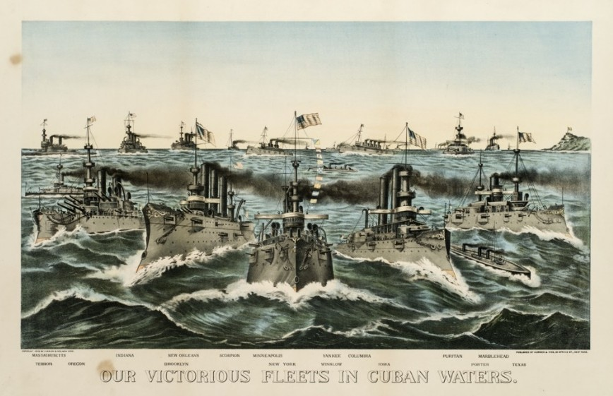
The Gilder Lehrman Institute of American History, GLC07048 (top) and GLC03534 (above).

Are the documents pro- or anti-imperialist?
Circle one
Pro-imperialist Anti-imperialist

Cite evidence from the primary sources above to support your answer:
According to the documents, what would the US gain or lose as a result of imperialism?

Cite evidence from the documents to support your answer:

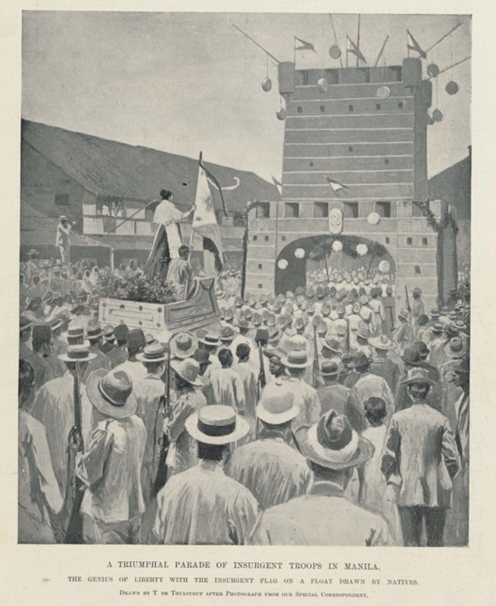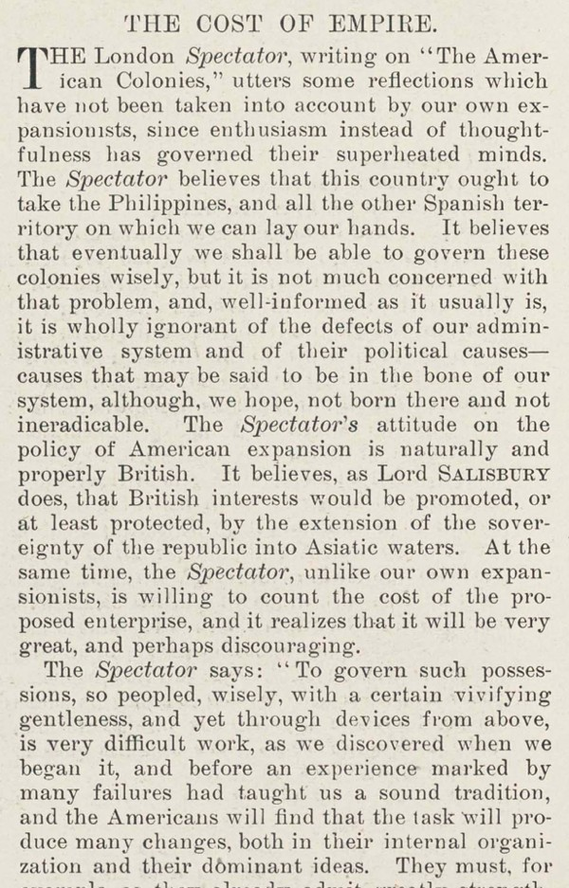29
Name(s)- Period- Date-

Analyzing Imperialism [Periodical Article]

Harper’s Weekly, November 26, 1898. (The Gilder Lehrman Institute of American History, GLC08725.13)

Is the document pro- or anti-imperialist?
Circle one
Pro-imperialist Anti-imperialist
According to the document, what would the US gain or lose as a result of imperialism?

Cite evidence from the primary source above to support your answer:

Cite evidence from the document to support your answer:

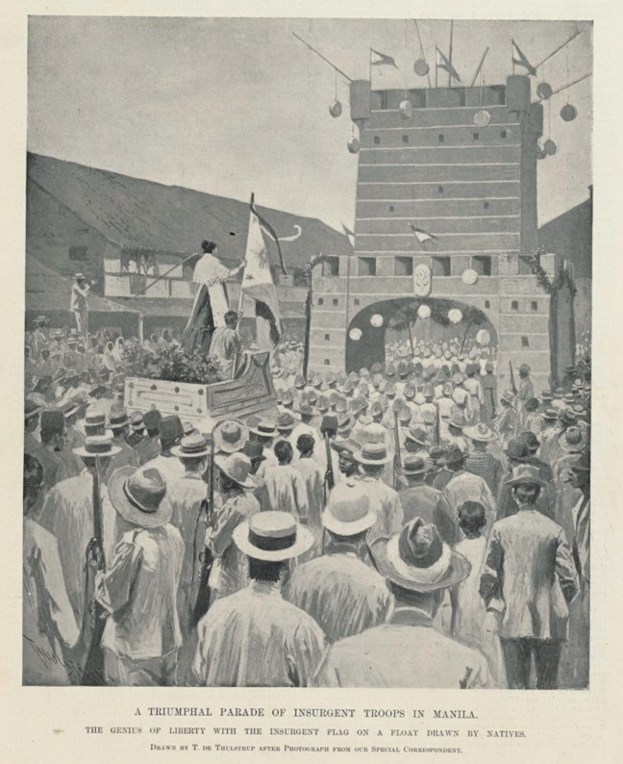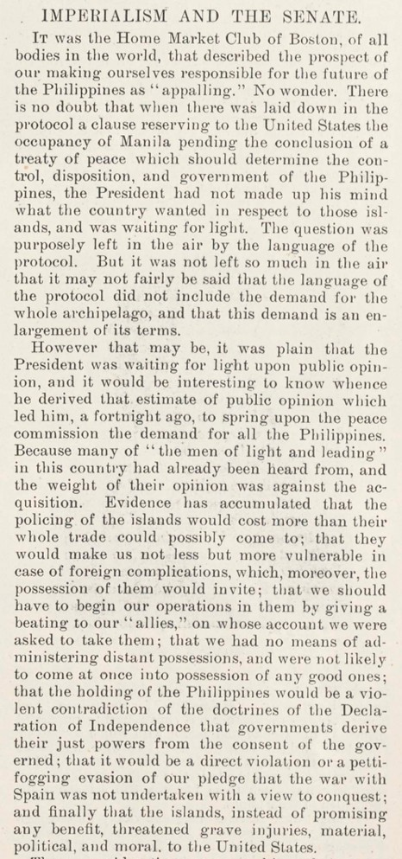30
Name(s)- Period- Date-

Analyzing Imperialism [Periodical Article]

Harper’s Weekly, November 26, 1898. (The Gilder Lehrman Institute of American History, GLC08725.13)

Is the document pro- or anti-imperialist?
Circle one
Pro-imperialist Anti-imperialist
According to the document, what would the US gain or lose as a result of imperialism?

Cite evidence from the primary source above to support your answer:

Cite evidence from the document to support your answer:

Treaty of Peace Between the United States and Spain; December 10, 1898 [excerpt]
[The representatives of Spain and the United States], having assembled in Paris, and having exchanged their full powers, which were found to be in due and proper form, have, after discussion of the matters before them, agreed upon the following articles:
Article I. Spain relinquishes all claim of sovereignty over and title to Cuba. And as the island is, upon its evacuation by Spain, to be occupied by the United States, the United States will, so long as such occupation shall last, assume and discharge the obligations that may under international law result from the fact of its occupation, for the protection of life and property.
Article II. Spain cedes to the United States the island of Porto Rico and other islands now under Spanish sovereignty in the West Indies, and the island of Guam in the Marianas or Ladrones.
Article III. Spain cedes to the United States the archipelago known as the Philippine Islands.

Is the document pro- or anti-imperialist?
Circle one
Pro-imperialist Anti-imperialist
According to the document, what would the US gain or lose as a result of imperialism?

31
Name(s)- Period- Date-
Analyzing Imperialism [Treaty]

Cite evidence from the primary source above to support your answer:

Cite evidence from the document to support your answer:

32
Name(s)- Period- Date-

Analyzing Imperialism [Speech]

FREE AMERICA FREE CUBA
FREE PHILIPPINES
ADDRESSES at A MEETING IN FANEUIL HALL (1901) [excerpts]
. . . Do not, my fellow-citizens, be deceived by the false and weak pleas that are put forth by the advocates of imperialism and oppression. “The Filipinos shall have liberty,” they say, “as much as is good for them,—as soon as they surrender to the United States all power to fight for liberty.” “Give up all your arms,” says the United States government, “and we will stop killing you. And, after that,— subject to the control of the United States,—you shall have such freedom as we think you are fit for.” A people who will resist such insolent dictation as this from an antagonist of enormous power is as worthy of liberty as ever were the Swiss, or the Dutch, or the Americas. . . .
Fellow-citizens, these people of the East and West Indies are at our mercy. Neither Cubans nor Filipinos can successfully defend their liberties against the tremendous power of the United States, if we are determined to put forth that power. Sooner or later their resistance must cease. Their leaders will be captured like Aguinaldo, or deported like Mabini, or killed in battle; but let us remember that when we deprive other men of their freedom, we endanger our own. “Those who deny freedom to others,” said Abraham Lincoln, “deserve it not themselves, and under a just God cannot long retain it.”

Is the document pro- or anti-imperialist?
Circle one
Pro-imperialist Anti-imperialist
According to the document, what would the US gain or lose as a result of imperialism?

Cite evidence from the primary source above to support your answer:

Cite evidence from the document to support your answer:

The unanimous Declaration of the thirteen united States of America, When in the Course of human events, it becomes necessary for one people to dissolve the political bands which have connected them with another, and to assume among the powers of the earth, the separate and equal station to which the Laws of Nature and of Nature's God entitle them, a decent respect to the opinions of mankind requires that they should declare the causes which impel them to the separation.
33

Name(s)- Period- Date-

Analyzing Imperialism [Declaration of Independence]
[Excerpt]
We hold these truths to be self-evident, that all men are created equal, that they are endowed by their Creator with certain unalienable Rights, that among these are Life, Liberty and the pursuit of Happiness.—That to secure these rights, Governments are instituted among Men, deriving their just powers from the consent of the governed,—That whenever any Form of Government becomes destructive of these ends, it is the Right of the People to alter or to abolish it, and to institute new Government, laying its foundation on such principles and organizing its powers in such form, as to them shall seem most likely to effect their Safety and Happiness. Prudence, indeed, will dictate that Governments long established should not be changed for light and transient causes; and accordingly all experience hath shewn, that mankind are more disposed to suffer, while evils are sufferable, than to right themselves by abolishing the forms to which they are accustomed. But when a long train of abuses and usurpations, pursuing invariably the same Object evinces a design to reduce them under absolute Despotism, it is their right, it is their duty, to throw off such Government, and to provide new Guards for their future security.—Such has been the patient sufferance of these Colonies; and such is now the necessity which constrains them to alter their former Systems of Government. The history of the present King of Great Britain is a history of repeated injuries and usurpations, all having in direct object the establishment of an absolute Tyranny over these States. To prove this, let Facts be submitted to a candid world. . . .

34

Name(s)- Period- Date-

The Imperialism Debate: Categorizing the Sources

Place the primary sources into two categories, pro-imperialist and anti-imperialist. Then support your decision with evidence from each document.

Pro-Imperialist Evidence | Anti-Imperialist Evidence
Document #1: Evidence: | Document #1: Evidence:
Document #2: Evidence: | Document #2: Evidence:
Document #3: Evidence: | Document #3: Evidence:
Document #4: Evidence: | Document #4: Evidence:
Document #5: Evidence: | Document #5: Evidence:

35

Name(s)- Period- Date-

The Imperialism Debate: What Is Gained? What Is Lost?

What is gained by American imperialism? | What is lost by American imperialism?

36

Name(s)- Period- Date-

Pro- and Anti-Imperialist Speeches: What Is Gained? What Is Lost?

Select phrases from the primary sources. Each phrase must come from a different document and accurately demonstrate the arguments of the pro- and anti-imperialists. Cite each source. Provide a title that summarizes the message of each speech.

Pro-Imperialist Speech  Summary Title: | Anti-Imperialist Speech  Summary Title:
Line 1:  Line 2:  Line 3:  Line 4:  Line 5: | Line 1:  Line 2:  Line 3:  Line 4:  Line 5:

37

Name(s)- Period- Date-

Sample Pro- and Anti-Imperialist Speeches: What Is Gained? What Is Lost?

Select phrases from the primary sources. Each phrase must come from a different document and accurately demonstrate the arguments of the pro- and anti-imperialists. Cite each source. Provide a title for each speech that summarizes the message of the speech.

Pro-Imperialist Speech  Summary Title: Expanding Liberty | Anti-Imperialist Speech  Summary Title: Imperialism Is Oppression
Line 1: “This is a never to be forgotten day.”  Diary of Edward Emerich  Line 2: “Spain cedes to the United States the archipelago known as the Philippine Islands”  Treaty of Paris, 1898  Line 3: “American ‘Imperialism’ means the expansion of American Ideals. It is leading of a people to a higher and broader life and a freer political status.”  Hawaiian Star  Line 4: “In accepting this responsibility we are fulfilling the highest national obligation of humanity and civilization.”  Marietta Daily Leader  Line 5: “We have given them all the liberty they ever had.”  Henry Cabot Lodge | Line 1: “Do not, my fellow citizens, be deceived by the false and weak pleas that are put forth by the advocates of imperialism and oppression.”  Addresses at A Meeting in Faneuil Hall  Line 2: “Gee but this is an awful stretch.”  Puck  Line 3: “The only difference between imperialism and piracy is that the latter is practiced at sea.”  Benjamin F. Shively  Line 4: “A long train of abuses and usurpations, pursuing invariably the same Object evinces a design to reduce them under absolute Despotism, it is their right, it is their duty, to throw off such Government.”  Declaration of Independence  Line 5: “We urge Congress be promptly convened to announce to the Filipinos our purpose to concede to them the independence for which they have fought.”  American Anti-Imperialist League

38
Analyzing Imperialism [Political Cartoon]

Philadelphia Press, August 14, 1898. (Chicago University Library, Division of Rare and Manuscript Collections)

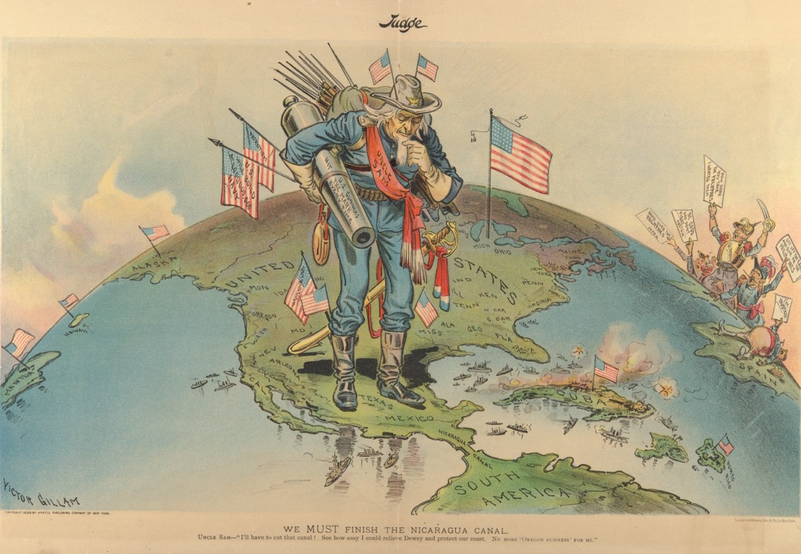39

Analyzing Imperialism [Political Cartoon]

Judge, June 18, 1898. (Chicago University Library, Division of Rare and Manuscript Collections)

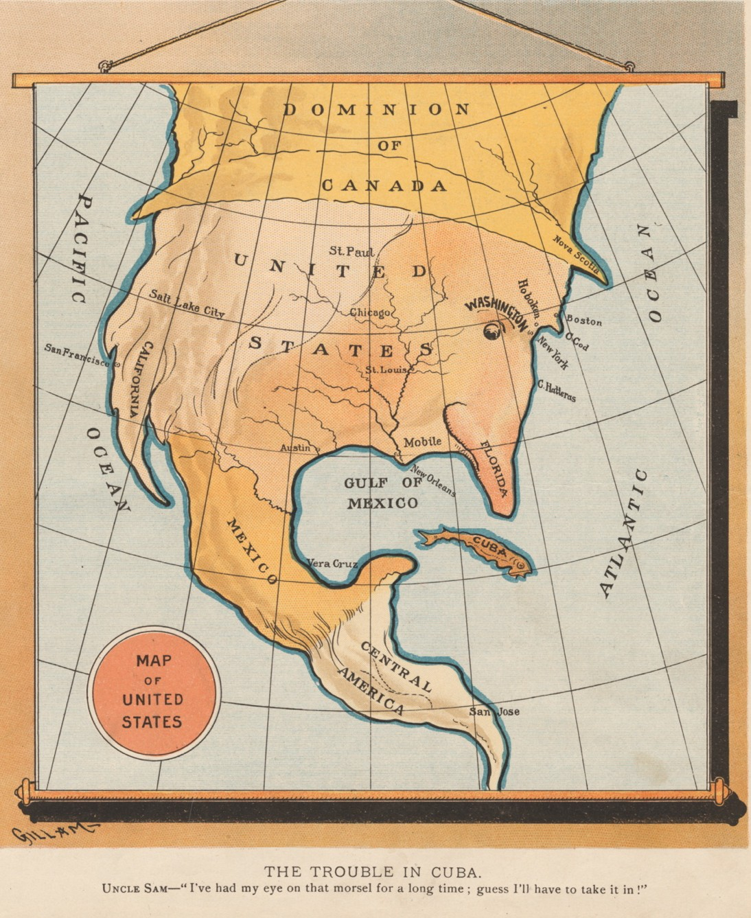40

Analyzing Imperialism [Political Cartoon]

Judge, August 10, 1895. (Chicago University Library, Division of Rare and Manuscript Collections)

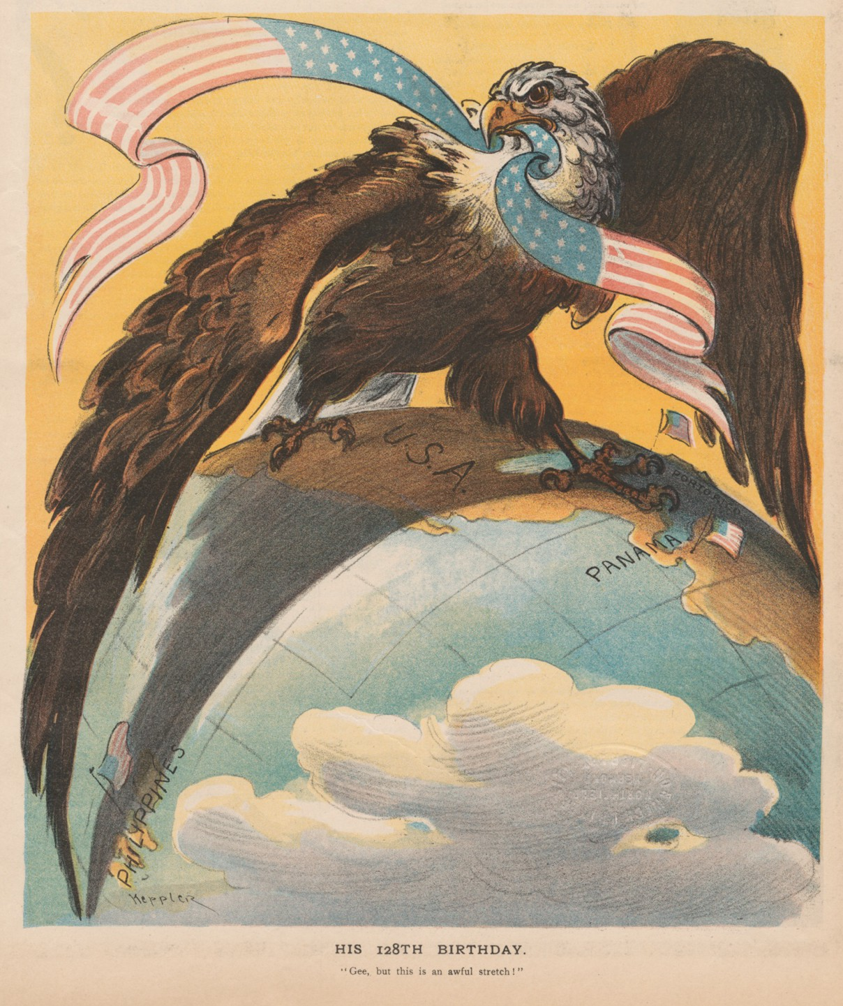41

Analyzing Imperialism [Political Cartoon]

Puck, June 29, 1904. (Chicago University Library, Division of Rare and Manuscript Collections)

42
Analyzing Imperialism [Newspaper Article]

St. Louis (MO) Republic, July 15, 1900

. . . “Imperialism” has for one of its definitions “a policy of territorial extension.” Under such a definition the United States has followed a course of “Imperialism” for a great many years. “Imperialism” carried the pioneers out west, “Imperialism” made the Louisiana purchase, “Imperialism” added California, Arizona and New Mexico to the Union; and “Imperialism secured the territory of Alaska. “Imperialism” seems to be a very old American word.
43
Analyzing Imperialism [Newspaper Article]

“IMPERIALISM” [excerpts]
. . . But “Imperialism” is defined to mean that “we, the United States, have found a helpless people over sea who are not equal to the task of self-government, whom the fortunes of war have thrown upon our hands and whom we are bound to guide along the path that leads to the broadest and fullest liberty.” . . .
“Imperialism of this kind is innately American. American “Imperialism” means the expansion of American ideals. It is the leading of a people to a higher and broader life and a freer political status. The word was applied to do an injury, it can be used to raise the [Republican] party to its lasting glory.

Hawaiian Star, August 9, 1900

44

Analyzing Imperialism [Newspaper Article]

ONLY A BUGABOO
AN EFFORT TO FRIGHTEN VOTERS [excerpts]
. . . The administration has not favored expansion for expansion’s sake. Except in the case of Hawaii, which had itself long ago applied for annexation, it did not seek the territory which has come under our flag. The expansion has come as the unavoidable result of the Spanish war. It was the universal demand of the American people that Spanish power should be expelled from the western hemisphere. The fate of the war brought the same destruction of Spanish power in the Philippines. . . .
We had extinguished Spanish authority; we could not permit anarchy; we could not throw the Philippines into the turmoil of foreign contention; the only thing left was to accept the responsibility ourselves. In accepting this responsibility we are fulfilling the highest national obligation of humanity and civilization, and to call the performance of that duty imperialism is simply an attempt to mislead the people with an opprobrious [shameful] term. Ours is a government of the people, by the people, and for the people. Imperialism is autocratic rule without law and against the public will.

Marietta (OH) Daily Leader, September 9, 1900

A DEFINITION OF IMPERIALISM by Louis R. Ehrich [excerpts] EDITOR CONSERVATIVE:
45
Analyzing Imperialism [Newspaper Article]
. . . The government of men without their rightful participation in the governing legislative body,—the enforcement of taxation without representation—the coercive imposition on a governed race of less favorable laws than those enjoyed by the governing race,—this, or what we are now doing to the people of Porto Rico, is imperialism.
. . . [T]he attempt to enforce unfounded sovereignty by military power,—the murdering of thousands of human beings because they are inspired with the republican virtue of desiring their independence,—all this, or what we are now doing in the Philippines, is imperialism. . . .
The theory that one man, because he is whiter or stronger, has title to greater rights than another—the willingness, for glory or for profit, to hold another race in subjugation,—the readiness by force to exploit foreign lands and foreign peoples,—the relegation of sovereignty and of government to might instead of the forum of right,—this is imperialism.

The Conservative, Nebraska City, NE, October 25, 1900

46

Analyzing Imperialism [Political Platform]

PLATFORM OF THE
AMERICAN ANTI-IMPERIALIST LEAGUE [excerpts]
We hold that the policy known as imperialism is hostile to liberty and tends toward militarism, an evil from which it has been our glory to be free. We regret that it has become necessary in the land of Washington and Lincoln to reaffirm that all men, of whatever race or color, are entitled to life, liberty, and the pursuit of happiness. We maintain that governments derive their just powers from the consent of the governed. We insist that the subjugation of any people is “criminal aggression” and open disloyalty to the distinctive principles of our government. . . .
We urge that Congress be promptly convened to announce to the Filipinos our purpose to concede to them the independence for which they have so long fought and which of right is theirs.
The United States have always protested against the doctrine of international law which permits the subjugation of the weak by the strong. A self-governing state cannot accept sovereignty over an unwilling people. The United States cannot act upon the ancient heresy that might makes right. . . .
We hold with Abraham Lincoln, that “no man is good enough to govern another man without that other’s consent. When the white man governs himself, that is self-government, but when he governs himself and also governs another man, that is more than self-government—that is despotism.”

Carl Schurz, The Policy of Imperialism: Address by Hon. Carl Schurz at the Anti-Imperialist Conference in Chicago, October 17, 1899 (Chicago: American Anti-Imperialist League, 1899)

The Retention of the Philippine Islands: Speech of Hon. Henry Cabot Lodge, 1900 [excerpts]
47
Analyzing Imperialism [Political Speech]
Our opponents put forward as their chief objection that we have robbed these people [Filipinos] of their liberty and have taken them and hold them in defiance of the doctrine of the Declaration of Independence in regard to the consent of the governed. As to liberty, they have never had it, and have none now, except when we give it to them protected by the flag and the armies of the United States. Their insurrection against Spain, confined to one island, had been utterly abortive and could never have revived or been successful while Spain controlled the sea. We have given them all the liberty they ever had. We could not have robbed them of it, for they had none to lose. . . .
It has been stated over and over again that we have done great wrong in taking these islands without the consent of the governed, from which, according to American principles, all just government derives its powers. The consent of the governed! What did Jefferson mean by the
phrase? Upon whose consent did it rest? Was it upon that of all the people of the colonies duly
expressed? Most assuredly not.

Diary of Edward Emerich, US Army, June 14 and 15 and July 12, 1898 [excerpts]
48
Analyzing Imperialism [A Soldier’s Diary]

June 14 [San Francisco, CA]: . . . At 7.15 the Colo[rado] Reg took up the march to the S.S. China, streets were lined with people who cheered till they grew red in the face for Colorado’s boys the
“China” weighed anchor & pulled out into the bay how the people cheered.
June 15 Almost all the boys are writing letters of Goodbye to their friends & relatives. This is a
never to be forgotten day for we leave our native land on a 6000 mile trip in defence of “Old Glory.”
July 12 If Sampson & Schley have done their share in Cuba I guess US. has avenged the “Maine” &
those poor boys. . . .

Analyzing Imperialism [Print]
The Gilder Lehrman Institute of American History, GLC07048 (top) and GLC03534 (above).

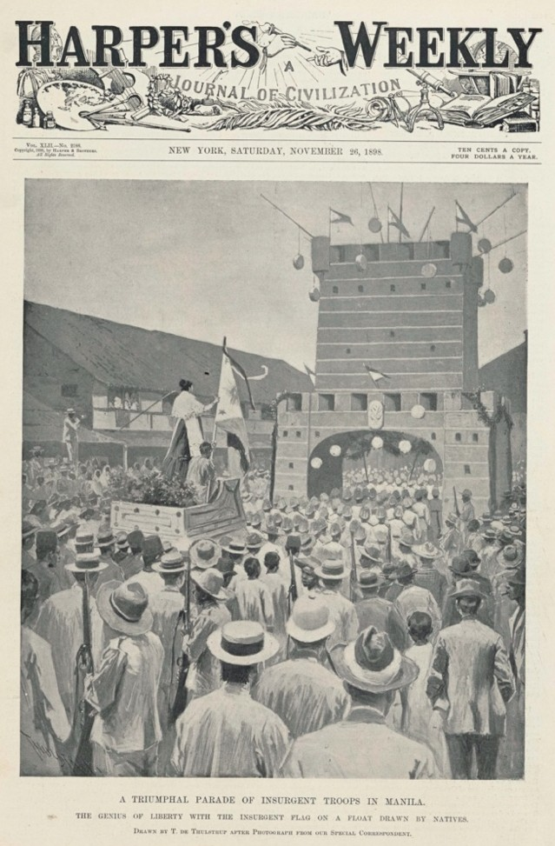
49
Analyzing Imperialism [Periodical Article]
Harper’s Weekly, November 26, 1898. (The Gilder Lehrman Institute of American History, GLC08725.13)

50
Analyzing Imperialism: [Periodical Article]
Harper’s Weekly, November 26, 1898. (The Gilder Lehrman Institute of American History, GLC08725.13)

Treaty of Peace Between the United States and Spain; December 10, 1898 [excerpts]
51
Analyzing Imperialism [Treaty]
[The representatives of Spain and the United States], having assembled in Paris, and having exchanged their full powers, which were found to be in due and proper form, have, after discussion of the matters before them, agreed upon the following articles:
Article I. Spain relinquishes all claim of sovereignty over and title to Cuba. And as the island is, upon its evacuation by Spain, to be occupied by the United States, the United States will, so long as such occupation shall last, assume and discharge the obligations that may under international law result from the fact of its occupation, for the protection of life and property.
Article II. Spain cedes to the United States the island of Porto Rico and other islands now under Spanish sovereignty in the West Indies, and the island of Guam in the Marianas or Ladrones.
Article III. Spain cedes to the United States the archipelago known as the Philippine Islands.

52

Analyzing Imperialism [Speech]

FREE AMERICA FREE CUBA
FREE PHILIPPINES
ADDRESSES at A MEETING IN FANEUIL HALL (1901) [excerpts]
. . . Do not, my fellow-citizens, be deceived by the false and weak pleas that are put forth by the advocates of imperialism and oppression. “The Filipinos shall have liberty,” they say, “as much as is good for them,—as soon as they surrender to the United States all power to fight for liberty.” “Give up all your arms,” says the United States government, “and we will stop killing you. And, after that,— subject to the control of the United States,—you shall have such freedom as we think you are fit for.” A people who will resist such insolent dictation as this from an antagonist of enormous power is as worthy of liberty as ever were the Swiss, or the Dutch, or the Americas. . . .
Fellow-citizens, these people of the East and West Indies are at our mercy. Neither Cubans nor Filipinos can successfully defend their liberties against the tremendous power of the United States, if we are determined to put forth that power. Sooner or later their resistance must cease. Their leaders will be captured like Aguinaldo, or deported like Mabini, or killed in battle; but let us remember that when we deprive other men of their freedom, we endanger our own. “Those who deny freedom to others,” said Abraham Lincoln, “deserve it not themselves, and under a just God cannot long retain it.”

