by Nate McAlister

America’s Role in the World: World War I to World War II

UNIT OVERVIEW
This unit has been developed by the Gilder Lehrman Institute of American History in partnership with World101 from the Council on Foreign Relations. These lesson plans were developed to enable students to understand, summarize, and evaluate original documents of historical significance.
Students will learn and practice skills that will help them analyze, assess, and develop knowledgeable and well-reasoned points of view on visual and textual source materials.
In the two lessons in this unit the students will analyze and assess cartoons, speeches, government documents, and other texts created between 1915 and 1941. The objective is to have students recognize the contrasting arguments of the isolationists and interventionists and analyze key elements of the debate about America’s role in the world between World War I and World War II. Using these key elements students will examine, identify, evaluate, and discuss significant ideas from several isolationist- and interventionist-focused documents. As an assessment, they will use the documents to create a scripted news conference aimed at shifting the opinion of the American public toward isolation or intervention in the world.

NUMBER OF CLASS PERIODS: 2–3
GRADE LEVEL(S): 7–12

UNIT OBJECTIVES
Students will be able to
- Analyze primary source documents
- Infer subtle messages from primary sources
- Summarize the meaning of primary sources
- Incorporate primary source materials in a scripted news conference

ESSENTIAL QUESTIONS
What part should the United States have played in the world between 1918 and 1941?

CCSS.ELA-Literacy.RH.6-8.1: Cite specific textual evidence to support analysis of primary and secondary sources.
2
COMMON CORE STATE STANDARDS
CCSS.ELA-Literacy.RH.6-8.2: Determine the central ideas or information of a primary or secondary source; provide an accurate summary of the source distinct from prior knowledge or opinions.
CCSS.ELA-Literacy.RH.11-12.1: Cite specific textual evidence to support analysis of primary and secondary sources, connecting insights gained from specific details to an understanding of the text as a whole.
CCSS.ELA-Literacy.RH.11-12.2: Determine the central ideas or information of a primary or secondary source; provide an accurate summary that makes clear the relationships among the key details and ideas.
CCSS.ELA-Literacy.SL.8.2: Analyze the purpose of information presented in diverse media and formats (e.g., visually, quantitatively, orally) and evaluate the motives (e.g., social, commercial, political) behind its presentation.
CCSS.ELA-Literacy.SL.11-12.1: Initiate and participate effectively in a range of collaborative discussions (one-on-one, in groups, and teacher-led) with diverse partners on grades 11-12 topics, texts, and issues, building on others’ ideas and expressing their own clearly and persuasively.
CCSS.ELA-Literacy.SL.11-12.2: Integrate multiple sources of information presented in diverse formats and media (e.g., visually, quantitatively, orally) in order to make informed decisions and solve problems, evaluating the credibility and accuracy of each source and noting any discrepancies among the data.
CCSS.ELA-Literacy.W.8.2: Write informative/explanatory texts to examine a topic and convey ideas, concepts, and information through the selection, organization, and analysis of relevant content.
CCSS.ELA-Literacy.W.11-12.2: Write informative/explanatory texts to examine and convey complex ideas, concepts, and information clearly and accurately through the effective selection, organization, and analysis of content.
CCSS.ELA-Literacy.W.11-12.2.B: Develop the topic thoroughly by selecting the most significant and relevant facts, extended definitions, concrete details, quotations, or other information and examples appropriate to the audience’s knowledge of the topic.

3

LESSON 1: ANALYZING THE ISOLATIONIST AND INTERVENTIONIST MESSAGES

OVERVIEW
In the first lesson, students will identify, examine, and analyze the language and imagery of primary sources related to the debate between isolationists and interventionists from 1915 to 1941. Students will work with a variety of primary sources including cartoons, speeches, government documents, and other texts. For each document students will identify important actions, moods, and phrases associated with the argument and cite evidence from the document to support their answer. At the end of the lesson, the class will come together to discuss both sides of the debate and which side had better arguments.

HISTORICAL BACKGROUND

America’s Role in the World: World War I to World War II by Michael Neiberg
Between World War I and World War II the United States emerged on the world stage as a superpower. This ascendancy had military, economic, humanitarian, and cultural dimensions. Some Americans expressed discomfort with this unwelcome new role, believing that it ran counter to the nation’s traditions of isolation from Europe’s internecine wars. Others argued that in an interconnected and global world order, the days of isolation and neutrality were long over. Still others saw an opportunity to remake the world in America’s image, promoting democracy and free markets as a means of ensuring world prosperity and peace.
Although few Americans in 1914 wanted to enter World War I, the majority believed that the United States had an obligation to ensure that autocratic Germany did not destroy the democracies of France and Great Britain. Millions of Americans gave of their time and their money to help the Allied cause. Tens of thousands volunteered as doctors, nurses, ambulance drivers, airmen, and soldiers in the British and French armies. The sinking of the Lusitania in 1915 proved to Americans that they would not be able to remain neutral merely because they wanted to. The war was coming ever closer to American shores.

4

In April 1917 the United States finally felt a sufficient threat to enter the war. The Germans had resumed unrestricted submarine warfare and, through the Zimmerman Telegram, had proposed the creation of a German-Mexican-Japanese alliance aimed at dividing the American West between them. President Wilson pledged to seek no territorial expansion through foreign war, a first in American history. He spoke in idealistic terms about American war aims in his famous Fourteen Points speech of January 1918.
Despite the victory on the battlefield, many Americans grew despondent and disillusioned by the failures of the Paris Peace Conference. The war had not, in the end, made the world any safer or more democratic. The United States remained active in international affairs in the 1920s and 1930s, but the American people and their leaders remained wary of fighting another war.
The fall of France in 1940 shook Americans out of their slumber. They responded with massive defense spending bills and an unprecedented introduction of conscription in peacetime. Isolationism faded but did not entirely vanish until the Japanese attack on Pearl Harbor of December 7, 1941.
The Second World War made the United States a true superpower with atomic weapons and a booming economy. American losses in material and human costs had been far lower than those of China, the Soviet Union, or Germany, leaving the nation in a position of dominance. Still, Americans debated whether to use that power or retreat into isolation once more. Even before the war ended, however, the United States made its choice to be a more active player in the world, helping to usher in the United Nations and creating the Bretton Woods economic system. Questions remained, however, about the proper place of the United States in the world, questions that stay with us even today.

Michael Neiberg is the chair of War Studies at the US Army War College and the author of Potsdam: The End of World War II and the Remaking of Europe (2015) and Dance of the Furies: Europe and the Outbreak of War, 1914 (2011).

MATERIALS
Optional Historical Background
- “America’s Role in the World: World War I to World War II” by Michael Neiberg with the activity sheet

Foreign Relations, world101.cfr.org/historical-context/world-war/how-did-united-states- become-global-power.
5
- “How Did the United States Become a Global Power?” in World101 from the Council on
Isolationist Documents
- Cartoon 1: Harry Grant Dart, “Some People Think I Should Have Stayed T’Hum [Home],” Life, June 26, 1919, p. 1129. Available on Google Books, google.com/books/edition/Life/L0jZAAAAMAAJ.
Background: This cartoon shows a beleaguered Uncle Sam with an eye patch tripping over barbed wire carrying the “Monroe Doctrine” in his right hand and “prestige” in his left. In the background are explosions, and two bricks, one titled Italy and the other Japan, are being hurled toward Uncle Sam. The message is clear that the United States should not be involved.
- Cartoon 2: Winsor McCay, “Better Keep to the Old Channel,” Topeka State Journal, October 22, 1919, Chronicling America: Historic American Newspapers, Library of Congress, chronicling America.loc.gov.
Background: This cartoon shows the United States represented as a passenger liner attempting to avoid treacherous and deadly icebergs as it makes its way through the ocean. Each of the icebergs is represented by a different threat to US “independence.” These include the League of Nations, Foreign Entanglements, Foreign Treaties, and a Treaty with France and England.
- Political Address [excerpts]: George Washington, Farewell Address, Claypoole’s Advertiser, September 19, 1796, The Gilder Lehrman Institute of American History, GLC00185.
- Speech [excerpts]: Henry Cabot Lodge (MA), Speech on the Constitution of the League of Nations, February 28, 1919, Congressional Record 57 (1919), pp. 4520–4522 and 4528.
- Speech [excerpts]: “Speech of Hon. George Holden Tinkham of Massachusetts in the House of Representatives, February 3, 1933,” Carbon County (MT) News, March 8, 1933, Chronicling America: Historic American Newspapers, Library of Congress, chroniclingamerica.loc.gov.

6

- Book [excerpts]: Smedley D. Butler, War Is a Racket (Los Angeles: Feral Press, 2003, orig. 1935), pp. 6–7, 17, and 21.
- Speech [excerpt]: Gerald P. Nye (ND), “No Further without War, Extension of Remarks of Hon. Gerald P. Nye of North Dakota in the Senate of the United States, Thursday, May 8, 1941, Radio Address by Hon. Gerald P. Nye, of North Dakota,” Congressional Record 87 (1941), pp. A2191–A2192.
Interventionist Documents
- Cartoon 3: “My Country, Tis of Thee,” Life, February 10, 1916, Cornell University Library, Division of Rare & Manuscript Collections.
Background: “This map appeared on the cover of Life magazine on February 10, 1916. It was part of the effort of American interventionists to overcome isolationist sentiment insisting on continued neutrality in the ongoing European War. The US has been renamed New Prussia, and American city names have been replaced with German (or Germanized) versions.
Washington is New Berlin, Chicago is Schlauterhaus, and Boston is Kulturplatz. Denverburg and Salzlakenburg are presumably German, but Florida has become Turconia, California is Japonica, and the northwest is dominated by Nagaseattle and New Kobe. New Mexico is an ‘American Reservation’ in Der Grosse Desert.” (Courtesy Cornell University Library, Division of Rare & Manuscript Collections)
- Cartoon 4: Clifford Berryman, “Lafayette, We Are Here!” May 22, 1940, Berryman Political Cartoon Collection, 1896–1949, Records of the US Senate, Record Group 46, National Archives.
Background: “Isolationism, the wish to be separated from the troubles in Europe and Asia, was a powerful influence on American foreign policy in the period between the two world wars and was especially strong in the years preceding World War II. Many politicians and individuals called for the US government to build ‘Fortress America,’ a mighty defensive shield which would protect America from foreign military attack. As cartoonist Clifford Berryman sees it, this was the reverse of the American attitude in World War I when American troops landed in France shouting their support with a hearty ‘Lafayette, we are here’ (referring to French support for America during the Revolutionary War). Now in the period of

7

isolationism and neutrality, Uncle Sam could only sit behind his sealed off America and proclaim ‘Lafayette, we are here!’” (Courtesy National Archives and Records Administration)
- Speech [excerpt]: Woodrow Wilson, Address of the President of the United States, Delivered at a Joint Session of the Two Houses of Congress, April 2, 1917 (Garden City NY: Doubleday, Page & Co., 1917), pp. 3–4, 11, 16, 19, 24–25, 29–30, The Gilder Lehrman Institute of American History, GLC00466.
- Press Statement [excerpts]: William C. McAdoo, Press statement regarding Woodrow Wilson’s work at the Peace Conference (Versailles), March 4, 1921, The Gilder Lehrman Institute of American History. GLC03967.
- Government Report [excerpts]: Charles Firich, Polish Character of Upper Silesia according to Official Prussian Sources and the Results of the Plebiscite, trans. Waldemar A. Przedpelski (Warsaw: Central Polish Plebiscite Committee, 1921), pp. 9–10, The Gilder Lehrman Institute of American History, GLC02766.16.
- Speech [excerpts]: Franklin D. Roosevelt, Address of the President at Chautauqua, N.Y., August 14, 1936, The Gilder Lehrman Institute of American History. GLC04599.
- Policy Statement [excerpts]: Committee to Defend America by Aiding the Allies, Statement of Policy, March 17, 1941, New York NY, David M. Rubenstein Rare Book & Manuscript Library, Duke University Libraries, idn.duke.edu.
Activity Sheets
  - Analyzing Isolationist Arguments
  - Analyzing Interventionist Arguments

PROCEDURE
- Optional: You may choose to incorporate the Historical Background (and the Important Phrases activity sheet) at any point throughout the two lessons in this unit, or you may discuss the information in the essay with the class. In addition, you may have the students read “How Did the United States Become a Global Power?” in World101, world101.cfr.org/historical- context/world-war/how-did-united-states-become-global-power.

8

- Place students into pairs or small groups and hand out, provide a digital copy of, or screen share the four Analyzing a Cartoon: Isolationist and Interventionist Arguments activity sheets.
- Lead the class through the analysis of one of the political cartoons. Have students conduct a brief 30-second analysis on their own and elicit answers about the actions, mood or tone, and message of the cartoon. It is perfectly fine if they disagree. Next, have them cite evidence from the political cartoon that supports their answers. The analysis and discussion of evidence is crucial to a deeper understanding of the primary source.
- Have students complete the analysis of the remaining cartoons. If you are in a hybrid teaching setting, make certain that at least one person from each group is in-person. If you are working remotely, you may place students in breakout rooms.
- Lead a brief class discussion of the messages in the cartoons and have students answer the essential question: What part should the United States have played in the world between 1918 and 1941?
- With students still in their small groups, hand out, provide a digital copy of, or screen share the Analyzing Isolationist Arguments activity sheets, Analyzing Interventionist Arguments activity sheets, and all ten texts.
If time or student learning level is a consideration, you may choose to use the following two primary sources for each side of the argument.
Analyzing Isolationist Arguments activity sheets paired with the following documents:
  - Washington’s Farewell Address, 1796
  - Smedley D. Butler, War Is a Racket, 1935
Analyzing Interventionist Arguments activity sheets paired with the following documents:
- Woodrow Wilson, The President’s Address, April 2, 1917
- Franklin Roosevelt, Address of the President at Chautauqua, NY, 1936
- Lead the students in a “share read” of one of the texts. To share read the text, have the students follow along silently while you begin to read aloud, modeling prosody, inflection, and punctuation. Ask the class to join in with the reading after a few sentences while you continue to read aloud. This technique will support struggling readers and English language learners.

- Students will analyze the five isolationist and five interventionist primary sources and identify the most important or powerful phrase in each text, writing it into the appropriate activity sheet. They will explain their reasons for selecting each phrase.
9
8. Have students complete the remaining activity sheets.
- Students will determine the overall message of the isolationist and interventionist texts taken together and answer the essential question: What part should the United States have played in the world between 1918 and 1941?
- When they have completed all of the activity sheets, have them discuss which set of primary sources had the greatest impact and the most effective message.
- Have students answer the essential question as a wrap-up discussion or an exit ticket activity: What part should the United States have played in the world between 1918 and 1941?

OVERVIEW
10
LESSON 2: Isolationist/Interventionist News Conference
In the second lesson, the students will use the materials from Lesson 1 to create and present a scripted news conference. At the end of the lesson, the class will come together to discuss the news conferences and the effectiveness of the messages, and answer the essential question.

MATERIALS
- Materials used in Lesson 1
- Assessment Activity: Isolationist/Interventionist News Conference
- Teacher’s Resource: Examples of Isolationist/Interventionist News Conference activity sheets
- Assessment Activity: Isolationist/Interventionist Audience Response
- Teacher’s Resource: Examples of Audience Responses

PROCEDURE
- Optional: You may choose to incorporate the Historical Background (and the Important Phrases activity sheet) at any point throughout the two lessons in this unit, or you may discuss the information in the essay with the class. In addition, you may have the students read “How Did the United States Become a Global Power” from World101, world101.cfr.org/historical- context/world-war/how-did-united-states-become-global-power..
- Divide the class into small groups, evenly split between isolationists and interventionists if possible; for example, two groups of isolationists and two groups of interventionists. Each group is assigned either the isolationist or interventionist documents from Lesson 1. If you are in a hybrid teaching setting, make certain that at least one person from each group is in-person. If you are working remotely, you may wish to place students in breakout rooms.
- Students select who will take the role of speaker, with the other members of the group portraying reporters at the news conference.
- Hand out the Isolationist/Interventionist News Conference organizer. Working together, the students will write both the questions and the answers to those questions on the form. The

11

questions should highlight the major issues in the documents. The students should be careful to cite evidence from the texts in the answers given by the speaker. Each student will fill out their own complete copy of the questions and answers, not just their own question. If there are more than three “reporters,” they may write additional questions and answers on the back of the organizer. If possible, have the students watch a recording of a traditional news conference prior to this activity.
- Hand out the Audience Response organizers to the class. If there are more than three groups in each category, they may write additional responses on the back of the organizer.
- Presentation:
  - The speaker takes questions from reporters.
  - The reporters raise their hands, and the speaker selects them to ask their questions.
  - The news conference continues until all of the questions have been asked, one per reporter; if time permits, the students could script follow-up questions.
  - Using the Isolationist/Interventionist Audience Response organizer, have those students not presenting evaluate the effectiveness of the speaker’s answers. Have the audience members record the documents cited and the most effective evidence used, and write a brief summary of the speaker’s argument.
- Repeat the process with all groups. This may mean going into another class period to allow time for all of the presentations as well as time to debrief the experience.
- Have the class debrief the presentations. What evidence was the most effective? What made the speaker’s answers effective? What documents were cited? Focus on good oral presentation skills as well as which questions elicited the most meaningful answers.
- Have students answer the essential question as a wrap-up discussion or an exit ticket activity: What part should the United States have played in the world between 1918 and 1941?

12
Historical Background

America’s Role in the World: World War I to World War II by Michael Neiberg
Between World War I and World War II the United States emerged on the world stage as a superpower. This ascendancy had military, economic, humanitarian, and cultural dimensions. Some Americans expressed discomfort with this unwelcome new role, believing that it ran counter to the nation’s traditions of isolation from Europe’s internecine wars. Others argued that in an interconnected and global world order, the days of isolation and neutrality were long over. Still others saw an opportunity to remake the world in America’s image, promoting democracy and free markets as a means of ensuring world prosperity and peace.
Although few Americans in 1914 wanted to enter World War I, the majority believed that the United States had an obligation to ensure that autocratic Germany did not destroy the democracies of France and Great Britain. Millions of Americans gave of their time and their money to help the Allied cause. Tens of thousands volunteered as doctors, nurses, ambulance drivers, airmen, and soldiers in the British and French armies. The sinking of the Lusitania in 1915 proved to Americans that they would not be able to remain neutral merely because they wanted to. The war was coming ever closer to American shores.
In April 1917 the United States finally felt a sufficient threat to enter the war. The Germans had resumed unrestricted submarine warfare and, through the Zimmerman Telegram, had proposed the creation of a German-Mexican-Japanese alliance aimed at dividing the American West between them. President Wilson pledged to seek no territorial expansion through foreign war, a first in American history. He spoke in idealistic terms about American war aims in his famous Fourteen Points speech of January 1918.
Despite the victory on the battlefield, many Americans grew despondent and disillusioned by the failures of the Paris Peace Conference. The war had not, in the end, made the world any safer or more democratic. The United States remained active in international affairs in the 1920s and 1930s, but the American people and their leaders remained wary of fighting another war.
The fall of France in 1940 shook Americans out of their slumber. They responded with massive defense spending bills and an unprecedented introduction of conscription in peacetime. Isolationism faded but did not entirely vanish until the Japanese attack on Pearl Harbor of December 7, 1941.

13

The Second World War made the United States a true superpower with atomic weapons and a booming economy. American losses in material and human costs had been far lower than those of China, the Soviet Union, or Germany, leaving the nation in a position of dominance. Still, Americans debated whether to use that power or retreat into isolation once more. Even before the war ended, however, the United States made its choice to be a more active player in the world, helping to usher in the United Nations and creating the Bretton Woods economic system. Questions remained, however, about the proper place of the United States in the world, questions that stay with us even today.

Michael Neiberg is the chair of War Studies at the US Army War College and the author of Potsdam: The End of World War II and the Remaking of Europe (2015) and Dance of the Furies: Europe and the Outbreak of War, 1914 (2011).

14
Name(s)- Period- Date-

Historical Background: Important Phrases

Which phrases or sentences in this essay related to America’s role in the world between World War I and World War II are most informative or important? Choose three and give the reason for your choice.
Phrase 1:

Why is this phrase informative or important?

Phrase 2:

Why is this phrase informative or important?

Phrase 3:

Why is this phrase informative or important?

15
Name(s)- Period- Date-
Analyzing a Cartoon: Isolationist and Interventionist Arguments
Cartoon 1

Give the cartoon a title:
What action is taking place in the cartoon?
What mood or tone is created by the cartoon and what is creating that mood or tone?
Is the message of the cartoon isolationist or interventionist? Cite evidence to support your answer.

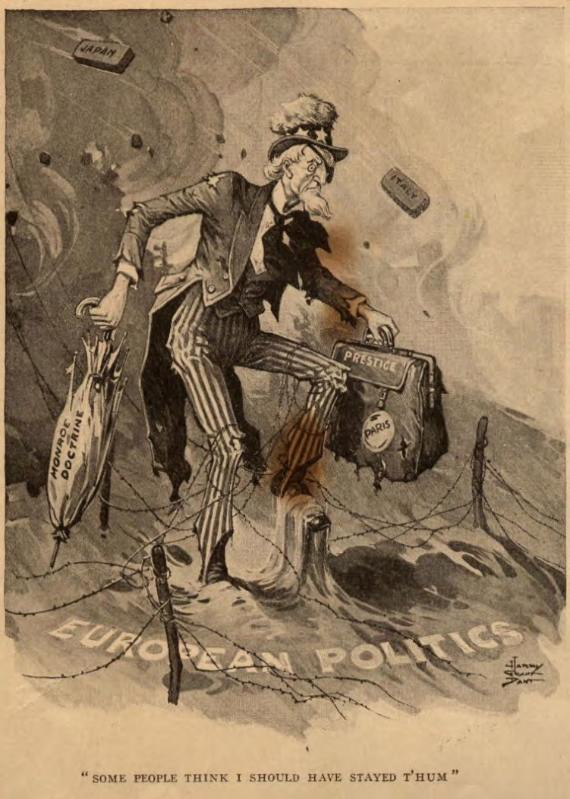Life, June 26, 1919 (Google Books)

Produced by the Gilder Lehrman Institute of American History. © 2021 Council on Foreign Relations
gilderlehrman.org and world101.cfr.org

16
Name(s)- Period- Date-
Analyzing a Cartoon: Isolationist and Interventionist Arguments
Cartoon 2

Give the cartoon a title:
What action is taking place in the cartoon?
What mood or tone is created by the cartoon and what is creating that mood or tone?
Is the message of the cartoon isolationist or interventionist? Cite evidence to support your answer.
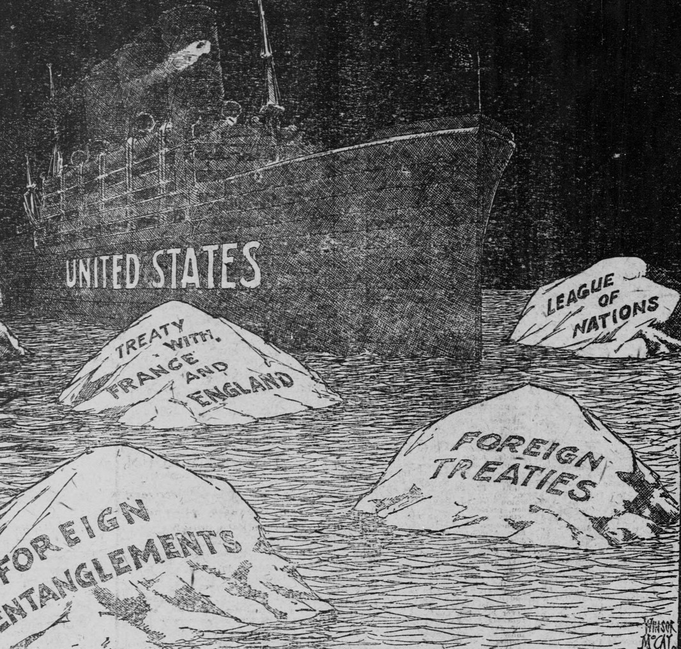
Topeka State Journal, October 22, 1919. (Library of Congress)

17
Name(s)- Period- Date-
Analyzing a Cartoon: Isolationist and Interventionist Arguments
Cartoon 3

Give the cartoon a title:
What action is taking place in the cartoon?
What mood or tone is created by the cartoon and what is creating that mood or tone?
Is the message of the cartoon isolationist or interventionist? Cite evidence to support your answer.
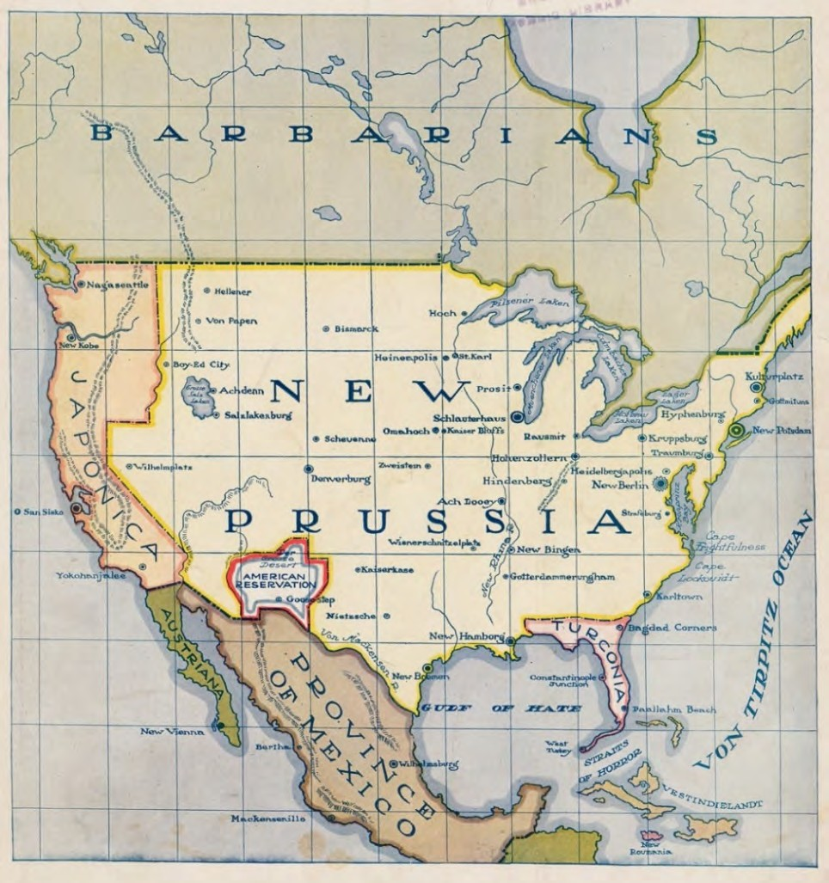
Life, February 10, 1916 (Cornell University Library)

18
Name(s)- Period- Date-
Analyzing a Cartoon: Isolationist and Interventionist Arguments
Cartoon 4

Give the cartoon a title:
What action is taking place in the cartoon?
What mood or tone is created by the cartoon and what is creating that mood or tone?
Is the message of the cartoon isolationist or interventionist? Cite evidence to support your answer.
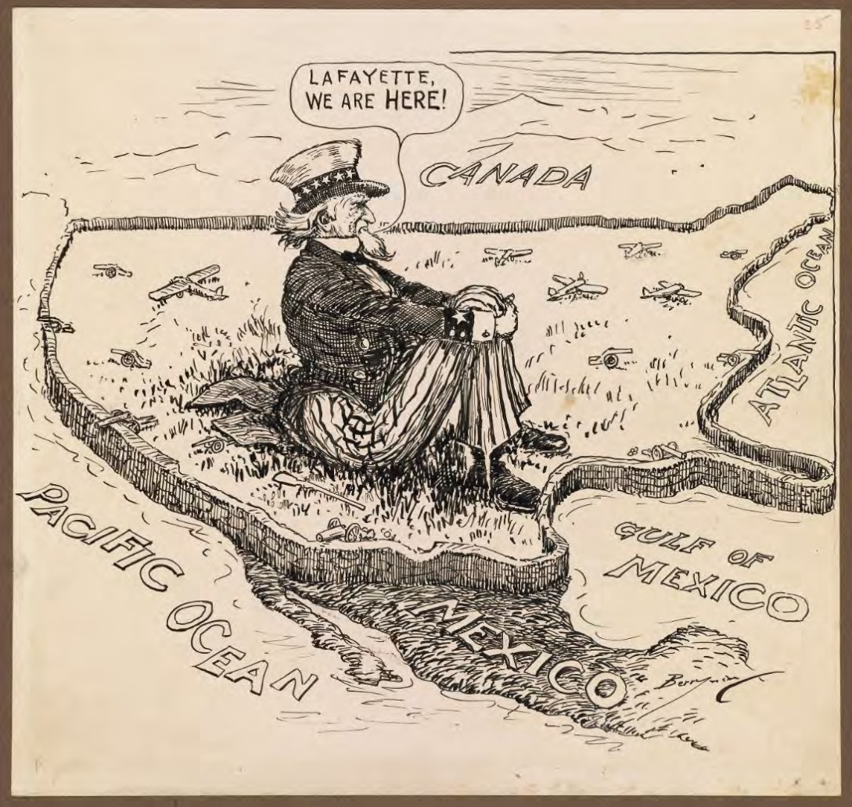
Clifford Berryman, 1940. (National Archives)

19
Name(s)- Period- Date-
Analyzing Isolationist Arguments
[Political Address]

George Washington’s Farewell Address, 1796 [excerpts]

Friends and Citizens:
. . . As avenues to foreign influence in innumerable ways, such attachments are particularly alarming to the truly enlightened and independent Patriot. How many opportunities do they afford to tamper with domestic factions, to practice the arts of seduction, to mislead public opinion, to influence or awe the Public Councils. Such an attachment of a small or weak, towards a great and powerful nation, dooms the former to be the satellite of the latter.
Against the insidious wiles of foreign influence (I conjure you to believe me, fellow-citizens) the jealousy of a free people ought to be constantly awake; since history and experience prove that foreign influence is one of the most baneful foes of Republican Government. Excessive partiality
for one foreign nation, and excessive dislike of another, cause those whom they actuate to see danger only on one side, and serve to veil and even second the arts of influence on the other. . . .
After deliberate examination with the aid of the best lights I could obtain, I was well satisfied that our country, under all the circumstances of the case, had a right to take, and was bound in duty and interest, to take a neutral position. Having taken it, I determined, as far as should depend upon me, to maintain it, with moderation, perseverance, and firmness.
The considerations which respect the right to hold this conduct, it is not necessary on this occasion to detail. I will only observe, that according to my understanding of the matter, that right, so far from being denied by any of the Belligerent Powers, has been virtually admitted by all.
The duty of holding a neutral conduct may be inferred, without anything more, from the obligation which justice and humanity impose on every nation, in cases in which it is free to act, to maintain inviolate the relations of peace and amity towards other nations.

Claypoole’s Advertiser, September 19, 1796 (The Gilder Lehrman Institute of American History, GLC00185)

20
Name(s)- Period- Date-
Analyzing Isolationist Arguments
[Speech]

Senator Henry Cabot Lodge, Speech on the Constitution of the League of Nations, 1919 [excerpts]

. . . No question has ever confronted the United States Senate which equals in importance that which is involved in the league of nations intended to secure the future peace of the world. There should be no undue haste in considering it. . . .
We abandon entirely by the proposed constitution [for the League of Nations] the policy laid down by Washington in his Farewell Address and the Monroe doctrine For nearly a century and a
quarter the policies laid down in the Farewell Address have been followed and adhered to by the Government of the United States and by the American people Washington declared against
permanent alliances. He did not close the door on temporary alliances for particular purposes.
Under the terms of this league draft reported by the committee to the peace conference the Monroe doctrine disappears. It has been our cherished guide and guard for nearly a century The
real essence of that doctrine is that American questions shall be settled by Americans alone; that the Americas shall be separated from Europe and from the interference of Europe We are not cutting
away dead limbs from the body politic, but abandoning two cardinal principles of American
government. . . .
In article 10 we, in common, of course, with the other signatories and members of the projected league, guarantee the territorial integrity and the political independence of every member of the league. If we guarantee any country on the earth, no matter how small or how large, in its
independence or its boundaries . . . we must maintain at any cost and we must be in constant
possession of fleets and armies capable of enforcing these guaranties at a moment’s notice I wish
them carefully to consider, therefore, whether they are willing to have the youth of America ordered to war by other nations. . . .
America and the American people are first in my heart now and always. I can never assent to any scheme no matter how fair its outward seeming which is not for the welfare and for the highest and best interest of my own beloved people of whom I am one—the American people—the people of the United States.

Congressional Record 57, pt. 5 (1919), pp. 4520–4522 and 4528.

21
Name(s)- Period- Date-
Analyzing Isolationist Arguments
[Speech]

“Speech of Hon. George Holden Tinkham of Massachusetts in the House of Representatives, February 3, 1933” [excerpts]

Mr. Chairman, the time has come to handle without gloves those who would denationalize the United States.
The time is here to unmask those disloyal and seditious organizations and individuals who are attempting to destroy the independence of the United States, to subvert her national integrity, and to involve her in advance in the next European war. . . .
The manipulation of public opinion by high-cost organized propaganda from sources which do not represent the general public will has become the poisoned cup from which the American Republic will perish. . . .
Since 1920 the American people have voted repeatedly against interference or participation in the political affairs of Europe. They have again and again expressed themselves decisively as opposed to political internationalism. Notwithstanding, they have seen party platforms and elected and appointed American officials repeatedly nullify their expressed will. This has occurred because the public opinion which writes party platforms and influences Government officials is subtly manipulated by high-cost propaganda, emanating from disloyal, seditious, and alien-minded sources, and from sources of self-interest and personal gain. . . .
It is the preeminent duty of the Congress of the United States to preserve American independence, to safeguard American nationality, and to keep the United States out of war.
The Congress can perform this duty only by throwing the bright light of publicity upon the foul intrigue now being perpetrated against the American people. The activities and vast expenditures of the disloyal and seditious organizations which are now poisoning American public opinion at its source demand complete exposure. Their purpose and methods should be disclosed. Their expenditures for the pollution of the pulpit, the platform, institutions of learning, and the press of the country should be uncovered. Those who are being paid should be named and identified. . . .

22
Name(s)- Period- Date-

Any affirmative commitment under the so-called Kellogg-Briand pact would destroy American neutrality, which has been the priceless heritage and safeguard of the United States since the founding of the Republic, and inevitably would mean war in support of one group of the belligerent European nations in the next war. The United States should remain the great neutral nation.

Carbon County (MT) News, March 8, 1933. (Library of Congress)

23
Name(s)- Period- Date-
Analyzing Isolationist Arguments
[Book]

Smedley D. Butler, War Is a Racket, 1935 [excerpts]

Until 1898 [the United States] didn’t own a bit of territory outside the mainland of North America Then we became “internationally minded.” We forgot, or shunted aside, the advice of the
Father of our Country. We forgot Washington’s warning about “entangling alliances.” We went to war. We acquired outside territory. At the end of the World War period, as a direct result of our fiddling in international affairs, our national debt had jumped to over $25,000,000,000. . . .
It would have been far cheaper (not to say safer) for the average American who pays the bills to stay out of foreign entanglements. For a very few this racket, like bootlegging and other underworld rackets, brings fancy profits, but the cost of operations is always transferred to the people—who do not profit. . . .
If you don’t believe this, visit the American cemeteries on the battlefields abroad. Or visit any of the veterans’ hospitals in the United States. I have visited eighteen government hospitals for
veterans. In them are a total of about 50,000 destroyed men—men who were the pick of the nation eighteen years ago.
Beautiful ideals were painted for our boys who were sent out to die. This was the “war to end wars.” This was the “war to make the world safe for democracy.” No one told them that dollars and cents were the real reason. No one mentioned to them, as they marched away, that their going and their dying would mean huge war profits. They were just told it was to be a “glorious adventure.”

Smedley D. Butler, War Is a Racket (Los Angeles: Feral Press, 2003, orig. 1935), pp. 6–7, 17, and 21.

24
Name(s)- Period- Date-
Analyzing Isolationist Arguments
[Speech]

Radio Address by Senator Gerald Nye, May 8, 1941 [excerpt]

. . . Put it down as a fundamental truth: If we get into this war it will not be because the President tried to keep us out.
America wants to stay out of this war. Those who believe they can create the public opinion that will catch up with the President and the interventionists ought to be answered by the people acting as those who know that the way to catch up with the President is to overtake him, as you would a runaway horse, and stop him.
Let America really have freedom from fear. We are at peace still with the world. The only censorship we know is voluntary. Truth can still be entertained and opinion still has right of expression.
Let us be done with this fear that our dependence is upon the British Navy, the only Navy that has ever practiced aggression against this hemisphere.
Let us devote our preparation to our own defense and be done with this fear that aggression may be practiced against us. If it is aggressors we fear and would stop, let us not become again the partner of the land which for three centuries of military aggression and conquest has builded the greatest empire of all time.
Let us, when we consider our world trade, in connection with the future, remember that on a normal basis it is only 4 percent or 5 percent of our economic dependence, and that our most severe competitor in this field is Great Britain.
Let us be doing more thinking of America and less of empires across the seas. If an empire dies, it will only mean that history is repeating itself, and that our forefathers successfully fought to free America from European empire builders. . . .

Congressional Record 87 (1941), pp. A2191–A2192.

25
Name(s)- Period- Date-
Analyzing Interventionist Arguments
[Speech]

Woodrow Wilson’s Address to Congress, April 2, 1917 [excerpts]

I have called the Congress into extraordinary session because there are serious, very serious, choices of policy to be made, and made immediately, which it was neither right nor constitutionally permissible that I should assume the responsibility of making. . . .
With a profound sense of the solemn and even tragical character of the step I am taking and of the grave responsibilities which it involves I advise that the Congress declare the recent course of
the Imperial German Government to be in fact nothing less than war against the Government and people of the United States. . . .
Neutrality is no longer feasible or desirable where the peace of the world is involved and the freedom of its peoples, and the menace to that peace and freedom lies in the existence of autocratic governments backed by organized force which is controlled wholly by their will, not by the will of their people. . . .
A steadfast concert for peace can never be maintained except by a partnership of democratic nations. No autocratic government could be trusted to keep faith within it or observe its covenants. It must be a league of honor, a partnership of opinion. . . .
The world must be made safe for democracy. Its peace must be planted upon the tested foundations of political liberty. We have no selfish ends to serve. We seek no indemnities for ourselves, no material compensation for the sacrifices we shall freely make. We are but one of the champions of the rights of mankind. We shall be satisfied when those rights have been made as secure as the faith and the freedom of nations can make them. . . .
To such a task we can dedicate our lives and our fortunes, everything that we are and everything that we have, with the pride of those who know that the day has come when America is privileged to spend her blood and her might for the principles that gave her birth and happiness and the peace which she has treasured. God helping her, she can do no other.

Woodrow Wilson, Address of the President of the United States, Delivered at a Joint Session of the Two Houses of Congress, April 2, 1917 (Garden City NY: Doubleday, Page & Co., 1917) (The Gilder Lehrman Institute, GLC00466)

26
Name(s)- Period- Date-
Analyzing Interventionist Arguments
[Press Statement]

Statement given by Ex-Secretary of the Treasury William C. McAdoo, 1921 [excerpts]

. . . I do not agree with those who hastily and inconsiderately adjudge the President’s work at the Peace Conference a failure. Whatever may be the imperfections of the Treaty from a political or economic standpoint, Woodrow Wilson did not fail. The outstanding thing for which he fought, the thing that transcends political and economic considerations, is the permanent peace of the world. Unless this is secured all else is a failure; without this the sublimest hope of humanity is sunk in the black abyss; without this all political and economic adjustments are unstable and sooner or later will disappear.
Woodrow Wilson laid the foundations of world peace and a new order in the Versailles Treaty. This Is the supreme need of civilization; this is his greatest work. The fact that the crowning structure [joining the League of Nations] has not yet reached completion, that it has been halted by the selfishness of designing politicians and the greed of materialistic national interests, has neither impaired nor destroyed those foundations. The tides of reaction will ignominiously exhaust themselves and the work of Woodrow Wilson will emerge unscathed and stand like the eternal rocks as the support of a new and better order of which peace and justice will be the keystone. . . .
No one can tear that star from the flag. With it America will lead the vanguard of humanity and civilization to a new day of human brotherhood and world order. This will not come immediately, but it will come inevitably in the slow and sure processes of time. . . .

(The Gilder Lehrman Institute of American History, GLC03967)

27
Name(s)- Period- Date-
Analyzing Interventionist Arguments
[Government Report]

Charles Firich, Polish Character of Upper Silesia, 1921 [excerpts]

“The state of Poland ought to be include all the lands inhabited by an unmistakably Polish population” (art. [article] 13 of Wilson’s program).

The historical fight of the German Imperialism with the Polish people, defending their homes is not yet over.
The free Allied nations of the world have crushed by united and tremendous effort Prussian Imperialism, which believed that force is the only base of law, and that the call “Drang nach Osten” (Press to the East) can justify any lawlessness.
After millions fell on the battlefields, the Treaty of Versailles announced that there would be: “Law, Justice and Freedom for all the nations hitherto oppressed”.
However, the fight of those two great ideas, of materialism based on lawlessness and force, and of idealism, basing the future of the humanity on law and justice, this fight is not yet over.
The waves of egotism and opportunism flood again the great ideas of the progress of humanity. Now is the highest time to begin the moral regeneration of the world by applying the principle of truth, justice and the love of fellowman to the relations between the Nations of the World. . . .
This turning away from the great Ideals of Western Democracy was not only a denial of the great conquests of the world’s war, but in consequence has led to great international complications. . . .
The right of the inhabitants to decide freely on their future—given them by the Versailles Treaty—has been cynically violated. . . .
TRUTH and JUSTICE and LIBERTY they expect to result from the final decision of the Powers.

(The Gilder Lehrman Institute of American History, GLC02766.16)

28
Name(s)- Period- Date-
Analyzing Interventionist Arguments
[Speech]

Address of the President [Franklin Roosevelt] at Chautauqua, NY, 1936 [excerpts]

. . . I am more concerned and less cheerful about international world conditions then about our immediate domestic prospects.
I say this to you not as a confirmed pessimist but as one who still hopes that envy, hatred and malice among nations have reached their peak and will be succeeded by a new tide of peace and good will. . . .
Long before I returned to Washington as President of the United States, I had made up my mind that pending what might be called a more opportune moment. I made the following
declaration:
“In the field of world policy I would dedicate this Nation to the policy of the good neighbor— the neighbor who resolutely respects himself and because he does so, respects the rights of others— the neighbor who respects his obligations and respects the sanctity of his agreements in and with a world of neighbors.”
. . . We are not isolationists except insofar as we seek to isolate ourselves completely from war.
Yet we must remember that so long as war exists on earth there will be some danger that even the nation which most ardently desires peace may be drawn into war. . . .
In one field, that of economic barriers, the American policy may be, I hope, of some assistance in discouraging the economic source of war and therefore a contribution towards the peace of the world. The trade agreements which we are making are not only finding outlets for the products of American fields and American factories but are also pointing the way to the elimination of embargoes, quotas and other devices which place such pressure on nations not possessing great natural resources that to them the price of peace seems less terrible than the price of war.
We do not maintain that a more liberal international trade will stop war but we fear that without a more liberal international trade war is a natural sequence. . . .
Nevertheless, if war should break out again in another continent, let us not blink the fact that we would find in this country thousands of Americans who, seeking immediate riches—fools’ gold— would attempt to break down or evade neutrality. . . .

29
Name(s)- Period- Date-

No matter how well we are supported by neutrality legislation, we must remember that no laws can be provided to cover every contingency, for it is impossible to imagine how every future event may shape itself. In spite of every possible forethought, international relations involve of necessity a vast uncharted area. . . . Peace will depend on their day to day decisions. . . .
We believe in democracy; we believe in freedom; we believe in peace. We offer to every nation of the world the handclasp of the good neighbor. Let those who wish our friendship look us in the eye and take our hand.
(The Gilder Lehrman Institute of American History, GLC04599)

30
Name(s)- Period- Date-
Analyzing Interventionist Arguments
[Policy Statement]

Committee to Defend America by Aiding the Allies, Policy Statement, March 1941 [excerpts]

The Committee to Defend America by Aiding the Allies is committed to an Allied success because America and the American way of life will be gravely imperiled by an Axis victory The
Committee will support the following measures to make this policy effective.
I. The full mobilization of American economic life for greater production with whatever sacrifices are necessary on the part of business, labor, agriculture and the consumer. . . .
Use by the American government of whatever means are necessary to insure prompt delivery of war materials to the Allies, including (1) repair of Allied naval vessels in American waters; (2) supply to the Allies of all possible merchant tonnage; (3) transfer to the Allies of additional destroyers and other naval craft; (4) permission to the Allies to organize convoys in American ports; (5) convoy of ships with American naval vessels if need be.
Our slogan will be “Deliver the goods to Britain now. ”
V. Strenuous efforts to combat Nazi and totalitarian propaganda in the Americas with care to preserve civil liberties and the Good Neighbor policy. . . .
Eventual victory for the forces of democracy must be translated into the institutions and machinery for durable peace with American participation. Public opinion must be mobilized now so that America will play an effective part in the organization of a lasting peace and will this time see the job through. . . .
We believe, and without reservation, that our only chance of establishing a peaceful world in which we might live in freedom and tranquility and preserve our institutions is to insure Allied victory. . . .

(David M. Rubenstein Rare Book & Manuscript Library, Duke University Libraries)

31
Name(s)- Period- Date-

Analyzing Isolationist Arguments

Using the Isolationist documents provided: Which are the most important or powerful phrases in the documents? Choose 5 phrases, one from each document.

Document: Phrase 1: | Why is this phrase important or powerful?
Document: Phrase 2: | Why is this phrase important or powerful?
Document: Phrase 3: | Why is this phrase important or powerful?
Document: Phrase 4: | Why is this phrase important or powerful?
Document: Phrase 5: | Why is this phrase important or powerful?
Based your analysis of the phrases you selected, state the overall message of the isolationists:
In your opinion, what part should the United States have played in the world between 1918 and 1941?

32
Name(s)- Period- Date-

Analyzing Interventionist Arguments

Using the Interventionist documents provided: Which are the most important or powerful phrases in the documents? Choose 5 phrases, one from each document.

Document: Phrase 1: | Why is this phrase important or powerful?
Document: Phrase 2: | Why is this phrase important or powerful?
Document: Phrase 3: | Why is this phrase important or powerful?
Document: Phrase 4: | Why is this phrase important or powerful?
Document: Phrase 5: | Why is this phrase important or powerful?
Based your analysis of the phrases you selected, state the overall message of the interventionists:
In your opinion, what part should the United States have played in the world between 1918 and 1941?

33
Name(s)- Period- Date-
Isolationist/Interventionist News Conference
News Conference:

Isolationist or Interventionist

Question #1:
Answer: | Evidence from the text:
Question #2:
Answer: | Evidence from the text:
Question #3:
Answer: | Evidence from the text:

Produced by the Gilder Lehrman Institute of American History. © 2021 Council on Foreign Relations
gilderlehrman.org and world101.cfr.org
34
Name(s)- Period- Date-
Examples of Isolationist News Conference
News Conference: Isolationist

Isolationist or Interventionist

Question #1: Is isolationism a founding principle of the United States?
Answer:  Yes, according to President George Washington, the United States should stay out of foreign entanglements. We should remain neutral. Look at this cartoon, we are the ship avoiding the problems of the world. | Evidence from the text:  “history and experience prove that foreign influence is one of the most baneful foes of republican government . . .  Excessive partiality for one foreign nation, and excessive dislike of another, cause those whom they actuate to see danger only on one side, and serve to veil and even second the arts of influence on the other.”  Washington’s Farewell Address, 1796 and Cartoon 1
Question #2: What are the benefits of Isolationism?
Answer:  One benefit is that the United States is not entangled in complicated treaties with foreign countries. This saves lives because we don’t have to help fight their wars. It also saves us money, because we don’t have to help pay for the war. | Evidence from the text:  “At the end of the World War period, as a direct result of our fiddling in international affairs, our national debt had jumped to over $25,000,000,000. . . .  It would have been far cheaper (not to say safer) for the average American who pays the bills to stay out of foreign entanglements. For a very few this racket, like bootlegging and other underworld rackets, brings fancy profits, but the cost of operations is always transferred to the people—who do not profit.”  Smedley Butler, 1935
Question #3: Why should the United States not be in the League of Nations?
Answer:  If the United States becomes a part of the League of Nations, we will have to fight every country’s problems. Can you imagine the cost? | Evidence from the text:  “If we guarantee any country on the earth, no matter how small or how large, in its independence or its boundaries . . . we must maintain at any cost…and we must be in constant possession of fleets and armies capable of enforcing these guaranties at a moment’s notice. I wish them carefully to consider, therefore, whether they are willing to have the youth of America ordered to war by other nations.”  Henry Cabot Lodge, 1919

35
Name(s)- Period- Date-
Examples of Interventionist News Conference
News Conference: Interventionist

Isolationist or Interventionist

Question #1: How can United States involvement help other countries?
Answer:  The United States can ensure that peace-loving countries are supported and that people around the world do not have to face tyranny. We can be a positive good around the world. | Evidence from the text:  “This turning away from the great Ideals of Western Democracy was not only a denial of the great conquests of the world’s war, but in consequence has led to great international complications.  TRUTH and JUSTICE and LIBERTY they expect to result from the final decision of the Powers.”  Polish Character of Upper Silesia, 1921
Question #2: Why doesn’t isolationism work?
Answer:  The United States is on the world’s stage. We are part of the global network of democracy. We cannot turn our backs on those who wish to take part in freedom and democracy. We can help others attain what we have. Look at this cartoon: if we do nothing, we are the victim. | Evidence from the text:  “The world must be made safe for democracy. Its peace must be planted upon the tested foundations of political liberty. We have no selfish ends to serve. We seek no indemnities for ourselves, no material compensation for the sacrifices we shall freely make. We are but one of the champions of the rights of mankind. We shall be satisfied when those rights have been made as secure as the faith and the freedom of nations can make them.”  Wilson’s Address, 1917 and Cartoon 4
Question #3: What are the economic benefits of interventionism?
Answer:  By helping to maintain peace around the world we strengthen our global neighborhood. By helping others, we help ourselves. | Evidence from the text:  “In the field of world policy I would dedicate this Nation to the policy of the good neighbor—the neighbor who resolutely respects himself and because he does so, respects the rights of others—the neighbor who respects his obligations and respects the sanctity of his agreements in and with a world of neighbors.”  President Roosevelt, 1936

36
Name(s)- Period- Date-
Isolationist Audience Response
Isolationist Arguments: Group #1

Specific Documents Cited:
Most Effective Evidence (Quote):
Brief Summary of Argument:

Isolationist Arguments Group #2

Specific Documents Cited:
Most Effective Evidence (Quote):
Brief Summary of Argument:

Isolationist Arguments Group #3

Specific Documents Cited:
Most Effective Evidence (Quote):
Brief Summary of Argument:
Overall message of the Isolationists

37
Name(s)- Period- Date-
Interventionist Audience Response
Interventionist Arguments: Group #1

Specific Documents Cited:
Most Effective Evidence (Quote):
Brief Summary of Argument:

Interventionist Arguments Group #2

Specific Documents Cited:
Most Effective Evidence (Quote):
Brief Summary of Argument:

Interventionist Arguments Group #3

Specific Documents Cited:
Most Effective Evidence (Quote):
Brief Summary of Argument:
Overall message of the Interventionists

387
Name(s)- Period- Date-
Examples of Isolationist Audience Response
Isolationist Arguments: Group #1

Specific Documents Cited: Washington’s Farewell Address, 1796 and Smedley, 1935
Most Effective Evidence (Quote): “history and experience prove that foreign influence is one of the most baneful foes of republican government”
Brief Summary of Argument: The United States should remain isolationist because it is a founding principle and it saves lives.

Examples of Interventionist Audience Response

Interventionist Arguments: Group #1

Specific Documents Cited: Wilson’s Address, 1917 and Polish Character of Upper Silesia, 1921
Most Effective Evidence (Quote): “This turning away from the great ideals of Western Democracy was not only a denial of the great conquests of the world’s war, but in consequence has led to great international complications.”
Brief Summary of Argument: The United States can help make the word better for everyone.

