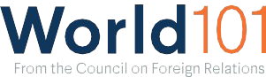
1

Global Era: Model Diplomacy Simulations

Overview
Model Diplomacy is a free classroom simulation of either the U.S. National Security Council (NSC) or the UN Security Council that takes place both online and in the classroom in a blended learning environment. It presents hypothetical situations based on real issues from the past and present. It has two historical cases from the Global Era.

Materials
The Model Diplomacy website

Instructional Plan
The following historical Model Diplomacy cases take place during the Global Era:
- Korean War in 1950
Set in September 1950. Five years after the conclusion of World War II, the Korean Peninsula is under threat of falling to a Soviet- supported, communist regime.
- NATO Enlargement in 1993
Set in December 1993. Following the collapse of the Soviet Union, many former Soviet states in Central and Eastern Europe express interest in joining the North Atlantic Treaty Organization.

