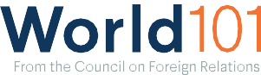

Model Diplomacy is a free classroom simulation of either the U.S. National Security Council or the UN Security Council that takes place both online and in the classroom in a blended learning environment. It presents hypothetical situations based on real issues of the past and present. The case “Unrest in Bahrain” is all about protests for democratic reforms, and “NATO
Enlargement in 1993” covers a number of issues including the role that the North Atlantic Treaty Organization (NATO) can play in preventing backsliding in new democracies.

Use the Model Diplomacy website to access the following cases:
- Unrest in Bahrain
Political unrest in Bahrain, a major non-NATO U.S. ally, has escalated to violent protests resulting in several deaths.
- NATO Enlargement in 1993
Set in December 1993. Following the collapse of the former Soviet Union, many former Soviet states in Central and Eastern Europe express interest in joining the North Atlantic Treaty Organization.

